My Favorite Rockcrok Recipes
Simple Recipes for our Everday Pan!
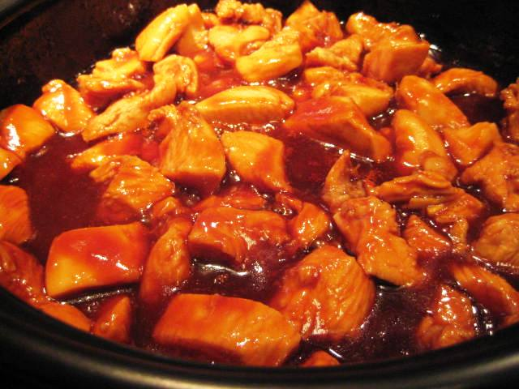 | Glazed Chicken Bits  2 tsp. soy sauce 2 tsp. honey  2 tsp. ketchup 1 tsp lemon juice  1 tsp. grated ginger root 4 gloves garlic  10 oz. chicken breasts  Mix together first four ingredients. Press garlic cloves and add to mixture. Cut chicken into 1 in. cubes. Place in a resealable plastic bag. Pour marinade over chicken. Marinate for 30 minutes in the fridge. Once marinated, pour mixture into your Rockcrok. Microwave on high for 5 to 6 minutes. All microwaves vary so check for doneness. The chicken is awesome at this point but I always drain the chicken bits and add a sauce on top. For sauce, mix up another batch of marinade. Heat the marinade alone for 1 minute in the microwave. Pour sauce over cooked chicken. When I’m doing weight watchers, this is a go-to recipe for me and my teenager loves it!
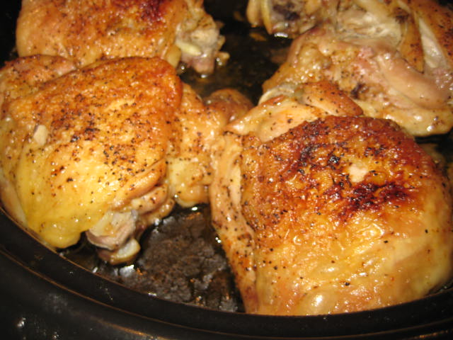 | Baked Chicken  5 Chicken Thighs  Slap Ya Mama or your favorite rub/seasoning  Simply spray the Rockcrok really well with oil. Heat on medium till oil starts to shimmer. Season thighs well and place in the oil. Brown on one side, 4-5 minutes and then flip and brown for a couple of more. Place lid on Rockcrok and bake at 350 degrees for 30 minutes or until tender.
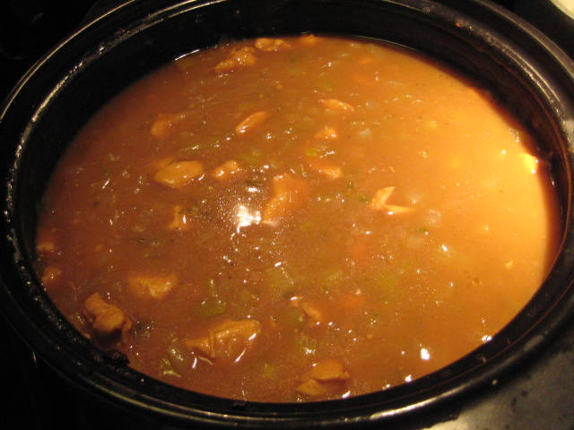 | Quick Chicken Stew  3 Chicken Breasts 1 Large Onion Diced  4 Stalks Celery Diced Salt and Pepper to Taste  1 Packet Onion Gravy Mix 1 Packet Brown Gravy Mix  1 ¾ c. water 2 tbsp. oil  Cut Chicken into 1 inch cubes. Add oil to Rockcrok. Heat till shimmering. Saute cubes till lightly browned. Remove from pan. Add onion and celery. Cook over medium heat till tender. Return chicken to pan. Mix gravy mixes with water and pour over chicken mixture. Cover and bake at 350 degrees for 25 to 30 minutes. Serve over rice.
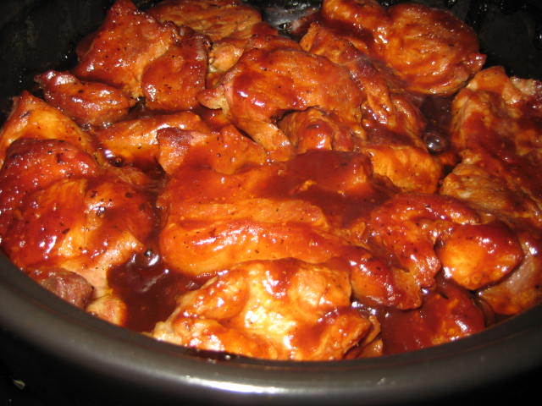 | Barbecued Country Style Pork Ribs  2-3 lbs Country Style Pork Ribs ( I used boneless)  Slap Ya Mama or your favorite rub/seasoning  Your favorite barbecue sauce  Sprinkle all sides of pork with seasoning. Spray Rockcrok with oil. Heat till shimmering. Add ribs and brown lightly on all sides. Cover and bake at 325 degrees for 45-60 minutes. Once tender, glaze with your favorite barbecue sauce. Unbelievably tender!
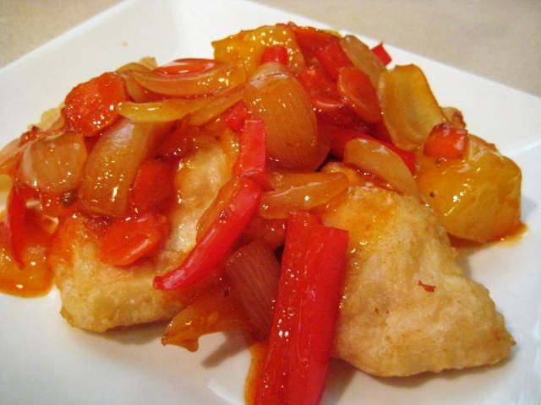 | Sweet and Sour Chicken  3-5 chicken breast ½ onion diced  salt and pepper ½ red bell pepper cut in strips  1 cup cornstarch 2 eggs, beaten  1/3 cup canola oil 1 bottle Sweet & Sour Sauce  Rinse chicken, trim off fat or extras and then cut into 1 inch cubes. Season with salt and pepper. Dip chicken into cornstarch and coat thoroughly and then into eggs. Heat oil in the Rockcrok. Cook chicken until browned. Remove and drain on paper towels. Drain most of oil from Rockcrok and add onion and peppers to the pan. Saute for a couple of minutes. Return chicken to the pan. Pour bottle of sauce over chicken. Turn to coat. Place in the oven at 350 degrees for 15 minutes. Turn chicken and then cook for 15 more minutes.
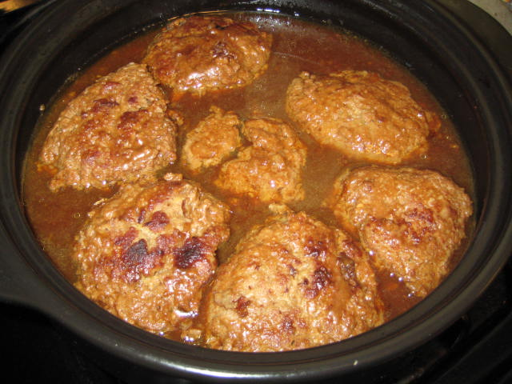 | Turkery Burgers  1 ½ to 2 lbs ground turkey 1 slice white bread  1 packet dry onion soup mix 1 egg  1 packet Onion Gravy Mix 1 packet Brown Gravy Mix  1 ¾ water  Tear bread into crumbs and mix with onion soup mix and egg. Add turkey and combine. Form into patties. Spray the pan with oil and heat over medium heat until shimmering. Place burgers in pan and brown on each side for 3-4 minutes. Mix gravy mixes with water and pour over burgers. Cover and bake in 350 degree oven for 20-30 minutes. For extra flavor, I sometimes spiral slice an onion over these. Serve over rice.
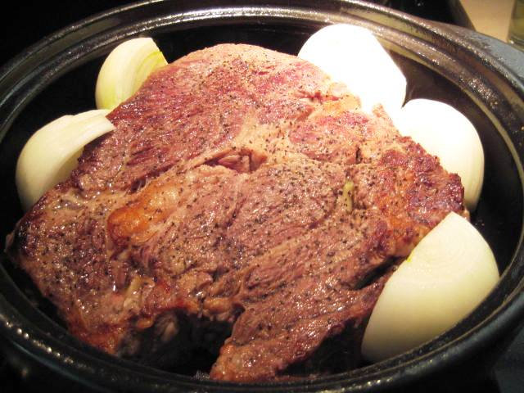  Note: This picture was taken after browning but before cooking. I didn’t get a chance to take a picture of the finished dish. It was attacked as soon as it came out of the oven! | Chuck Roast  1 2-3 lb Roast 2 onions  8 garlic cloves Salt and Pepper to taste  Cut holes in the roast and stuff the garlic cloves inside. Salt and pepper both sides of roast. Spray pan with oil and heat till shimmering. Add roast and brown on both sides. Cover and bake in oven at 325 degrees for 1 ½ hours. Peel onions and slice in half. Place in pan with roast, recover and return to oven for at least another hour. It really depends on the size of the roast and cut of the meat. Chuck roast needs to braise slowly. Bake until tender. It’s important to wait to add the onions. If you add them too early, they caramelize too much and your gravy ends up really sweet.
S’more Cake

3 milk chocolate candy bars (1.55 oz ), broken into squares
1 small pkg (9 oz) devil’s food cake or 1 2/3 cups from a regular-size package
1 egg
1 container (8 oz) sour cream
1 bag (10 oz) regular-size marshmallows or 4 cups mini marshmallows
3 whole graham crackers, coarsely crushed

Place oven rack in middle of oven; preheat broiler. Microwave chocolate in (2-cup) Prep Bowl on HIGH 30-60 seconds or until mostly melted. Stir until smooth; set aside. Combine cake mix, egg and sour cream in Classic Batter Bowl; mix using Small Mix ‘N Scraper® until blended. Pour batter into Rockcrok™ (2.5-qt.) Everyday Pan or Rockcrok™ (4-qt./3.8-L) Dutch Oven. Microwave, covered, on HIGH 4-5 minutes or until center of cake is firm and springs back when pressed. Remove pan from microwave; arrange marshmallows in an even layer over cake. Broil 30-60 seconds or until marshmallows are golden brown. Remove from broiler; sprinkle with crackers and drizzle with chocolate.
Ranch Pork Chops

4 Pork Chops 1 packet Ranch Dressing Seasoning
1 onion 1 can cream of chicken soup

Place pork chops in Rockcrok. Cover with soup and sprinkle dressing mix over soup. Spiral slice one onion on top of chops and soup. Cover and bake at 350 degrees for 1 to 1 ½ hours (until chops are tender). Uncover and place under broiler at low setting until onions start to brown. Serve over rice.

Please call me with any questions you have. I know you’re going to love
this wonderful addition to your kitchen!

Mary Stell
985-517-2111
E-mail: mstell@bellsouth.net
Website: www.pamperedchef.biz/marystell
Facebook: www.facebook.com/marystellspcpage

