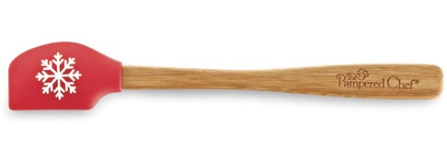  #1222 Snowflake Petite Scraper – Red  $6.50 | #1223 Snowflake Small Bamboo Spoon - Green  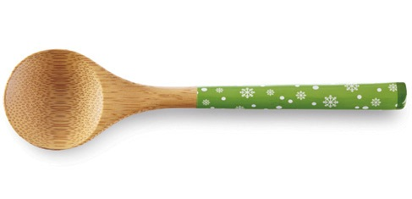  $3.50
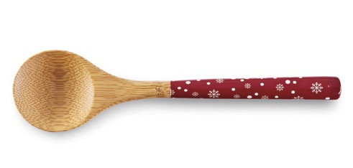  #1224 Snowflake Small Bamboo Spoon - Red  $3.50 | 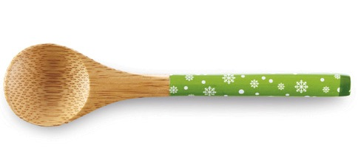  #1225 Snowflake Petite Bamboo Spoon - Green  $2.50
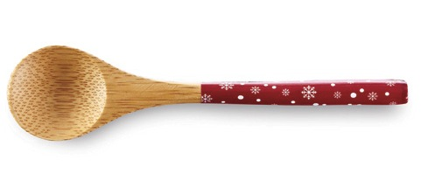  #1226 Snowflake Petite Bamboo Spoon - Red  $2.50 | #1229 On-the-Go e-Tablet Case  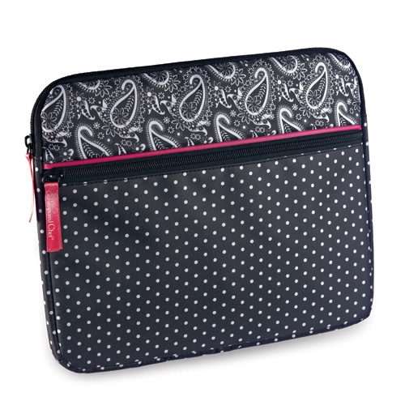  $15.50
#1241 Microwave Chip Maker  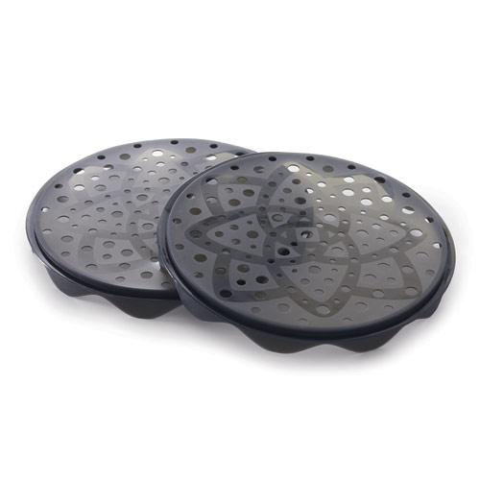  $26.50 | #1250 Quikut Paring Knife  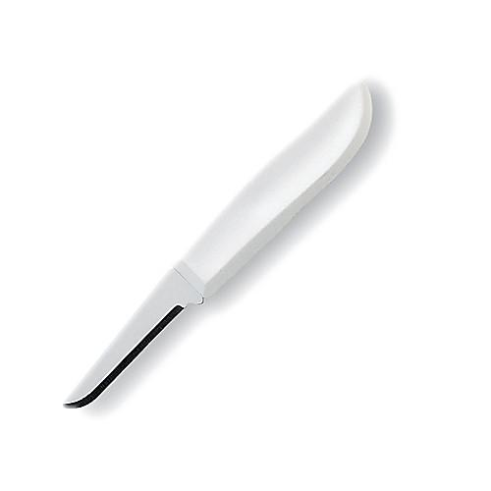  $2.25
#1256 Avocado Peeler  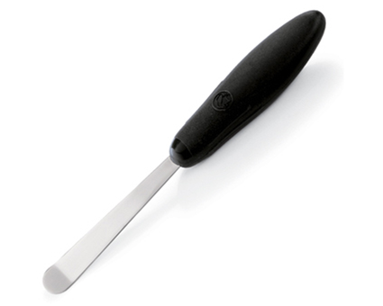  $7.00 | #1258 Quikut Paring Knives (set of 3)  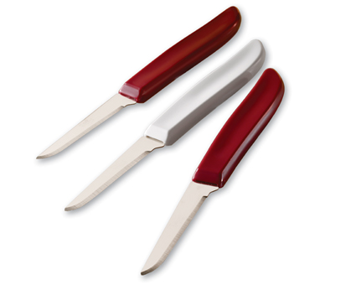  $5.50

