#1241 Microwave Chip Maker  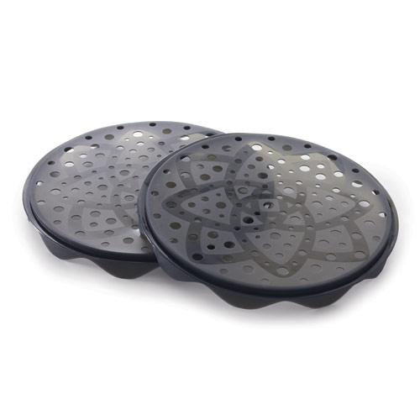  $26.50 |  | #1250 Quikut Paring Knife  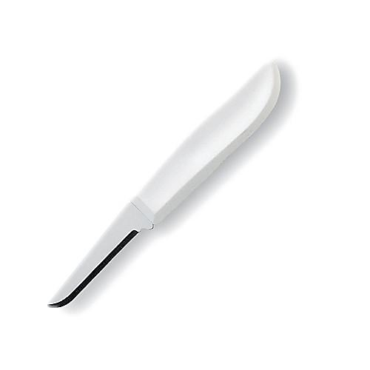  $2.25
#1256 Avocado Peeler  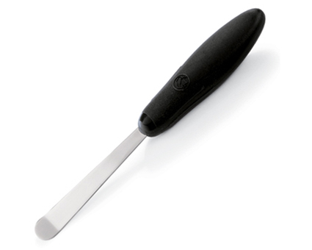  $7.00 |  | #1258 Quikut Paring Knives (set of 3)  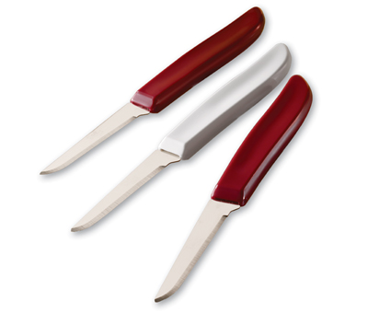  $5.50
#1260 Citrus Peeler  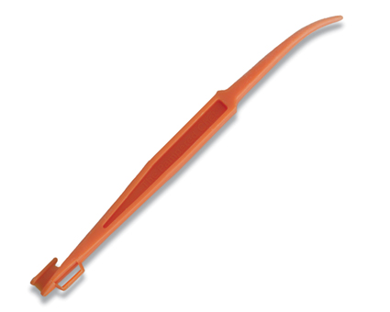  $1.00 |  | #1277 Rotary Grater  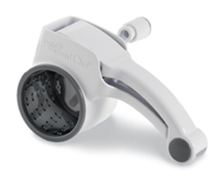  $20.00
#1302 Pizza Cutter  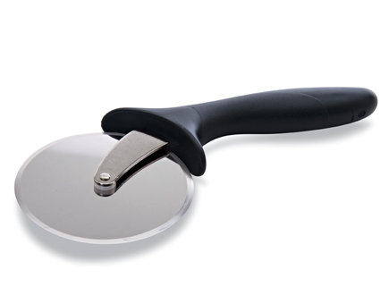  $10.50 |  | #1321 Deep Covered Baker – Cranberry  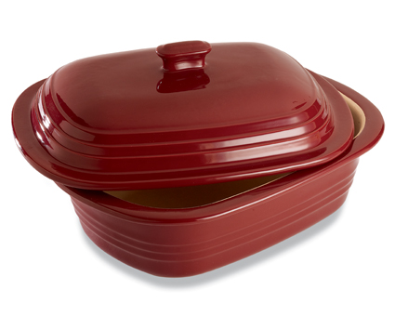  $85.00
#1329 Oven Mitt  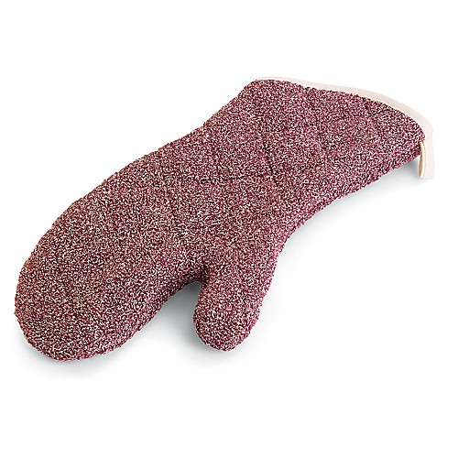  $17.50 |  | #1332 Deep Dish Pie Plate – Cranberry  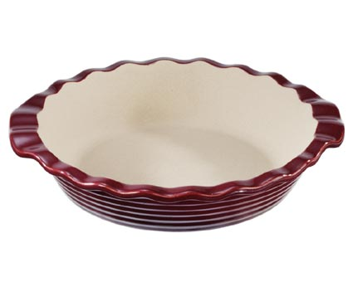  $35.00

