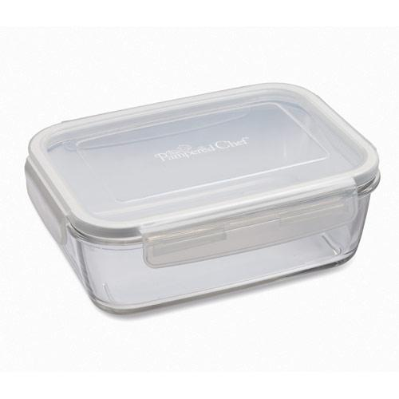  #1203 5 ¼-cup Rectangle Leakproof Glass Container  $17.50 | #1204 8 ¼-cup Rectangle Leakproof Glass Container  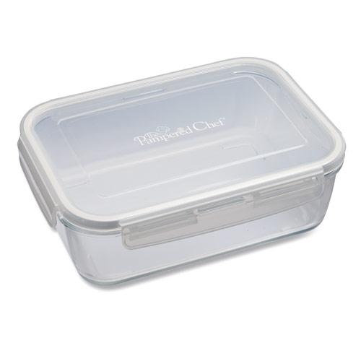  $23.50
#1205 Food Storage Labels  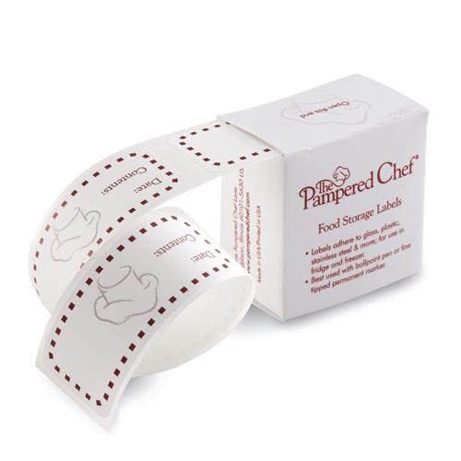  $4.75 | #1206 Fresh Lasting Lid System  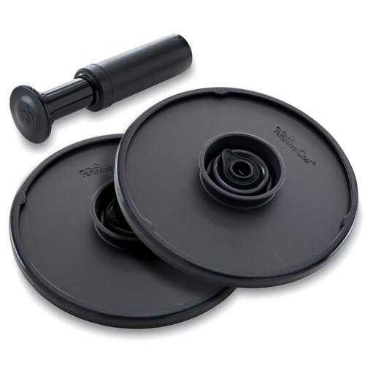  $36.00
#1212 On-the-Go  Insulated Lunch Tote  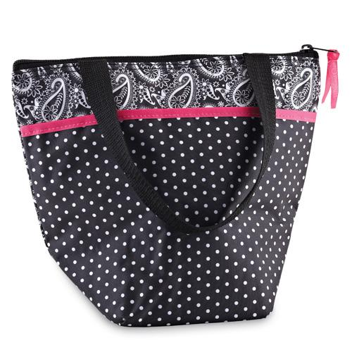  $12.50 | 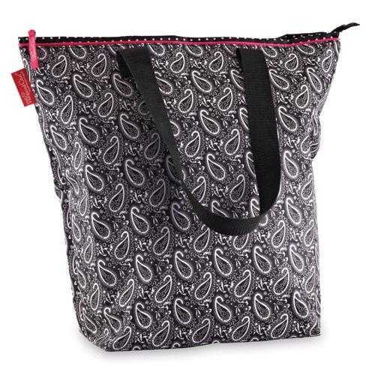  #1213 On-the-Go  Insulated Tote  $22.00
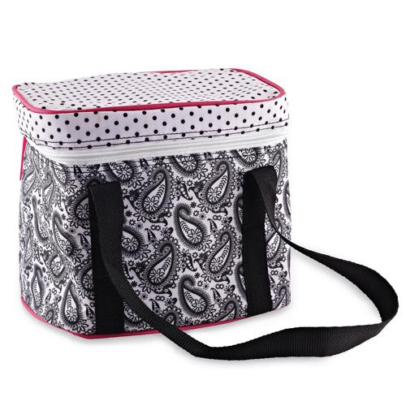  #1214 On-the-Go  Insulated Cooler  $16.50 | #1215 On-the-Go  Insulated Collapsible  Picnic Basket  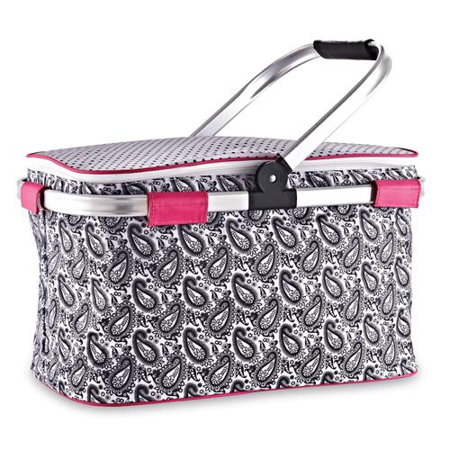  $41.00
#1218 On-the-Go Insulated Collapsible Cooler  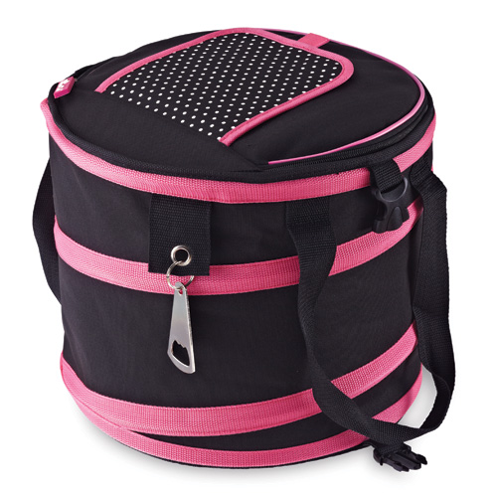  $34.00 | 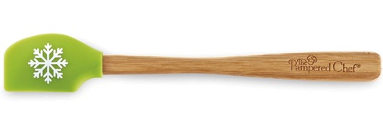  #1221 Snowflake Petite Scraper - Green  $6.50

