#1202 3-cup Square Leakproof Glass Container  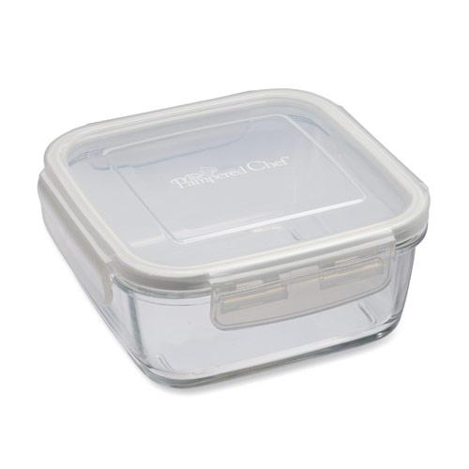  $13.50 |  | 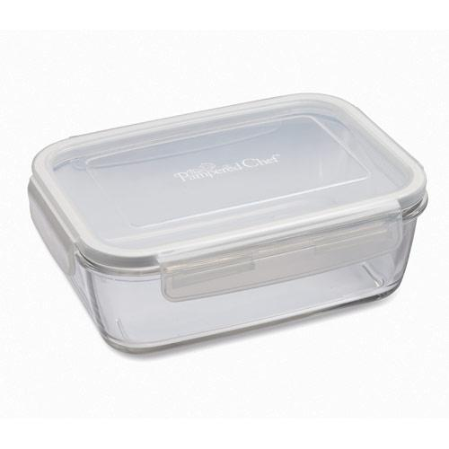  #1203 5 ¼-cup Rectangle Leakproof Glass Container  $17.50
#1204 8 ¼-cup Rectangle Leakproof Glass Container  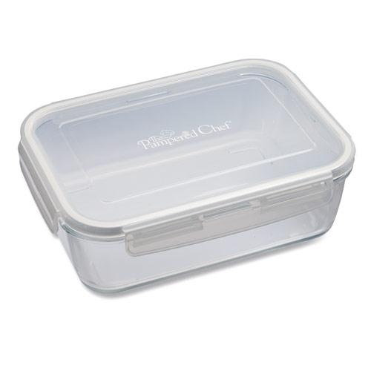  $23.50 |  | #1205 Food Storage Labels  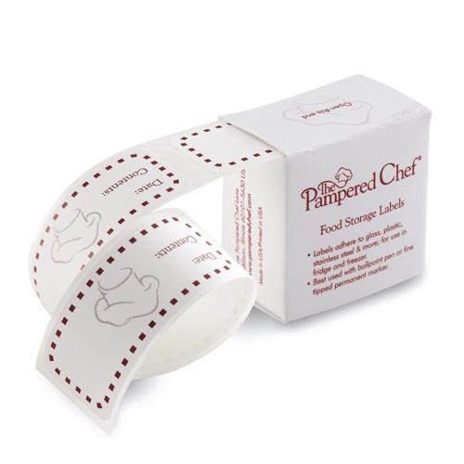  $4.75
#1206 Fresh Lasting Lid System  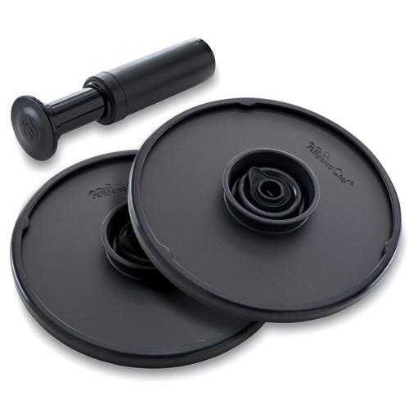  $36.00 |  | #1207 Drink Saver  (set of 4)  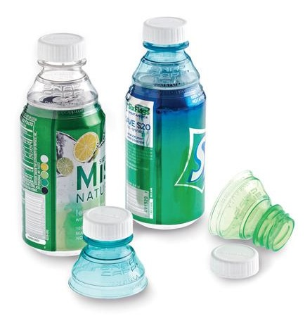  $9.50
#1212 On-the-Go  Insulated Lunch Tote  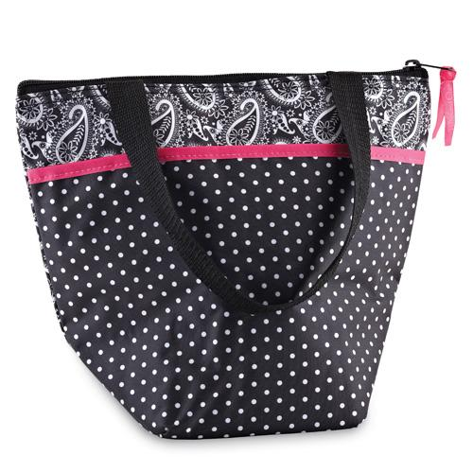  $12.50 |  | 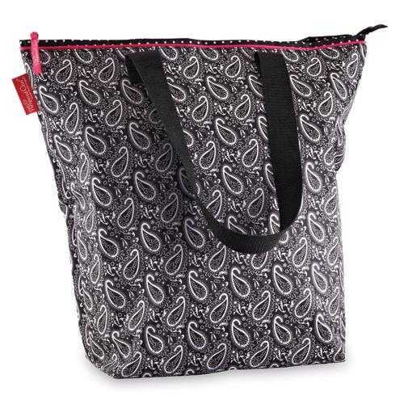  #1213 On-the-Go  Insulated Tote  $22.00
#1214 On-the-Go  Insulated Cooler  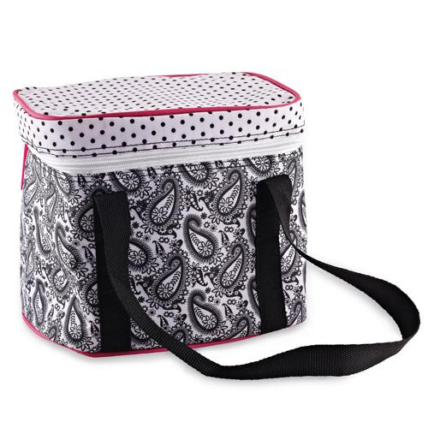  $16.50 |  | 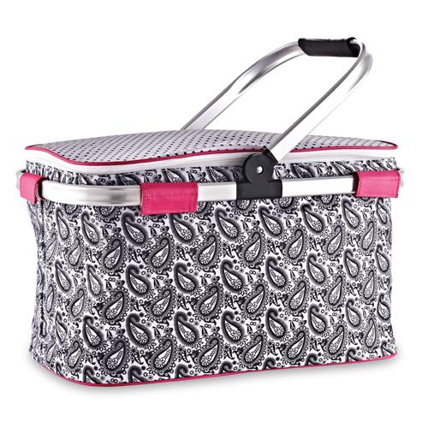  #1215 On-the-Go  Insulated Collapsible  Picnic Basket  $41.00

