#1166 Slice ‘N Serve®  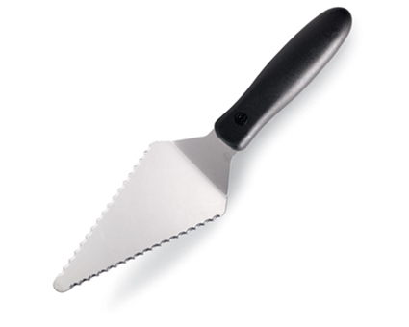  $8.50 | #1168 Nylon Slice ‘N Serve®  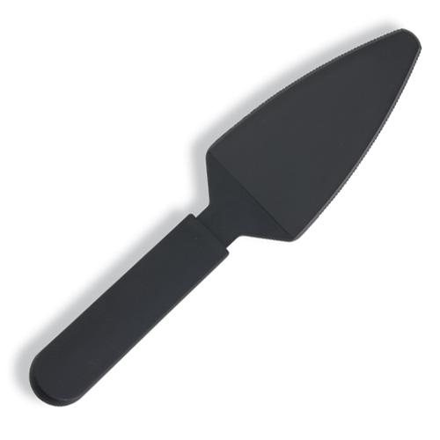  $5.50
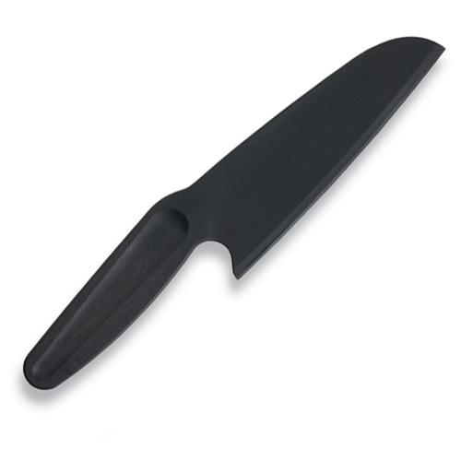  #1169 Nylon Knife  $5.50 | #1176 Core & More  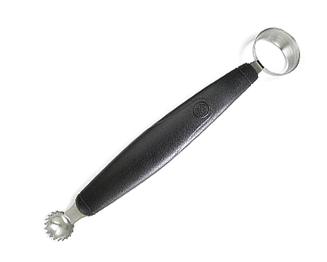  $11.50
#1182 Egg Slicer Plus®  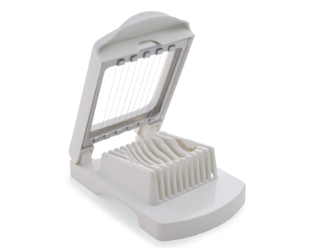  $12.00 | #1187 Egg Separator  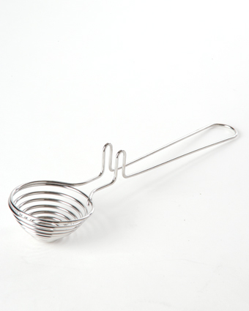  $7.00
#1188 Gravy Separator  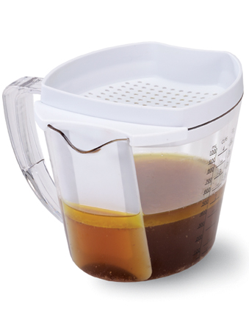  $27.00 | #1195 Cut-N-Seal®  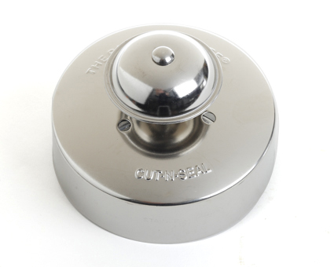  $10.00
#1201 1 ½-cup Square Leakproof Glass Container  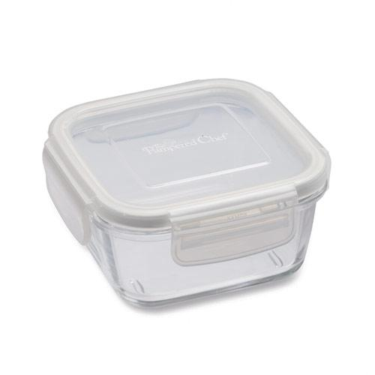  $10.50 | #1202 3-cup Square Leakproof Glass Container  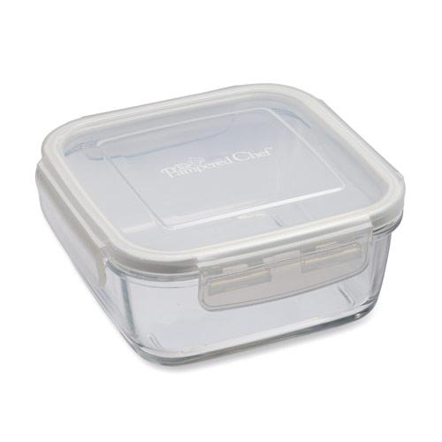  $13.50

