#1161 V-Shaped Cutter  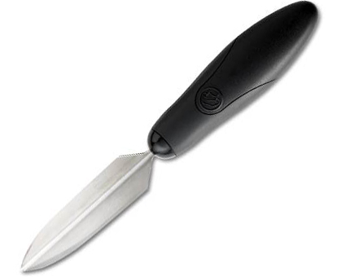  $10.50 |  | #1166 Slice ‘N Serve®  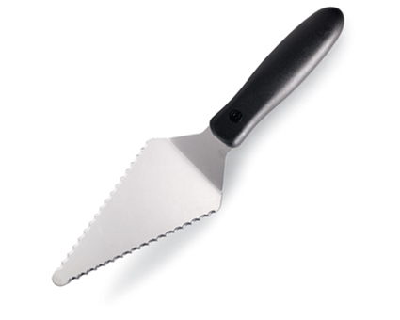  $8.50
#1168 Nylon Slice ‘N Serve®  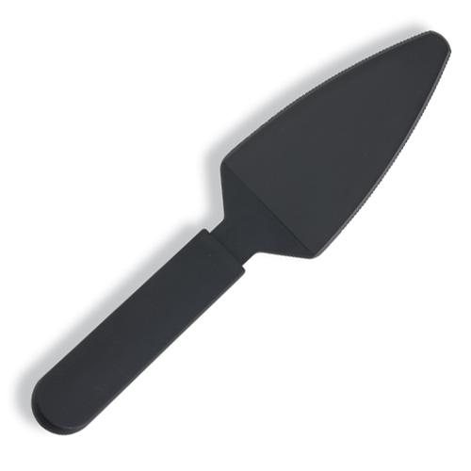  $5.50 |  | 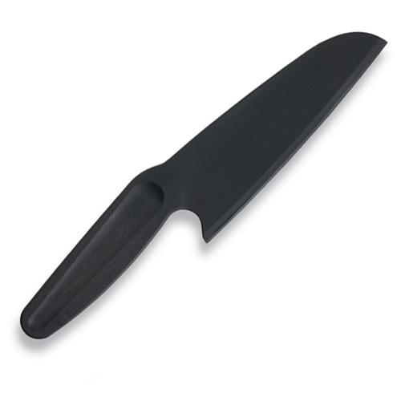  #1169 Nylon Knife  $5.50
#1176 Core & More  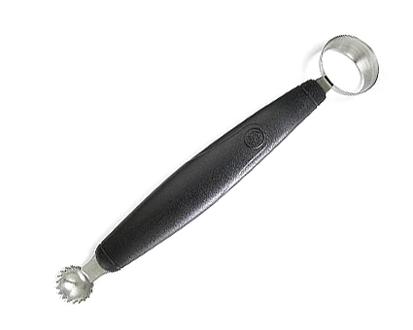  $11.50 |  | #1182 Egg Slicer Plus®  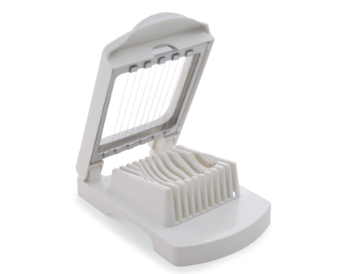  $12.00
#1187 Egg Separator  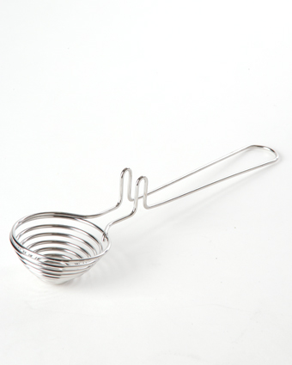  $7.00 |  | #1188 Gravy Separator  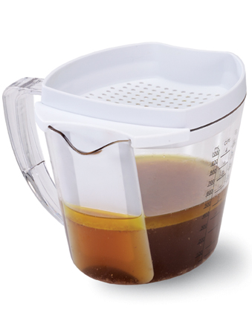  $27.00
#1195 Cut-N-Seal®  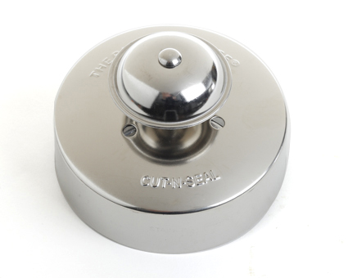  $10.00 |  | #1201 1 ½-cup Square Leakproof Glass Container  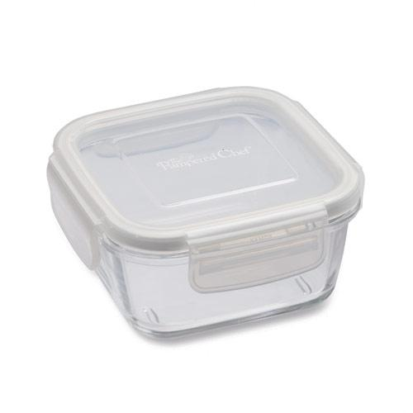  $10.50

