#1126 Cheese Knife  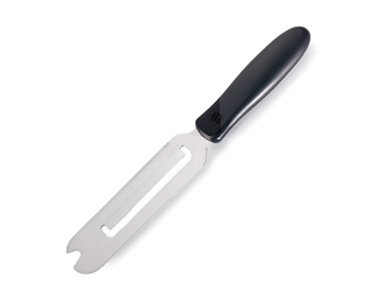  $10.00 | #1127 Grapefruite Knife  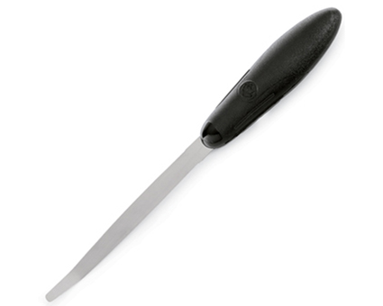  $8.50
#1129 Microplane® Coarse Grater with Food Holder Set  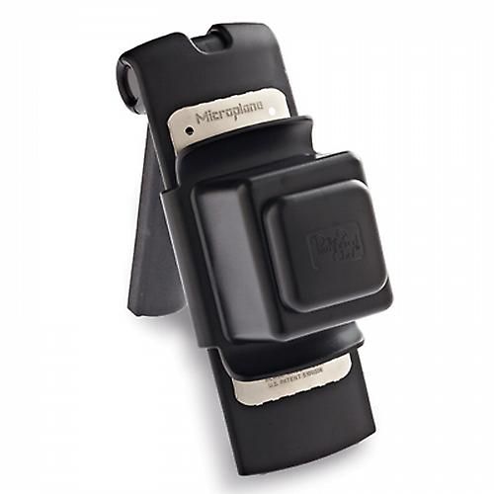  $34.50 | #1131 Fruit & Cheese Cutter  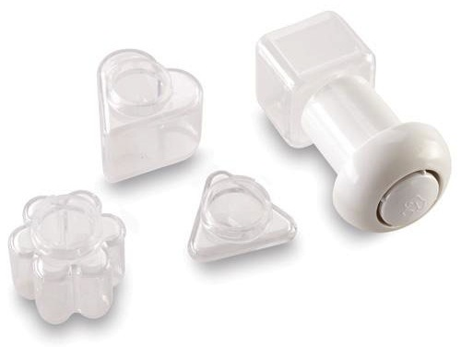  $11.50
#1132 Cheese Shaver  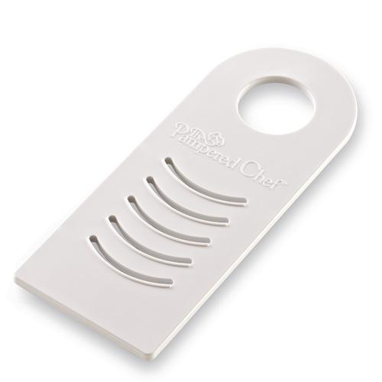  $9.50 | 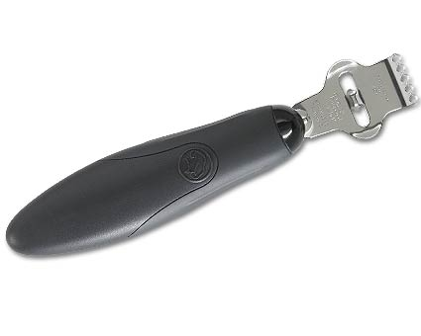  #1134 Zester/Scorer  $10.50
#1136 Spiral & Slice  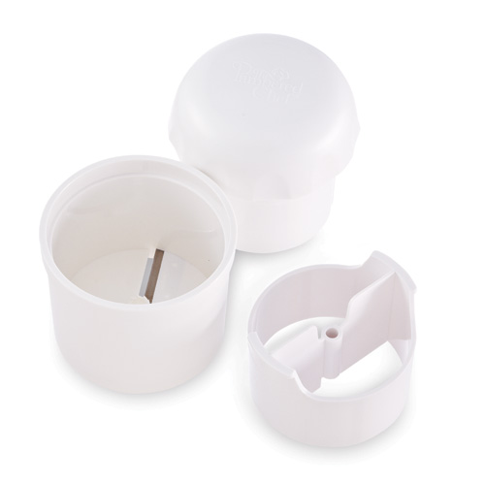  $26.00 | #1138 Bean Slicer  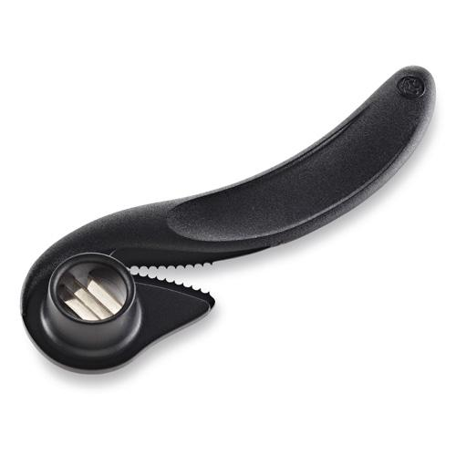  $6.50
#1139 Ginger Grater  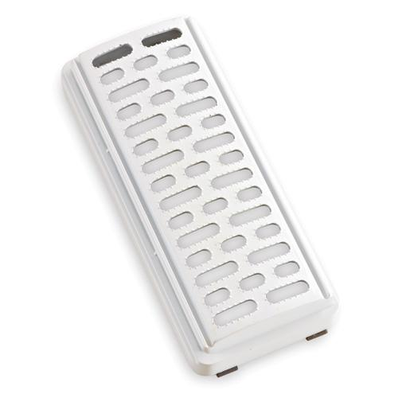  $9.50 | #1161 V-Shaped Cutter  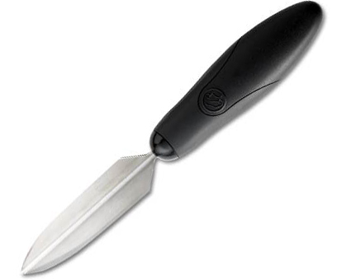  $10.50

