#1126 Cheese Knife  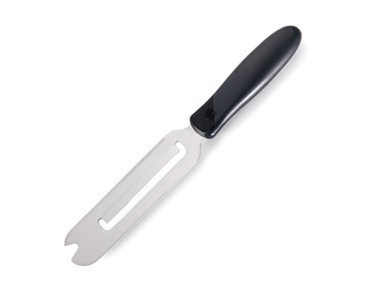  $10.00 |  | #1127 Grapefruite Knife  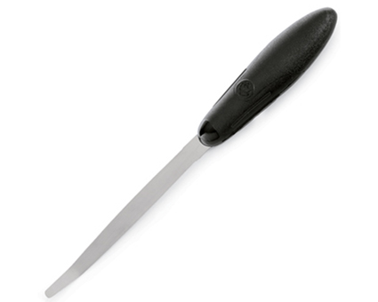  $8.50
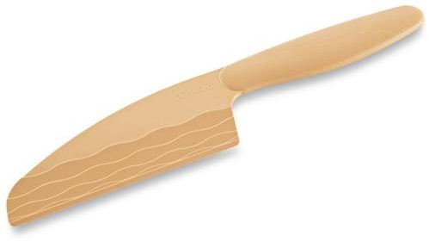  #1128 Easy Release Cheese Knife  $14.50 |  | #1129 Microplane® Coarse Grater with Food Holder Set  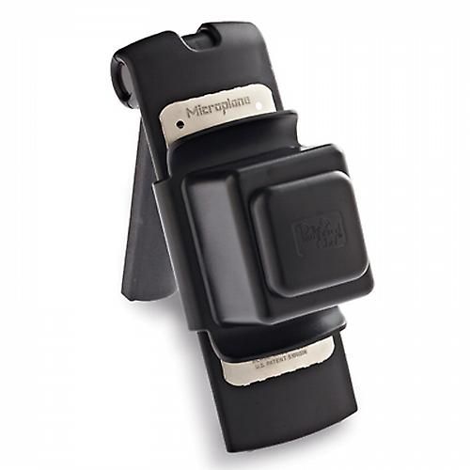  $34.50
#1131 Fruit & Cheese Cutter  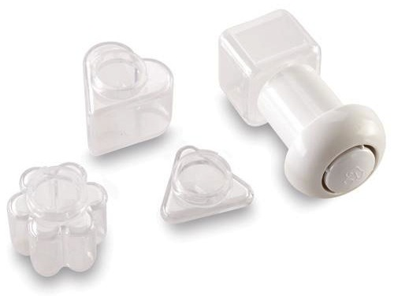  $11.50 |  | #1132 Cheese Shaver  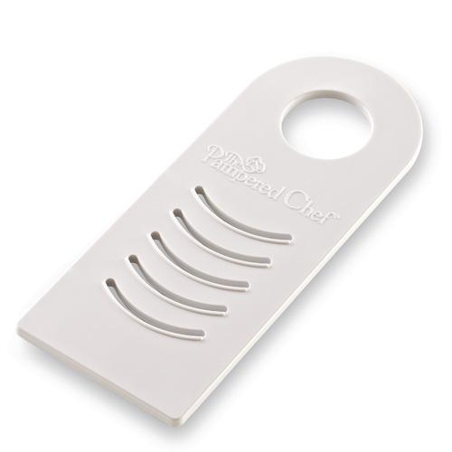  $9.50
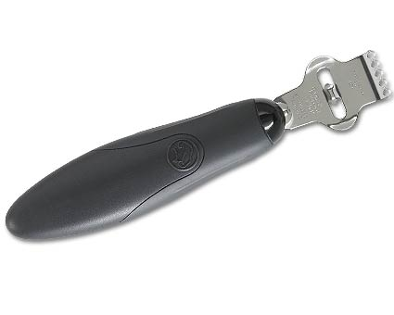  #1134 Zester/Scorer  $10.50 |  | #1137 Easy Release  Cheese Crumbler  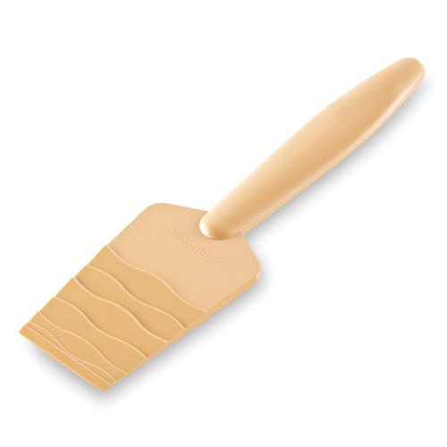  $10.00
#1138 Bean Slicer  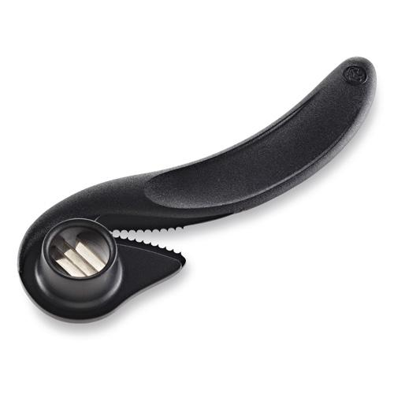  $6.50 |  | #1139 Ginger Grater  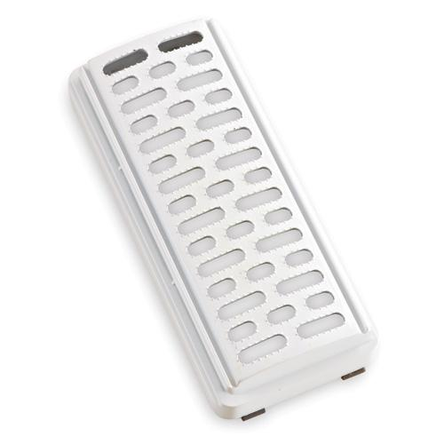  $9.50

