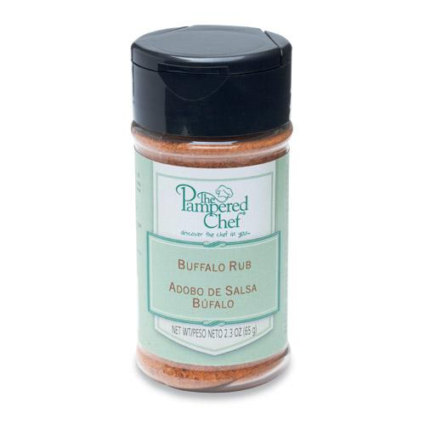  #9750 Buffalo Rub  $4.75 | #9752 Caramel Dessert Sauce  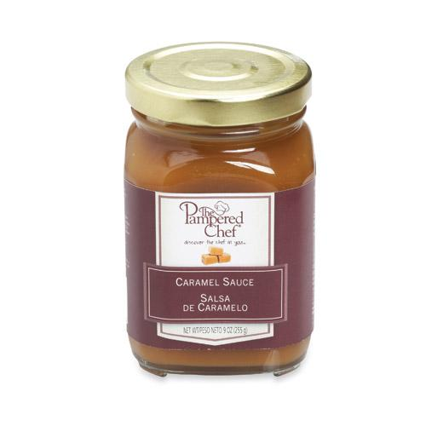  $10.00
#9753 Chocolate Raspberry Dessert Sauce  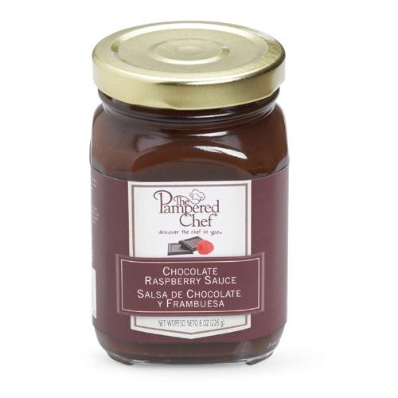  $10.00 | #9805 Parmesan-Garlic Oil Dipping Seasoning  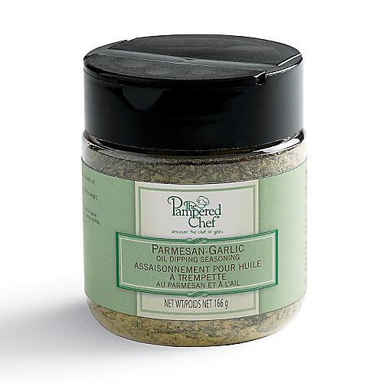  $7.25
#9806 Sun-Dried Tomato Herb Oil Dipping Seasoning  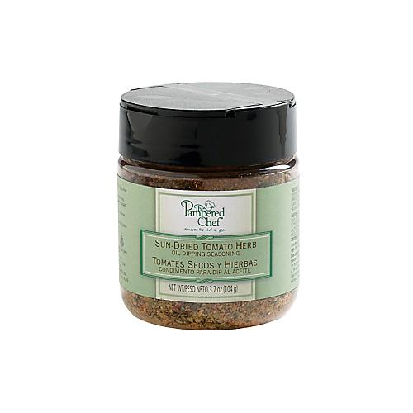  $7.25 | #9807 Spicy Pineapple Sauce  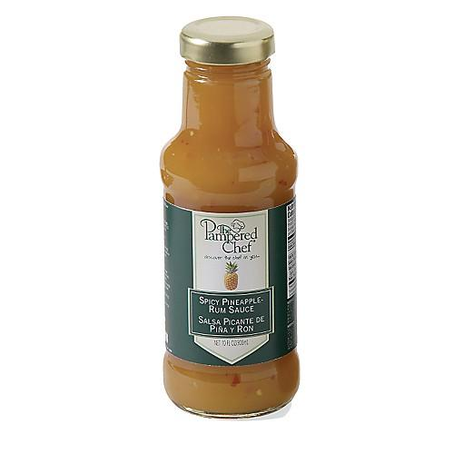  $12.00
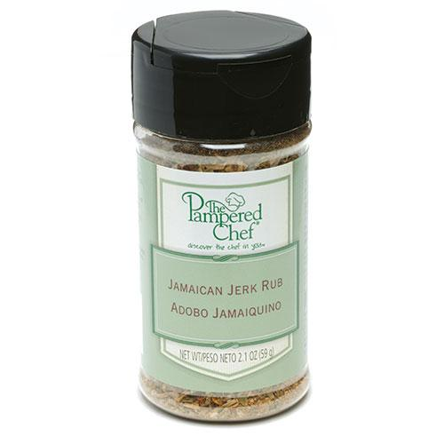  #9812 J amaican  J erk Rub  $4.75 | #9860 Asian Seasoning Mix  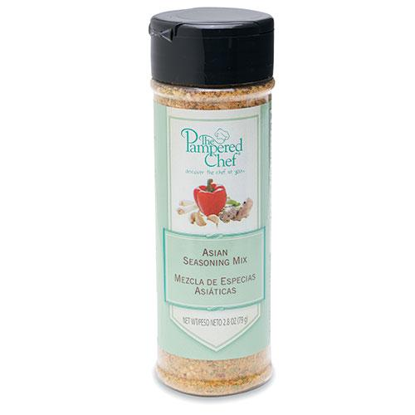  $6.25
#9864 Coarse Sea & Himalayan Salt  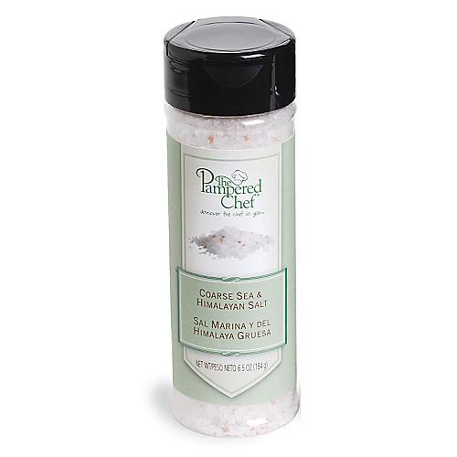  $6.50 | #9865 Peppercorn Medley  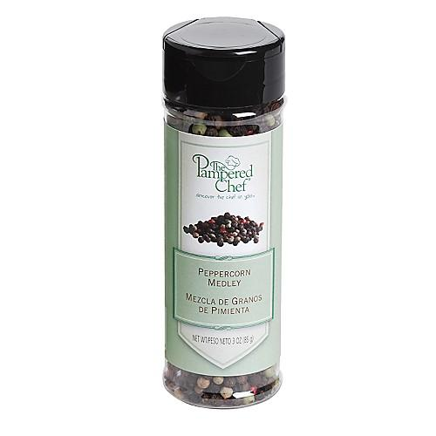  $7.50

