#9805 Parmesan-Garlic Oil Dipping Seasoning  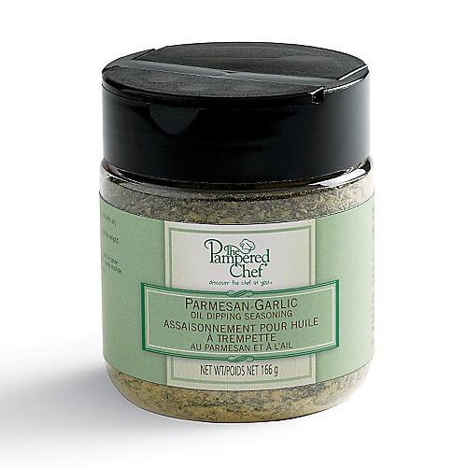  $7.25 |  | #9806 Sun-Dried Tomato Herb Oil Dipping Seasoning  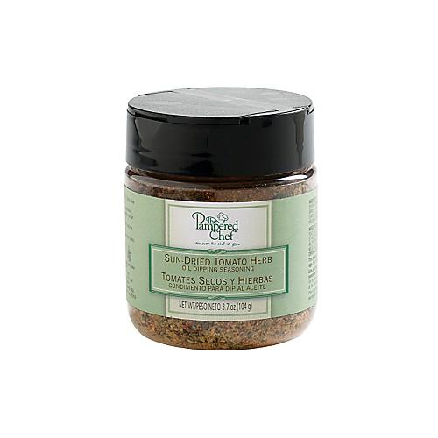  $7.25
#9807 Spicy Pineapple Sauce  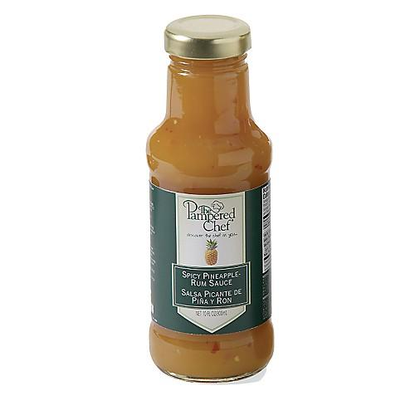  $12.00 |  | #9812 J amaican J erk Rub  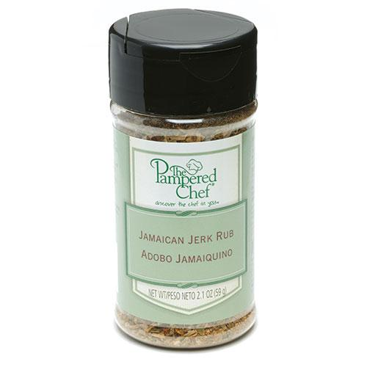  $4.75
#9860 Asian Seasoning Mix  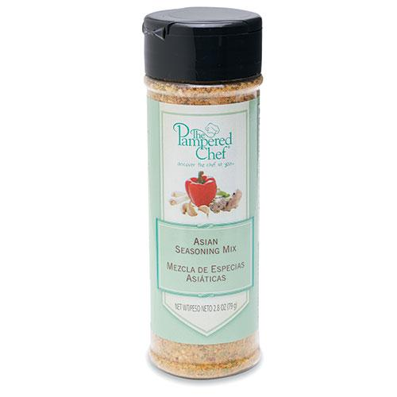  $6.25 |  | #9864 Coarse Sea & Himalayan Salt  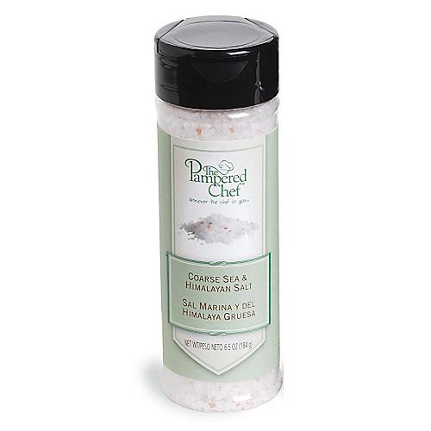  $6.50
#9865 Peppercorn Medley  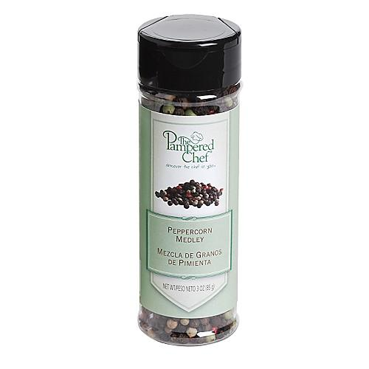  $7.50 |  | 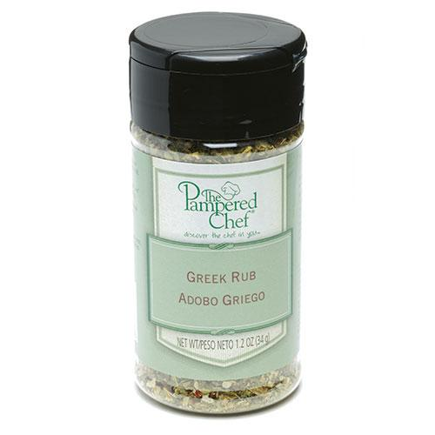  #9870 Greek Rub  $4.75
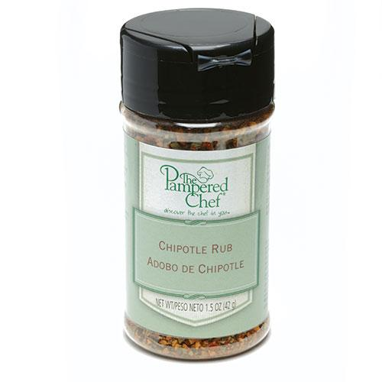

#9880 Chipotle Rub
$4.75

