#9721 Beer Bread Mix  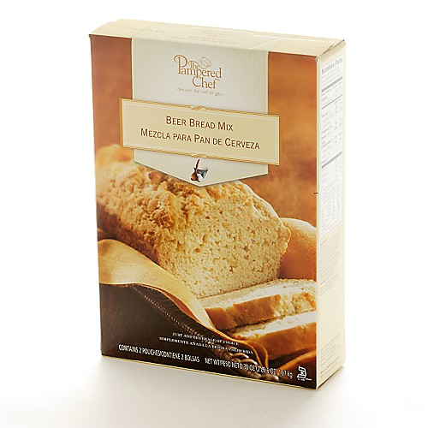  $10.50 |  | #9722 Smoky Barbecue Rub  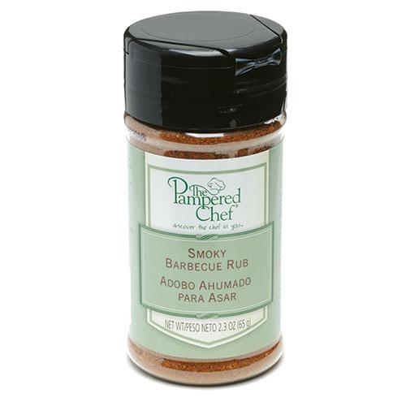  $4.75
#9723 Cinnamon Plus® Spice Blend  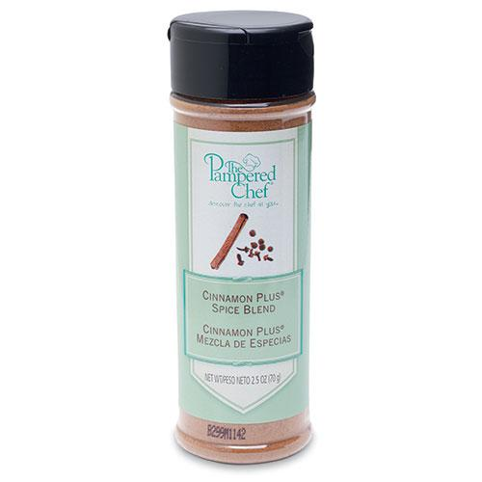  $6.25 |  | #9734 Citrus & Basil Rub  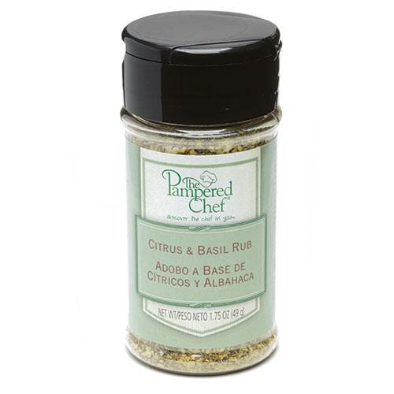  $4.75
#9736 Crushed Peppercorn & Garlic Rub  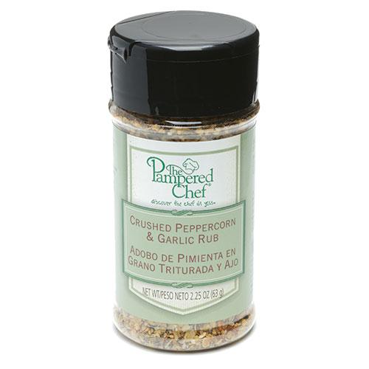  $4.75 |  | 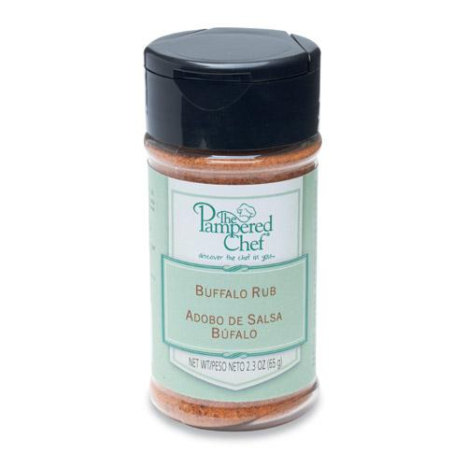  #9750 Buffalo Rub  $4.75
#9752 Caramel Dessert Sauce  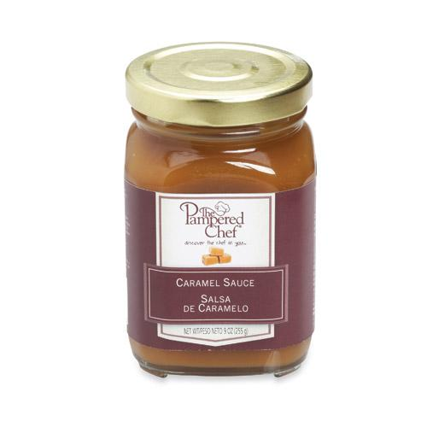  $10.00 |  | #9753 Chocolate Raspberry Dessert Sauce  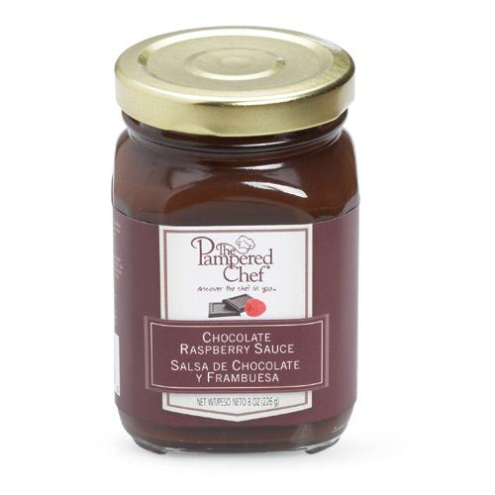  $10.00
#9754 Cherry Almond Dessert Sauce  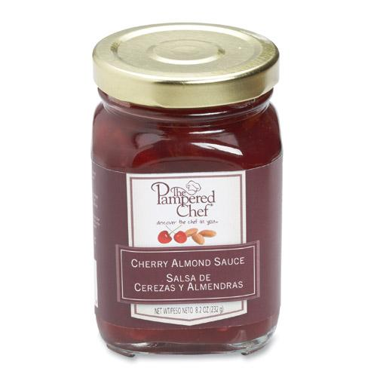  $10.00 |  | #9797 Thai Peanut Sauce  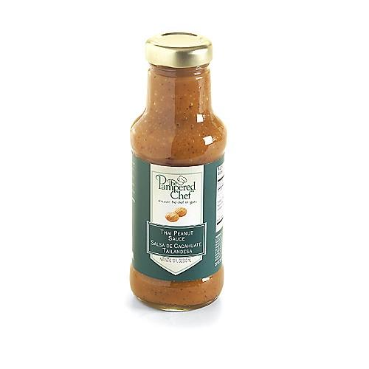  $12.00

