#9627 Cherry Balsamic Vinegar  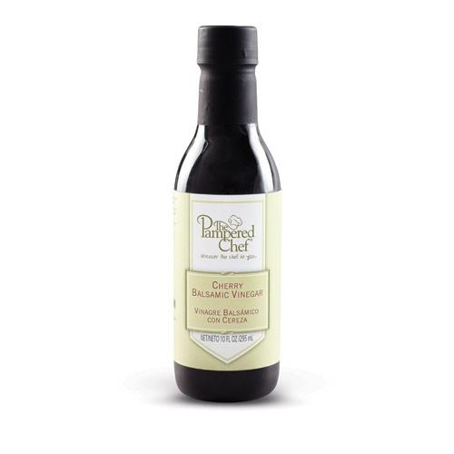  $16.50 | #9659 Three Onion Rub  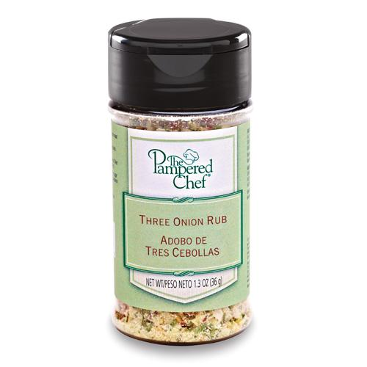  $4.75
#9662 Chocolate Peanut Butter Dessert Sauce  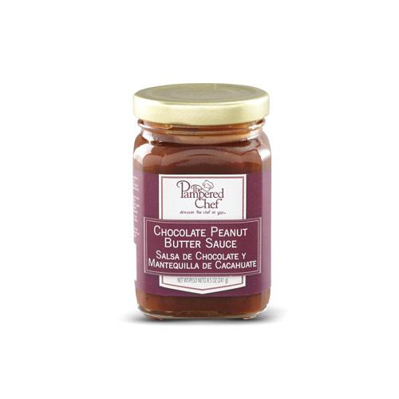  $10.00 | #9664 Chili Lime Rub  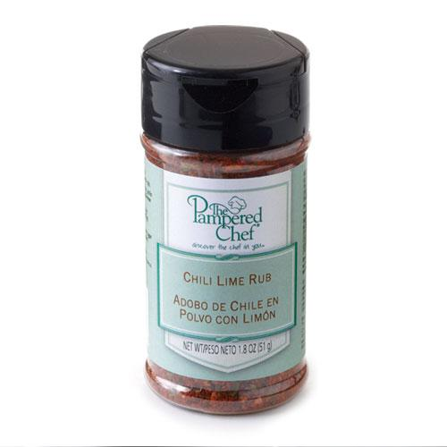  $4.75
#9666 Teriyaki with Honey Sauce  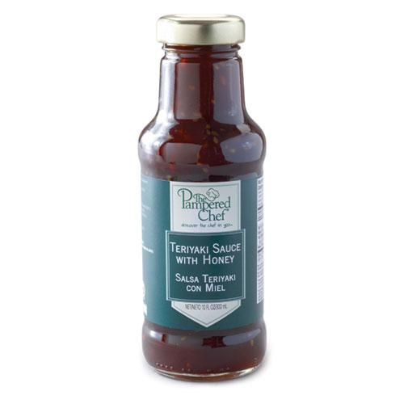  $12.00 | #9668 Smoky Applewood Rub  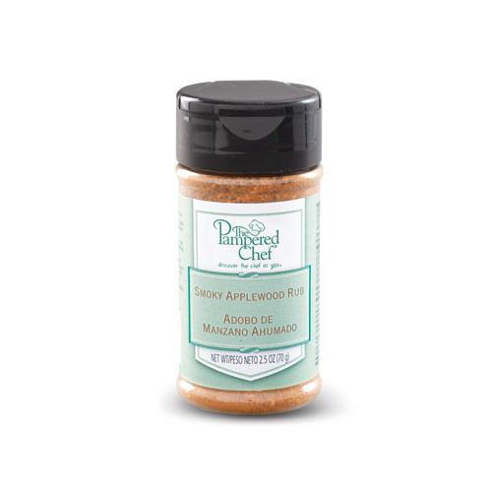  $4.75
#9680 Tex-Mex Rub  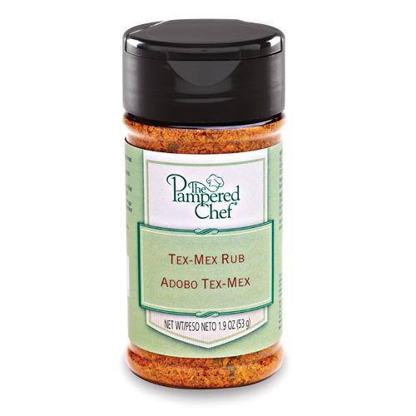  $4.75 | #9681 Ginger Citrus Rub  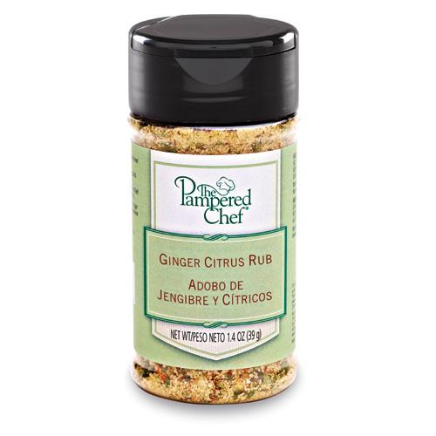  $4.75
#9686 Sweet Basil Rub  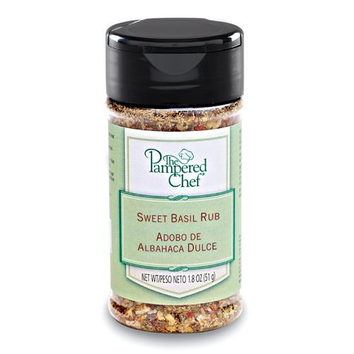  $4.75 | #9702 Raspberry Habanero Sauce  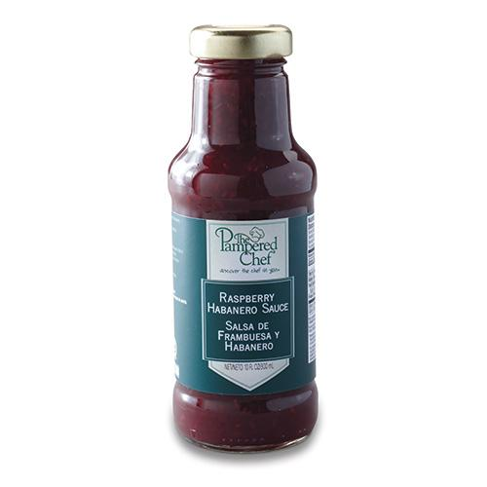  $12.00

