#9680 Tex-Mex Rub  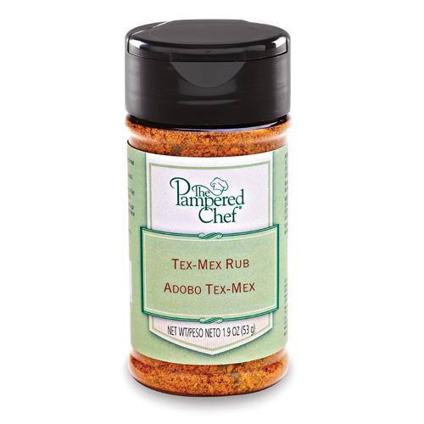  $4.75 |  | #9681 Ginger Citrus Rub  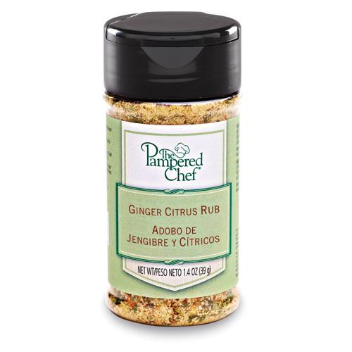  $4.75
#9686 Sweet Basil Rub  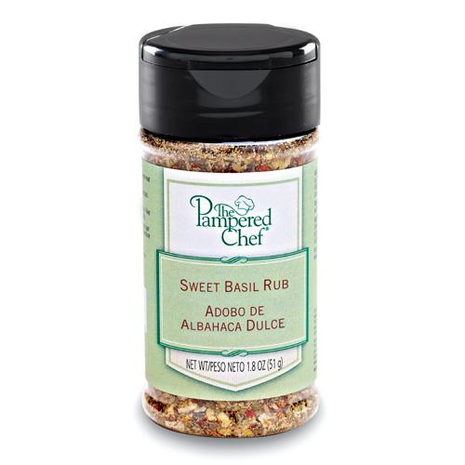  $4.75 |  | #9694 Indian Mild Curry Rub  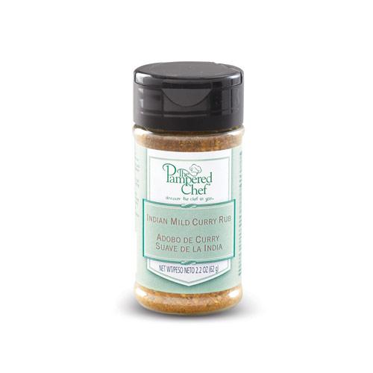  $4.75
#9702 Raspberry Habanero Sauce  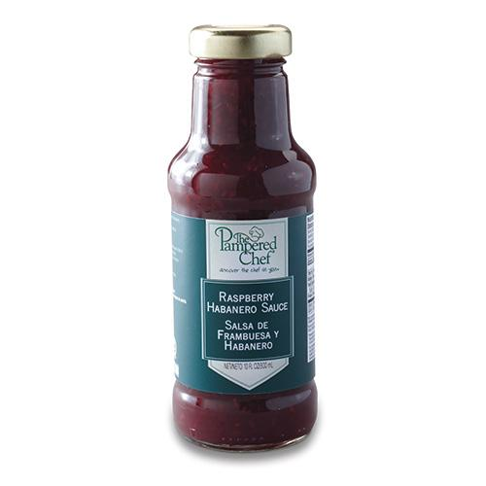  $12.00 |  | #9704 Lemon Pepper Rub  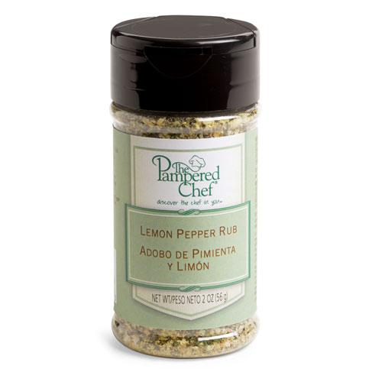  $4.75
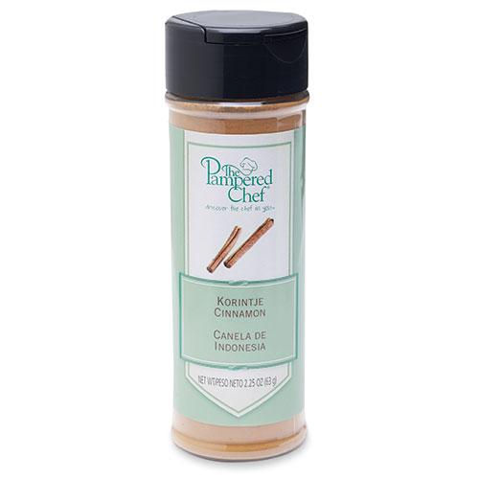  #9712 Korintje Cinnamon  $6.25 |  | #9713 All-Purpose Dill Seasoning Mix  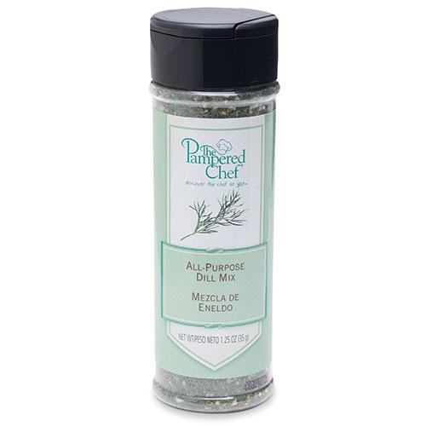  $6.25
#9714 Southwestern Seasoning Mix  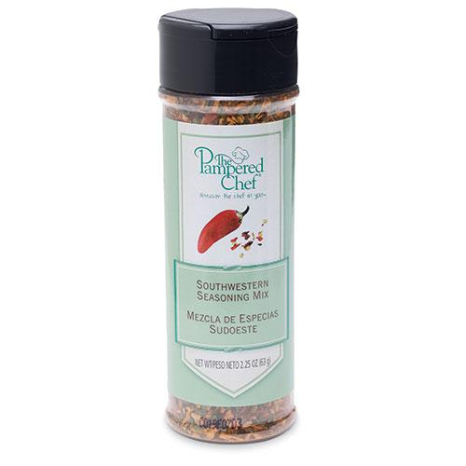  $6.25 |  | #9719 Italian Seasoning Mix  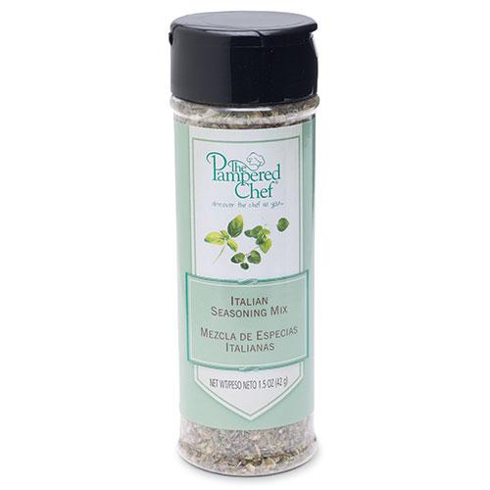  $6.25

