#1109 Ultimate Mandoline  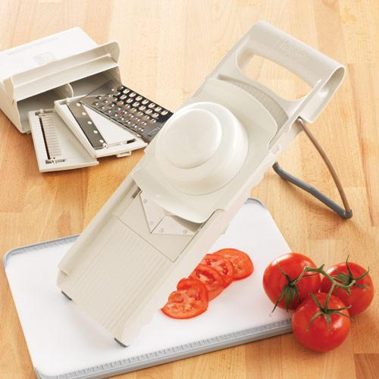  $66.00 |  | #1112 Small Bamboo Knife Block Set  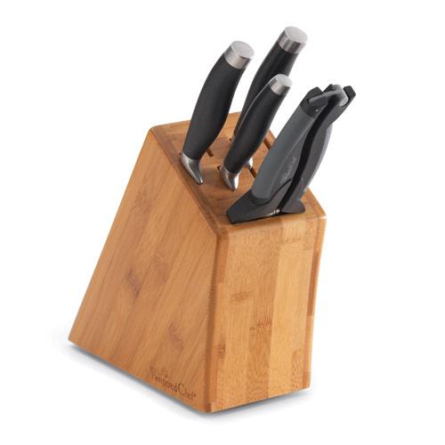  $155.00
#1113 Garlic Slicer  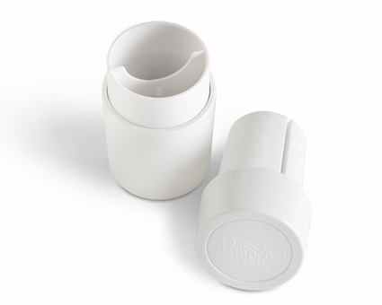  $15.00 |  | #1114 Kernel Cutter  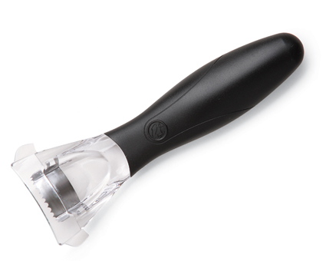  $8.50
#1117 Mini Professional Shears  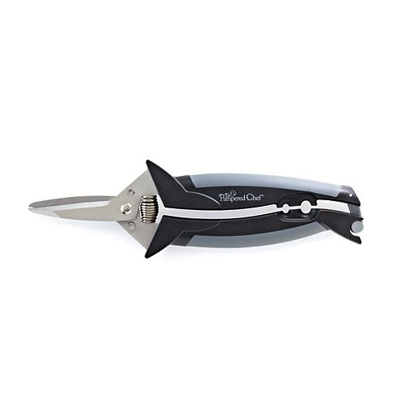  $22.50 |  | #1119 Nylon Serrated Knife  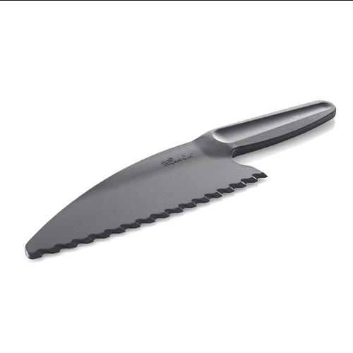  $5.50
#1121 Forged Cutlery  - 8.25” Carving Knife  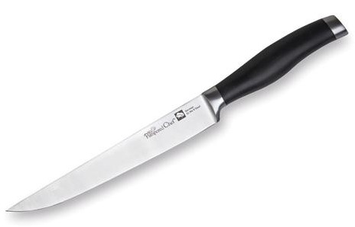  $69.00 |  | #1122 Color Coated  Peeling Knife  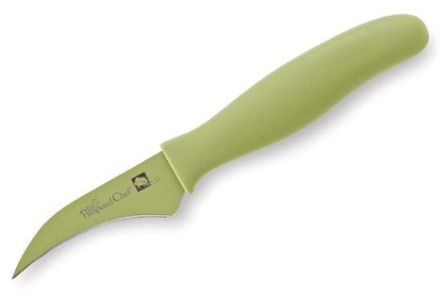  $13.50
#1123 Color Coated Nakiri Knife  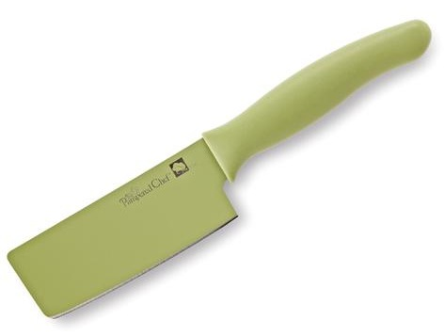  $18.00 |  | #1124 Food Holder  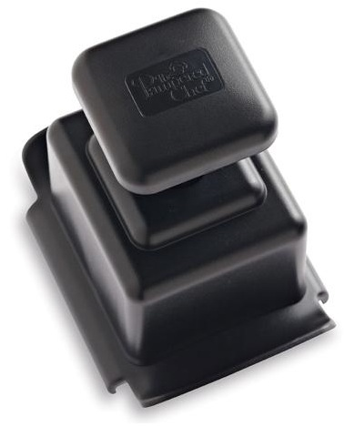  $10.50

