#9578 Bell Pepper Herb Rub  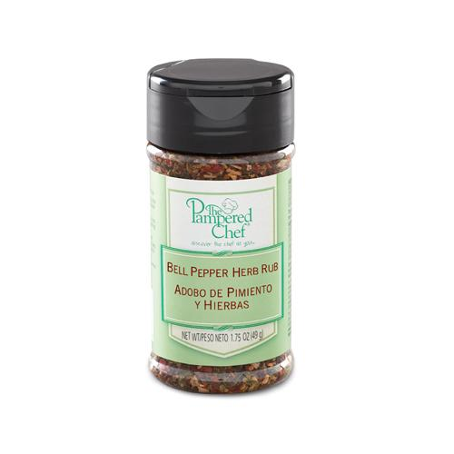  $4.75 | #9588 Lemon Rosemary Rub  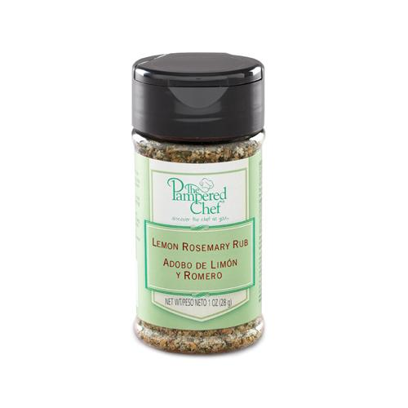  $4.75
#9593 Itty Bitty Bevs  Appletini Drink Mix  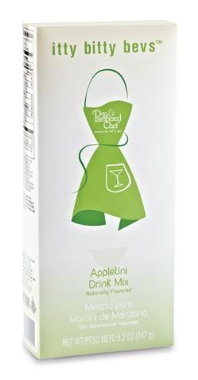  $8.50 | #9594 Itty Bitty Bevs  Cosmopolitan Drink Mix  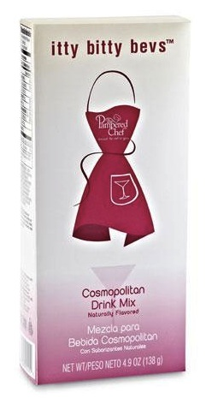  $8.50
#9597 Itty Bitty Bevs  Lemon Drop Drink Mix  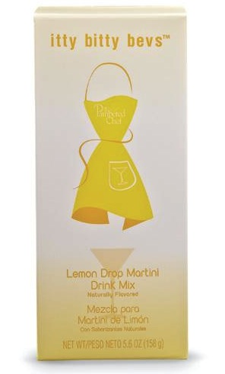  $8.50 | #9598 Itty Bitty Bevs  Strawberry Daiquiri Drink Mix  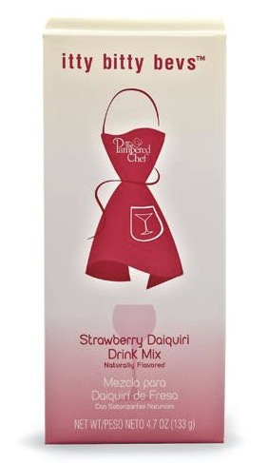  $8.50
#9613 Chocolate Caramel Dessert Sauce  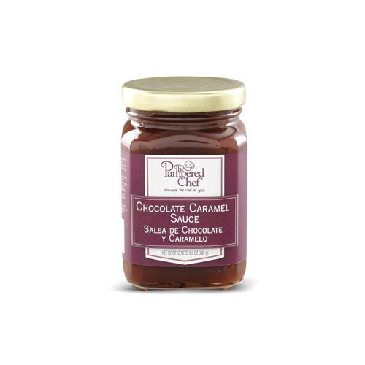  $10.00 | #9620 Orange-Infused Canola Oil  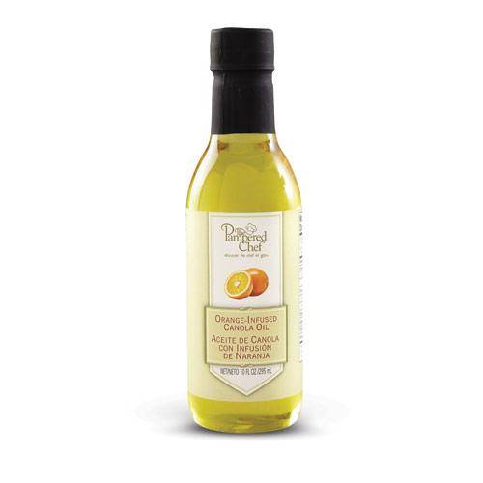  $12.00
#9621 Rosemary-Infused Canola Oil  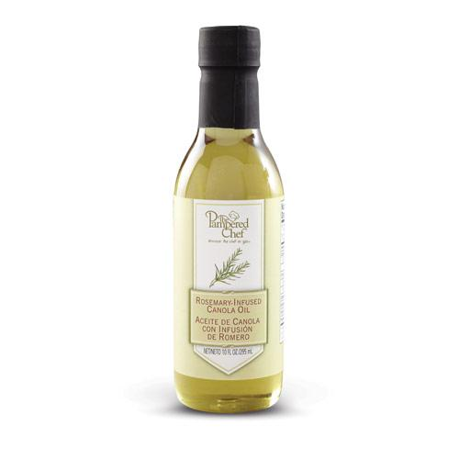  $12.00 | #9626 Pomegranate Balsamic Vinegar  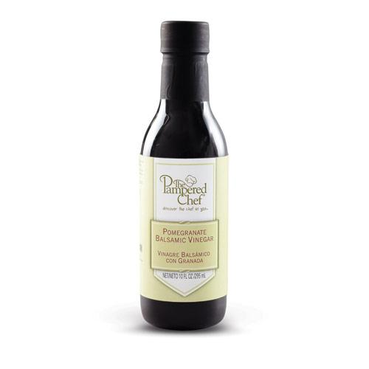  $16.50

