#9655 Smoky Red Pepper Rub  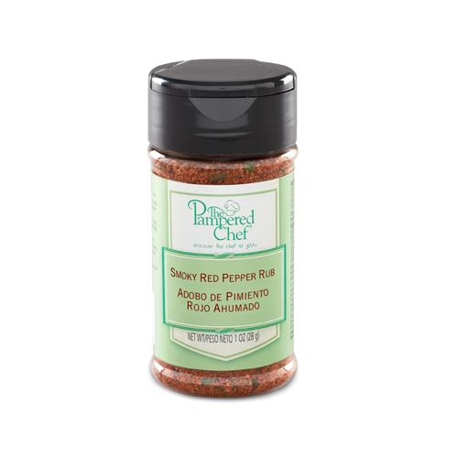  $4.75 |  | #9659 Three Onion Rub  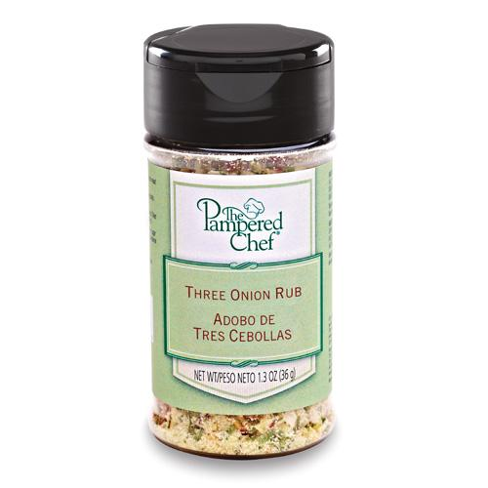  $4.75
#9660 Butterscotch Rum Dessert Sauce  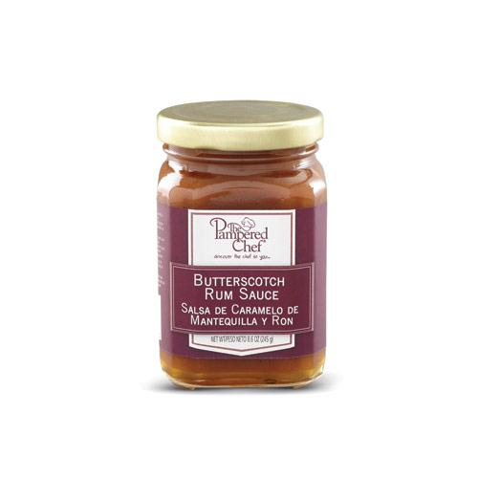  $10.00 |  | #9661 Chocolate Peppermint Dessert Sauce  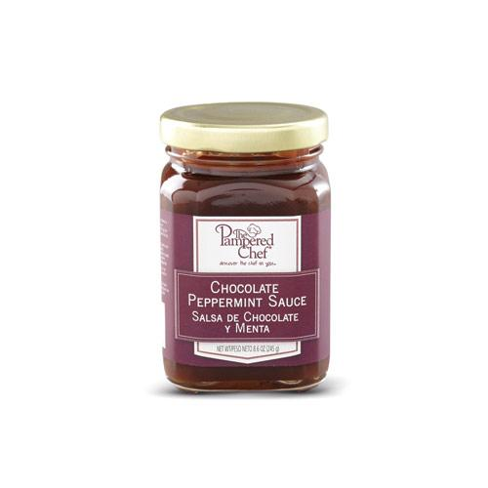  $10.00
#9662 Chocolate Peanut Butter Dessert Sauce  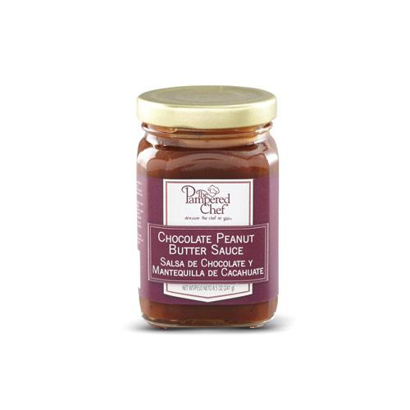  $10.00 |  | #9664 Chili Lime Rub  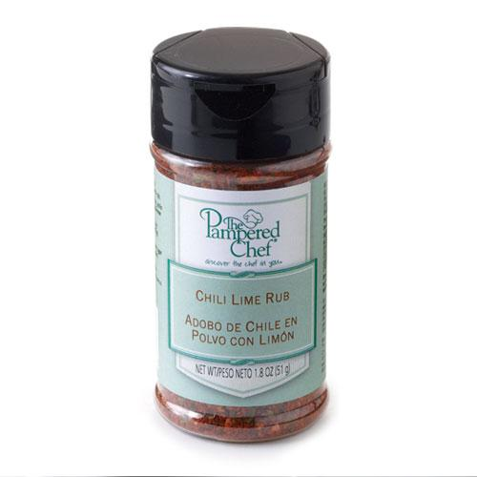  $4.75
#9665 Sweet & Sour Sauce  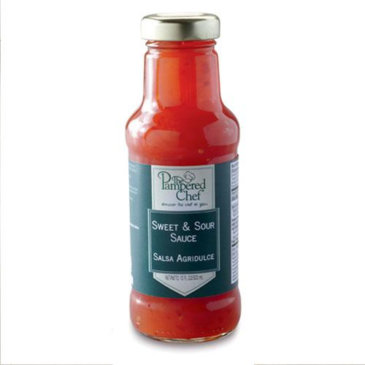  $12.00 |  | #9666 Teriyaki with Honey Sauce  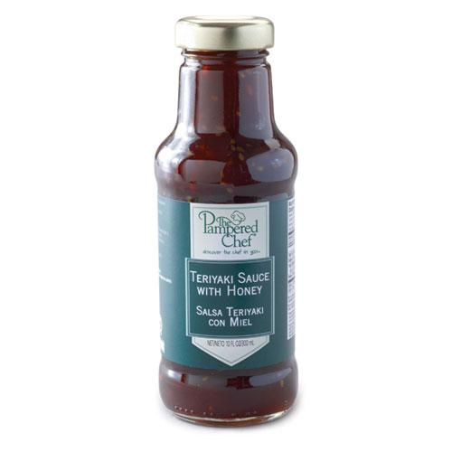  $12.00
#9667 Coconut Lime Dessert Sauce  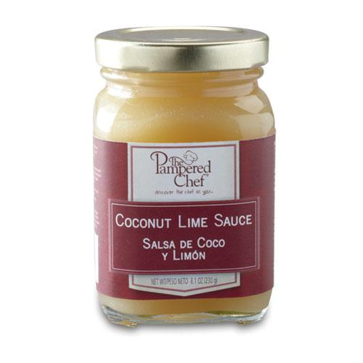  $10.00 |  | #9668 Smoky Applewood Rub  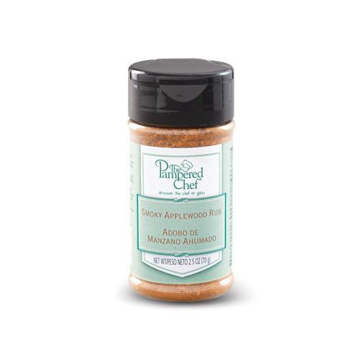  $4.75

