#9490 Dijon Honey Mustard Rub  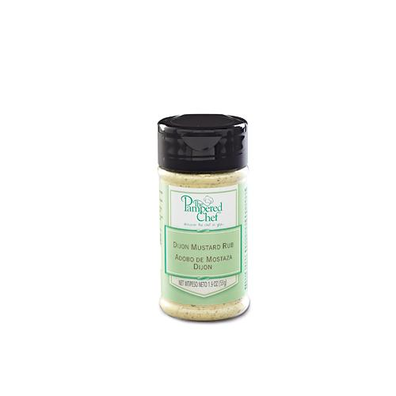  $4.75 | #9492 Garlic & Herb Rub  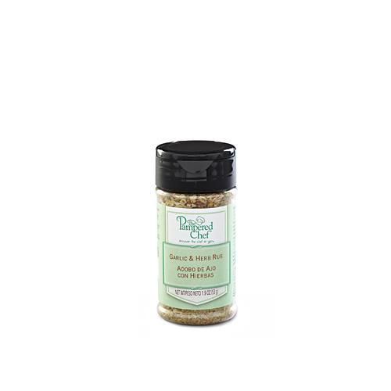  $4.75
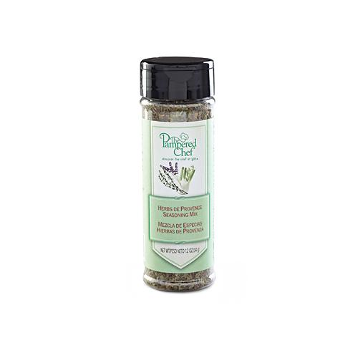  #9496 Herbs de Provence Seasoning Mix  $6.25 | #9497 Chive & Tarragon Seasoning Mix  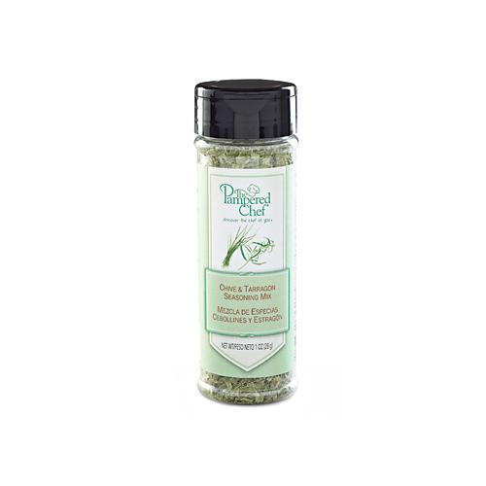  $6.25
#9499 Korean Barbecue Sauce  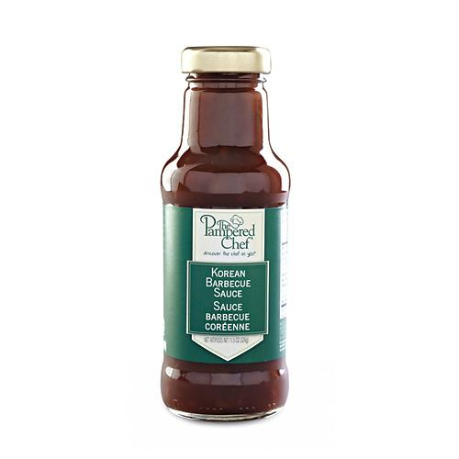  $12.00 | 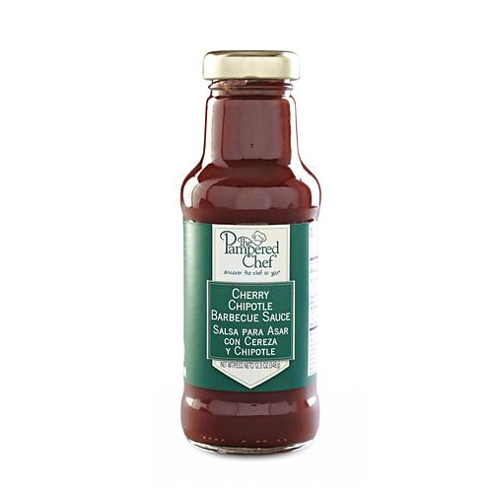  #9516 Cherry Chipotle Barbecue Sauce  $12.00
#9517 Beer Barbecue Sauce  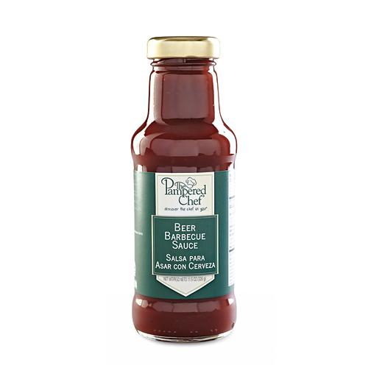  $12.00 | #9545 Itty Bitty Bevs Margarita Drink Mix  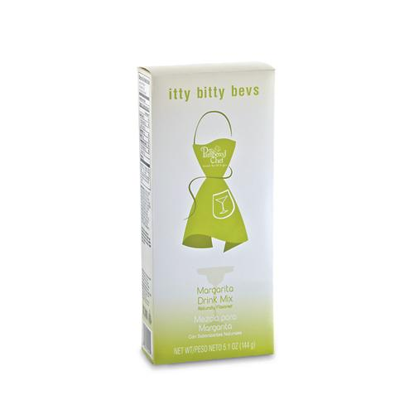  $8.50
#9570 Itty Bitty Bevs Cucumber Mojito Drink Mix  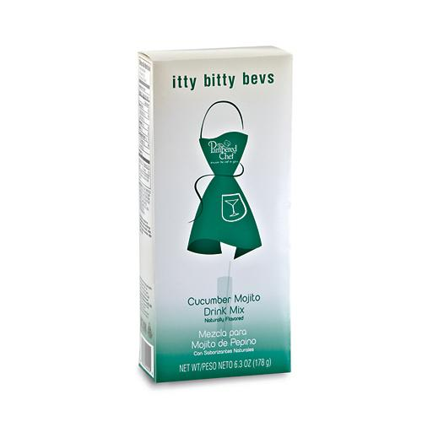  $8.50 | #9572 Maple Herb Rub  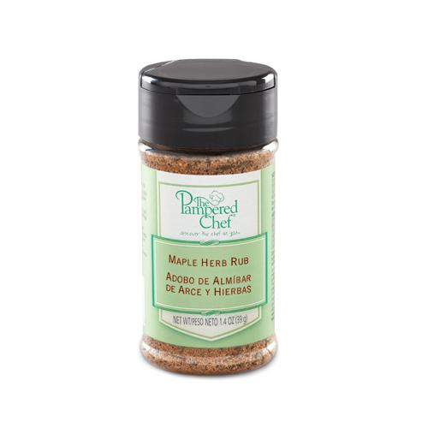  $4.75

