#9588 Lemon Rosemary Rub  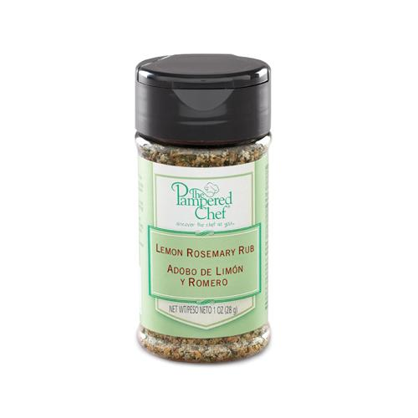  $4.75 |  | #9593 Itty Bitty Bevs  Appletini Drink Mix  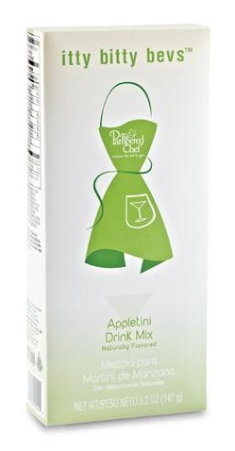  $8.50
#9594 Itty Bitty Bevs  Cosmopolitan Drink Mix  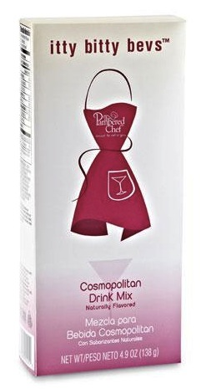  $8.50 |  | #9597 Itty Bitty Bevs  Lemon Drop Drink Mix  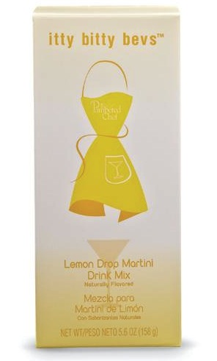  $8.50
#9598 Itty Bitty Bevs  Strawberry Daiquiri Drink Mix  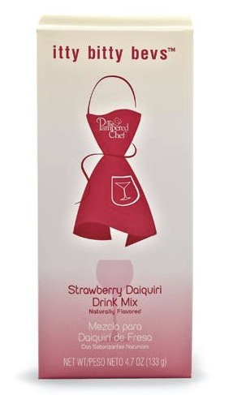  $8.50 |  | #9613 Chocolate Caramel Dessert Sauce  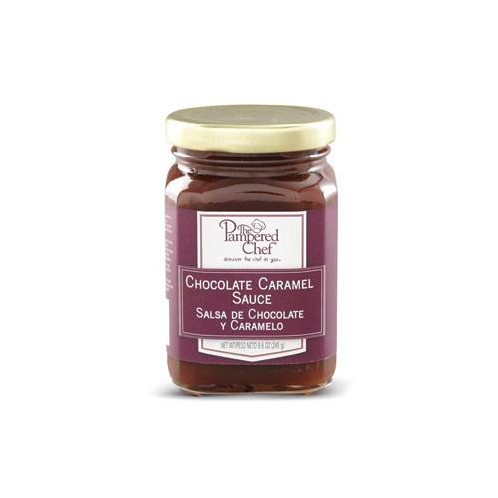  $10.00
#9620 Orange-Infused Canola Oil  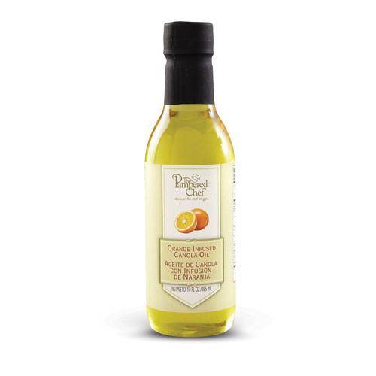  $12.00 |  | #9621 Rosemary-Infused Canola Oil  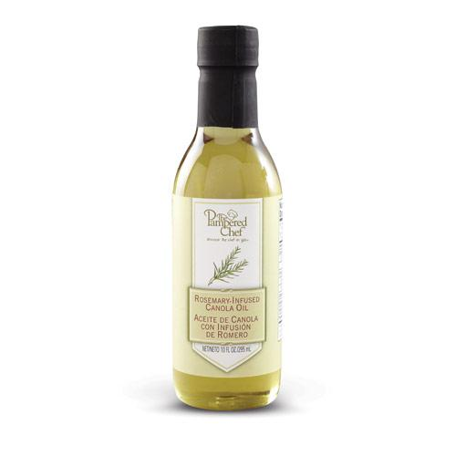  $12.00
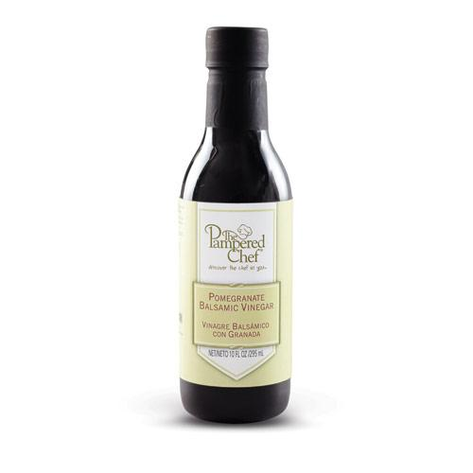  #9626 Pomegranate Balsamic Vinegar  $16.50 |  | #9627 Cherry Balsamic Vinegar  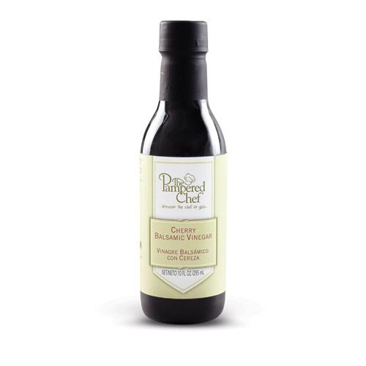  $16.50

