#3112 Salt & Pepper Shaker Set  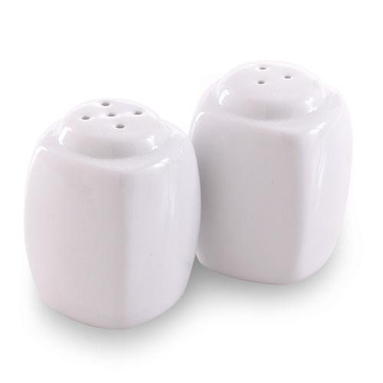  $10.00 | #3130 Ceramic Cookware  – 8” Sauté Pan  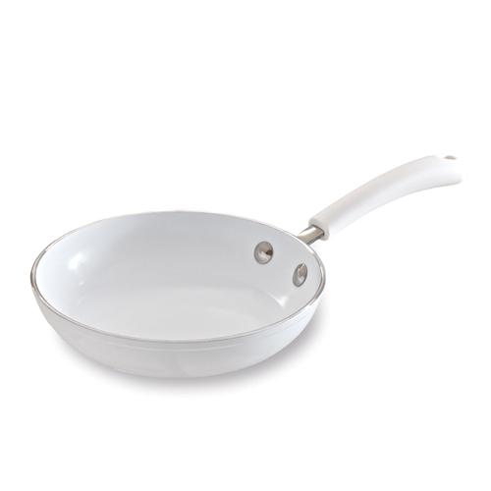  $39.00
#3131 Ceramic Cookware  – 10” Sauté Pan  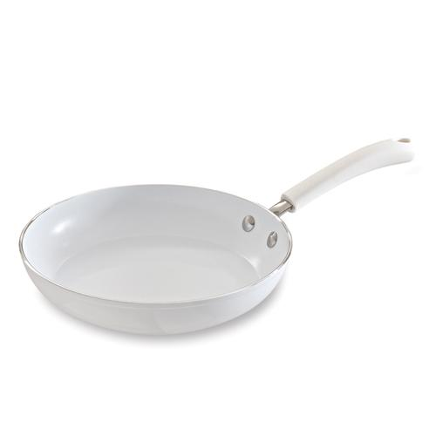  $60.00 | #3132 Ceramic Cookware  – 11” Covered Skillet  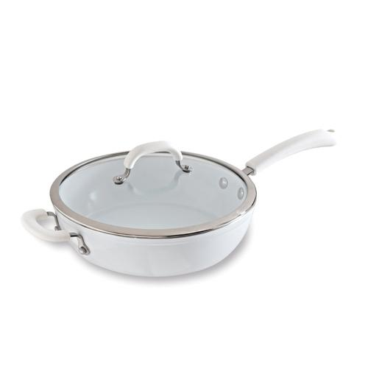  $100.00
#3133 Ceramic Cookware  – 2.75-qt. Covered Saucepan  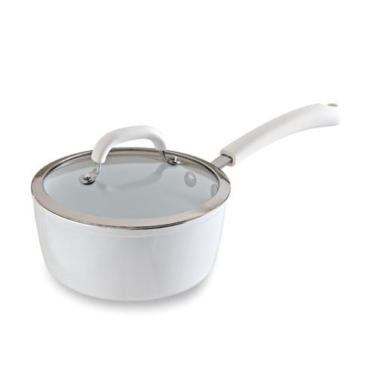  $80.00 | #3134 Ceramic Cookware  – 4.75-qt. Covered Saucepan  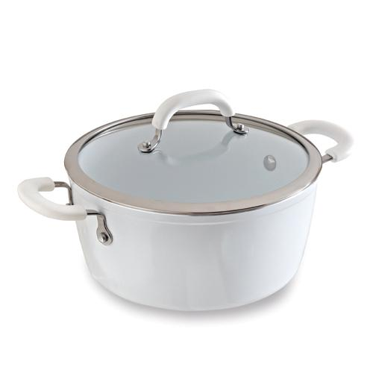  $100.00
#3139 Rockcrok™ - 2.5-qt. Everyday Pan  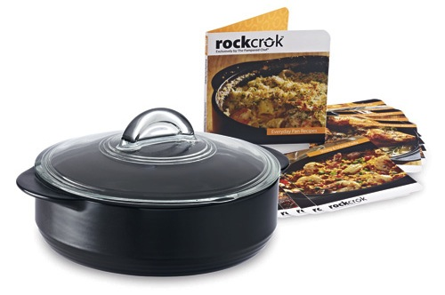  $80.00 | 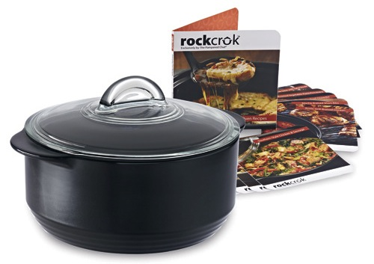  #3140 Rockcrok™ - 4-qt. Dutch Oven  $100.00
#5368 Stainless Cookware – 1.5 qt. Covered Saucepan  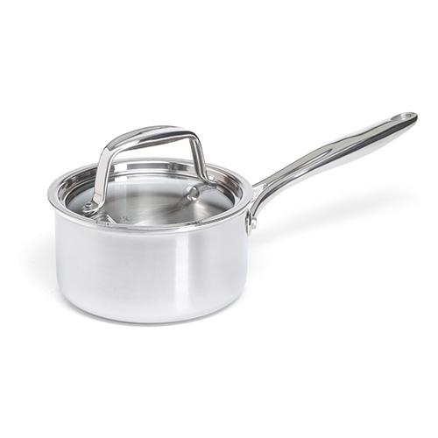  $95.00 | #9151 Garlic-Infused Canola Oil  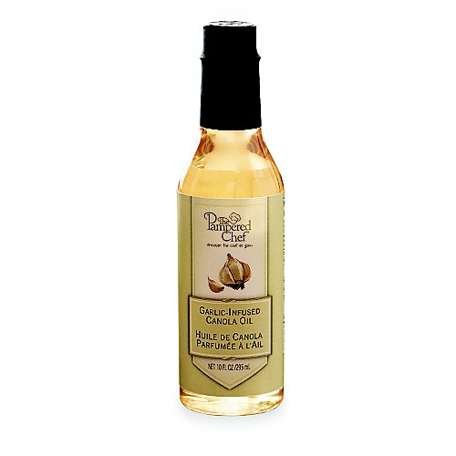  $12.00

