#9499 Korean Barbecue Sauce  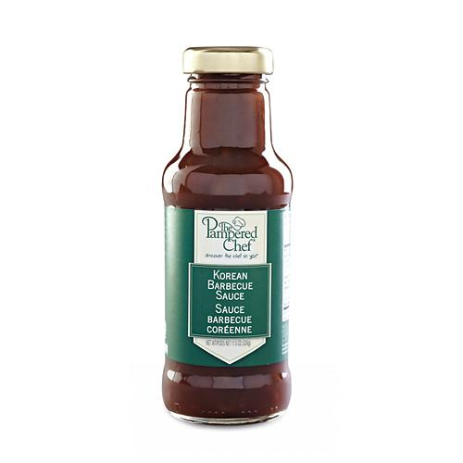  $12.00 |  | #9516 Cherry Chipotle Barbecue Sauce  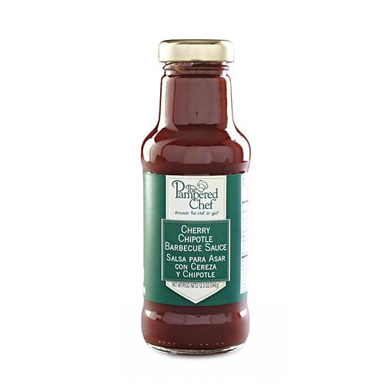  $12.00
#9517 Beer Barbecue Sauce  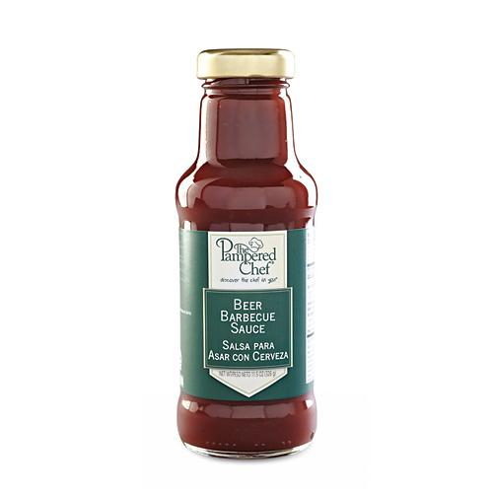  $12.00 |  | #9519 Blueberry Lemon Sauce  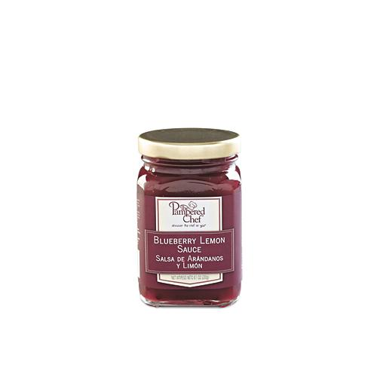  $10.00
#9521 Apricot Honey Sauce  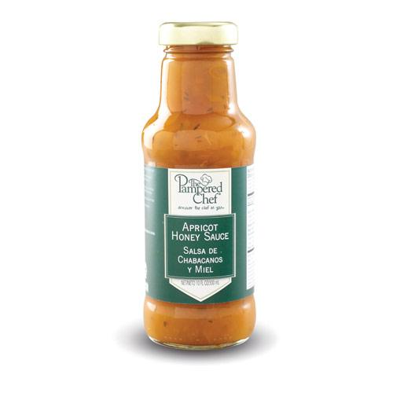  $12.00 |  | #9545 Itty Bitty Bevs Margarita Drink Mix  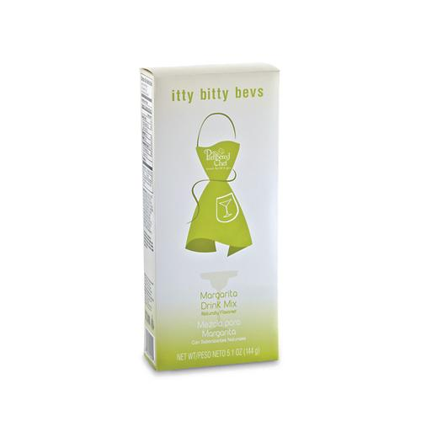  $8.50
#9570 Itty Bitty Bevs Cucumber Mojito Drink Mix  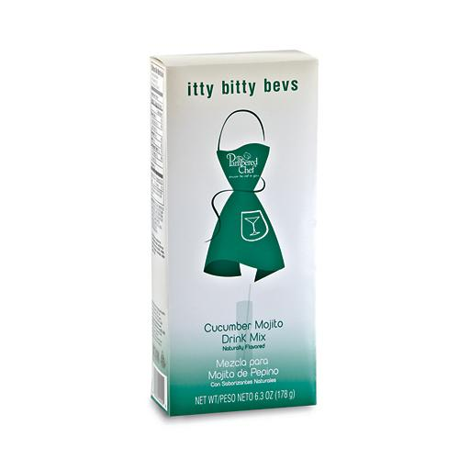  $8.50 |  | #9572 Maple Herb Rub  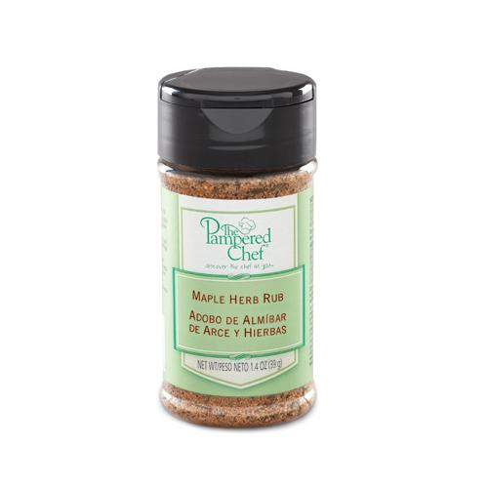  $4.75
#9578 Bell Pepper Herb Rub  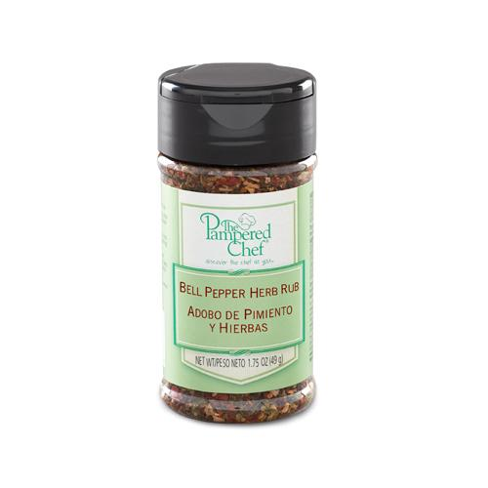  $4.75 |  | 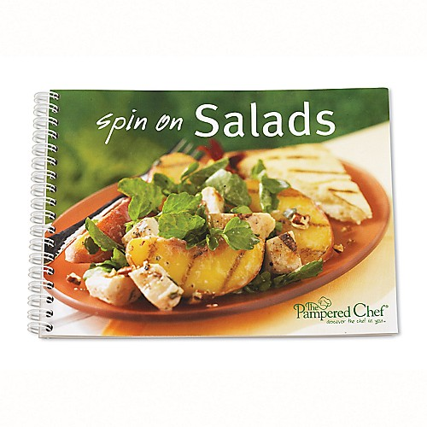  #9579 TPC Spin on Salads recipes collection  $8.00

