#3062 Simple Additions®  Pasta Bowls  (set of 2)  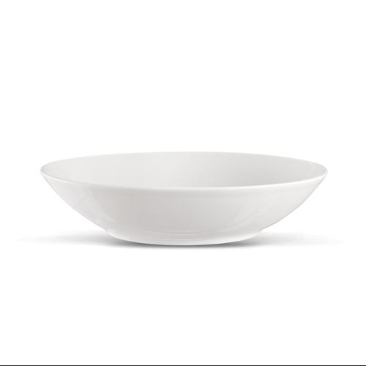  $20.00 | #3065 Simple Additions®  Salad Plates  (set of 2)  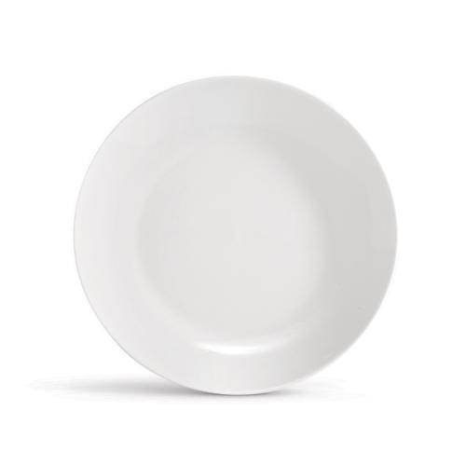  $18.00
#3066 Simple Additions®  Dinner Plates  (set of 2)  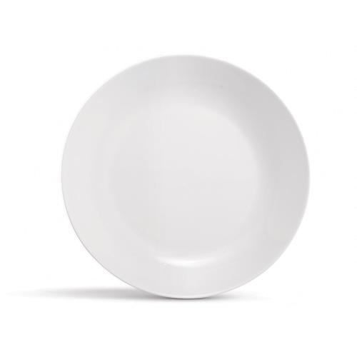  $24.00 | #3078 Simple Additions®  Small Square Bowls  (set of 2)  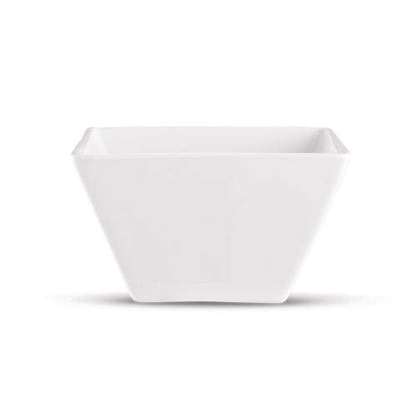  $16.00
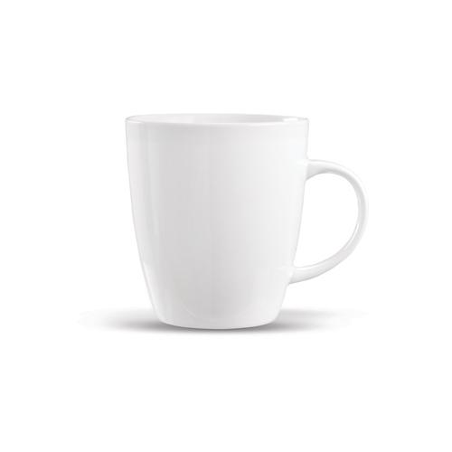  #3079 Simple Additions®  Cups (set of 2)  $18.00 | #3081 Simple Additions®  Small Round Bowls  (set of 2)  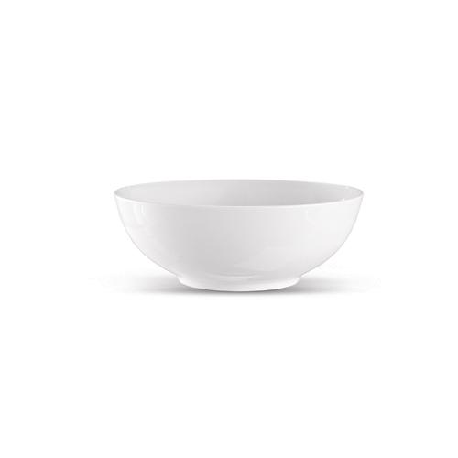  $18.00
#3084 Simple Additions®  Round Serving Bowl  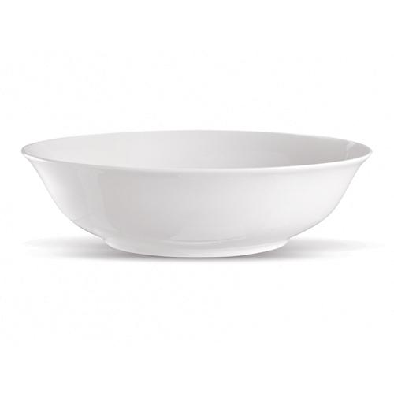  $18.00 | #3085 Simple Additions®  Oval Platter  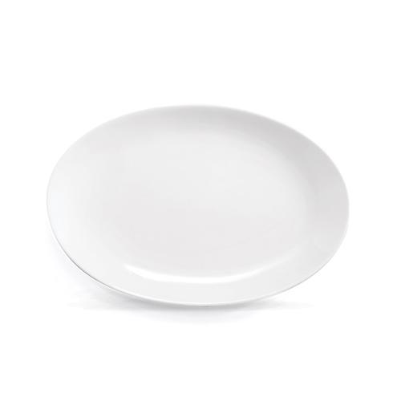  $20.00
#3110 Simple Additions®  16-Piece Dinnerware Set  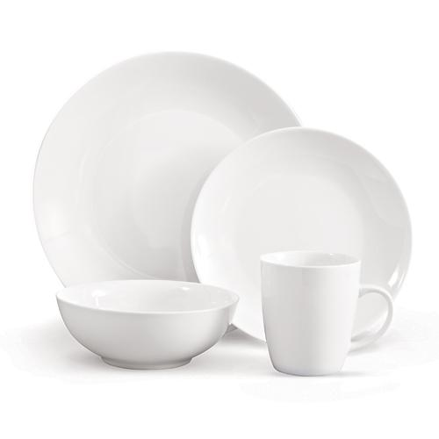  $125.00 | 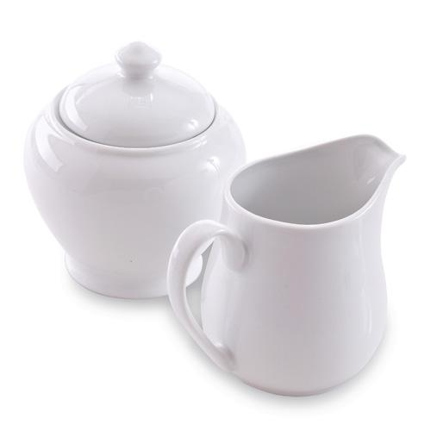  #3111 Sugar Bowl & Creamer Set  $24.00

