#3134 Ceramic Cookware  – 4.75-qt. Covered Saucepan  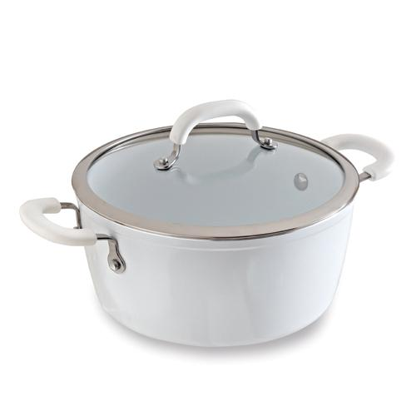  $100.00 |  | #5368 Stainless Cookware – 1.5 qt. Covered Saucepan  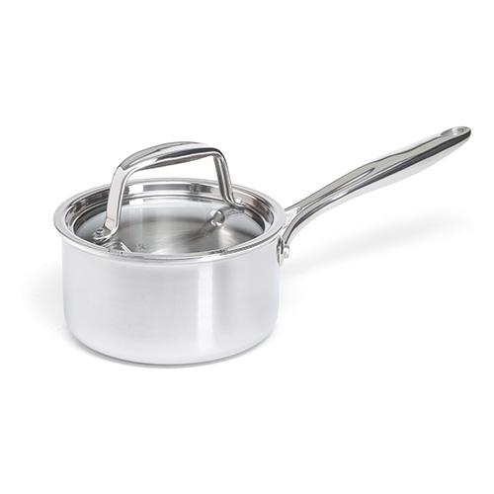  $95.00
#9151 Garlic-Infused Canola Oil  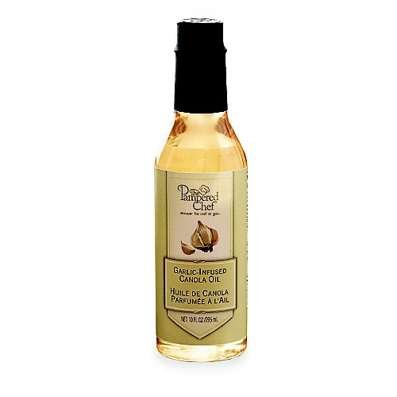  $12.00 |  | #9490 Dijon Honey Mustard Rub  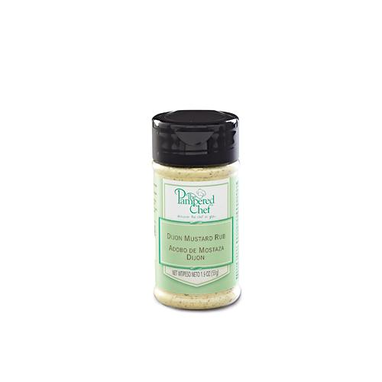  $4.75
#9491 Fennel & Herb Rub  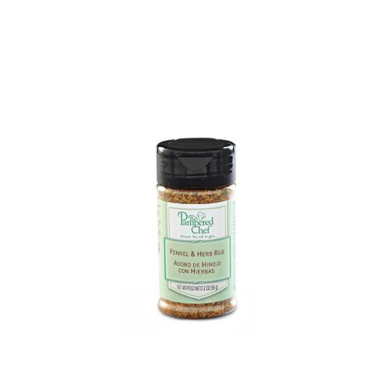  $4.75 |  | #9492 Garlic & Herb Rub  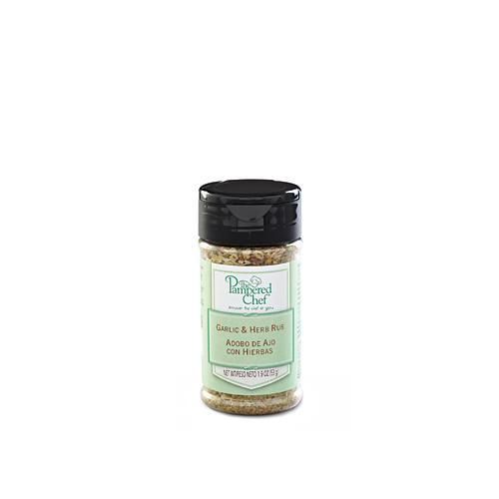  $4.75
#9493 Spicy Tangerine Rub  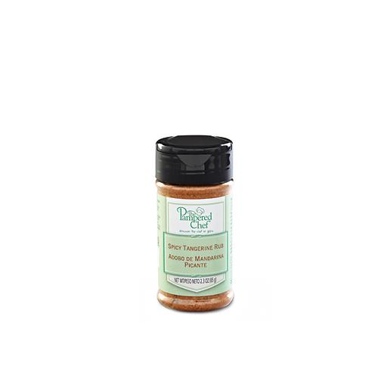  $4.75 |  | #9496 Herbs de Provence Seasoning Mix  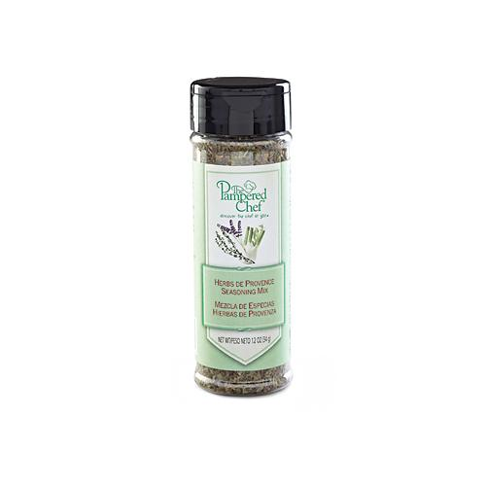  $6.25
#9497 Chive & Tarragon Seasoning Mix  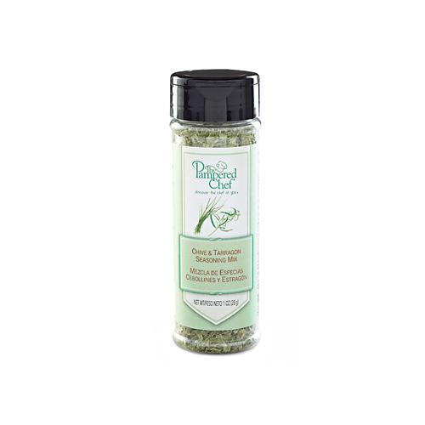  $6.25 |  | #9498 Carolina Mustard Barbecue Sauce  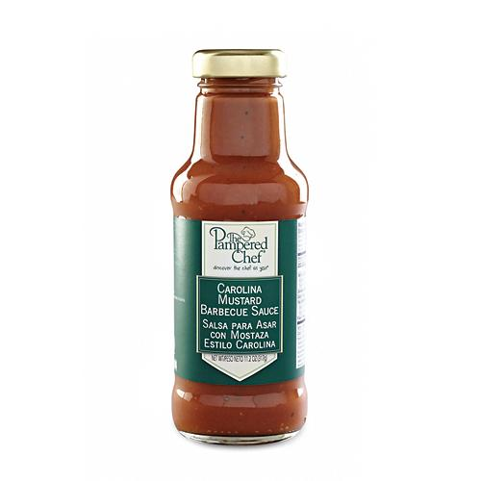  $12.00

