#2948 Round-Up  from the Heart®  Cork Trivet  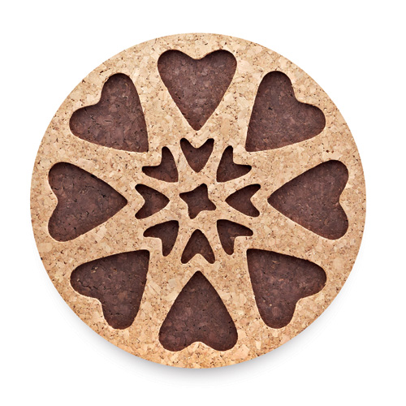  $9.50 | #2955 Chef’s Tongs  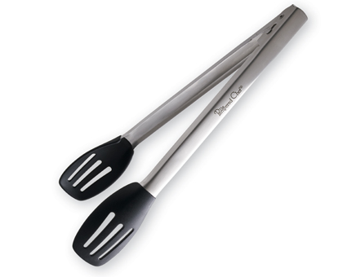  $22.50
#2956 Sauté Tongs  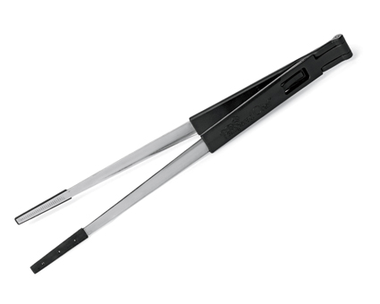  $13.50 | #2981 Microfiber Towel – Cranberry  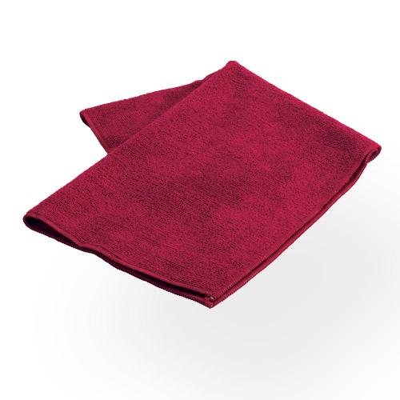  $8.50
#2997 i-Slice® – Cranberry  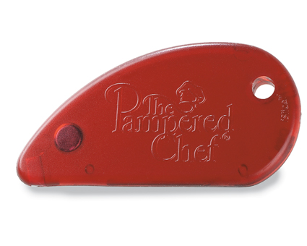  $4.00 | #2999 Bamboo Prep Towels  (set of 2)  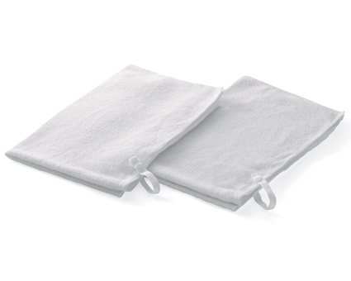  $17.50
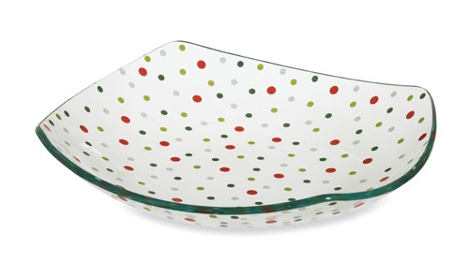  #3010 Holiday Dots Square Bowl  $19.50 | #3011 Snowmen Round Appetizer Plates  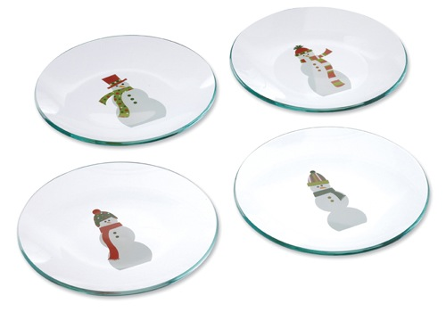  (set of 4)  $19.50
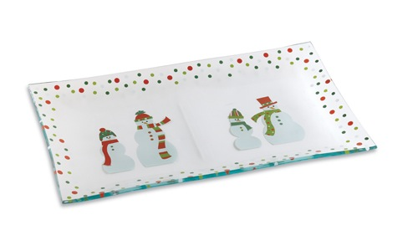  #3012 Snowmen Dots Divided Platter  $19.50 | 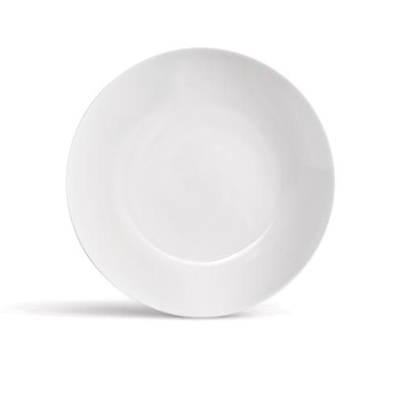  #3061 Simple Additions®  Appetizer Plates  (set of 4)  $20.00

