#3081 Simple Additions®  Small Round Bowls  (set of 2)  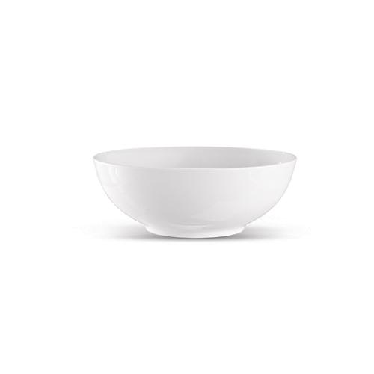  $18.00 |  | #3084 Simple Additions®  Round Serving Bowl  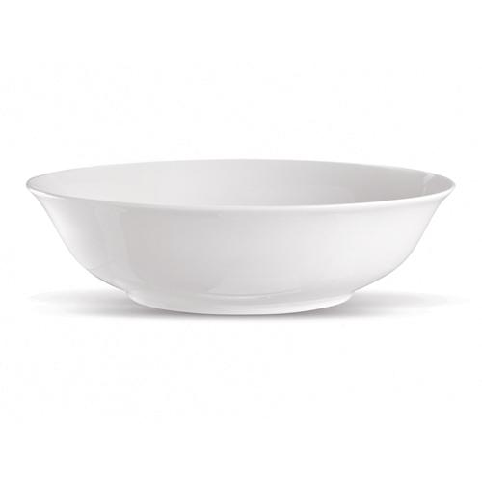  $18.00
#3085 Simple Additions®  Oval Platter  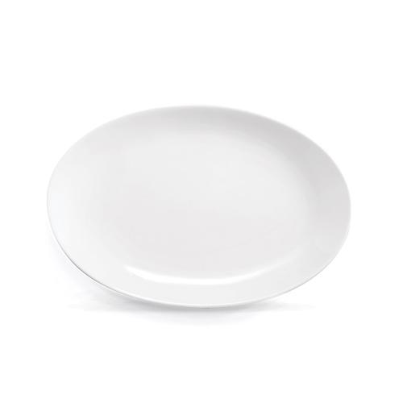  $20.00 |  | #3110 Simple Additions®  16-Piece Dinnerware Set  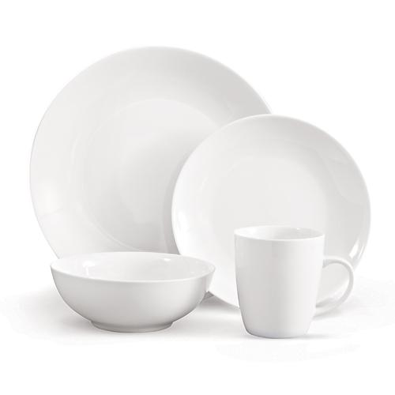  $125.00
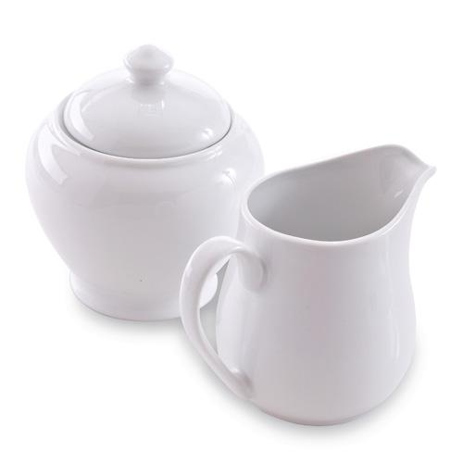  #3111 Sugar Bowl & Creamer Set  $24.00 |  | #3112 Salt & Pepper Shaker Set  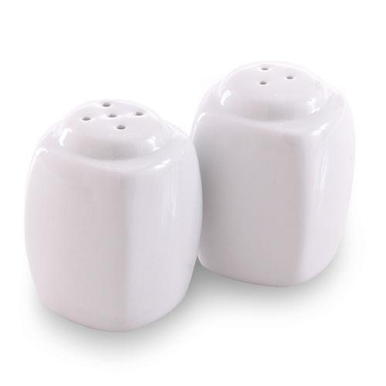  $10.00
#3130 Ceramic Cookware  – 8” Sauté Pan  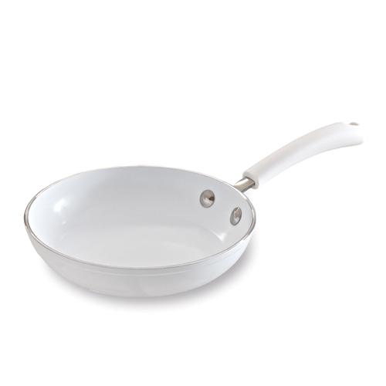  $39.00 |  | #3131 Ceramic Cookware  – 10” Sauté Pan  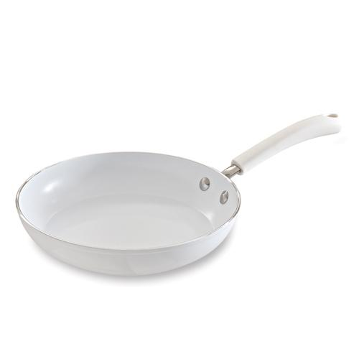  $60.00
#3132 Ceramic Cookware  – 11” Covered Skillet  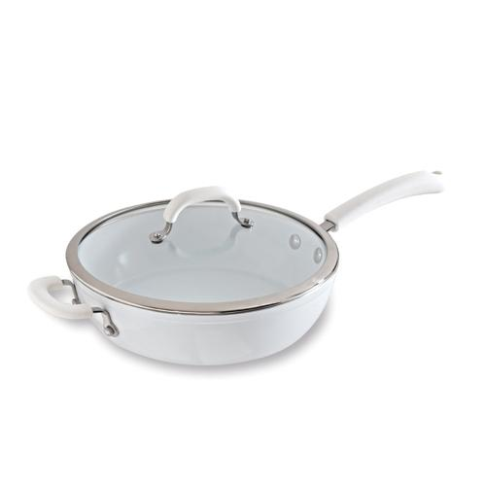  $100.00 |  | #3133 Ceramic Cookware  – 2.75-qt. Covered Saucepan  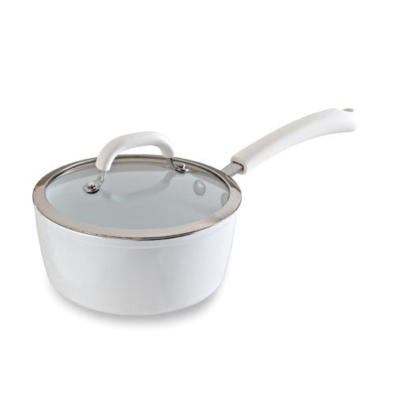  $80.00

