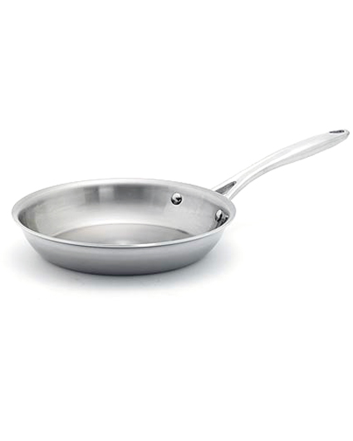  #2887 Stainless Cookware – 10” Sauté Pan  $99.00 | #2888 Cookware Protectors  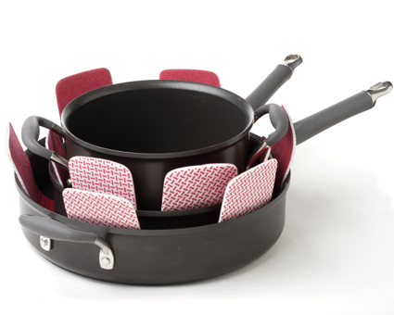  $10.50
#2889 Stainless Cleaner  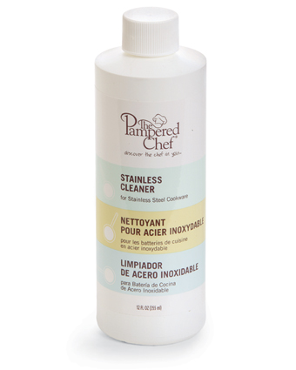  $9.75 | #2890 Stainless Cookware – 10” Covered Skillet  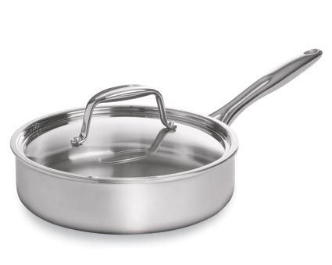  $168.00
#2892 Stainless Steamer  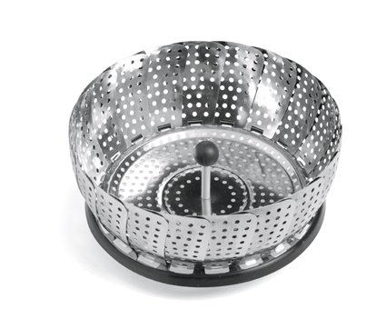  $16.50 | #2893 Stainless Cookware – 3-qt. Covered Saucepan  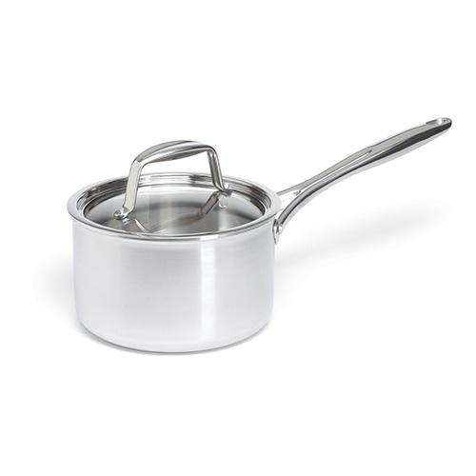  $158.00
#2894 Stainless Cookware – 8-qt. Covered Stockpot  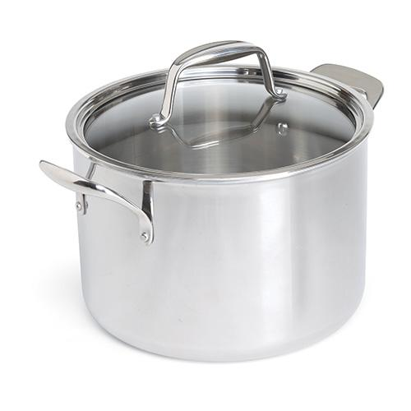  $235.00 | #2895 Beaded Cheese Bistro Set  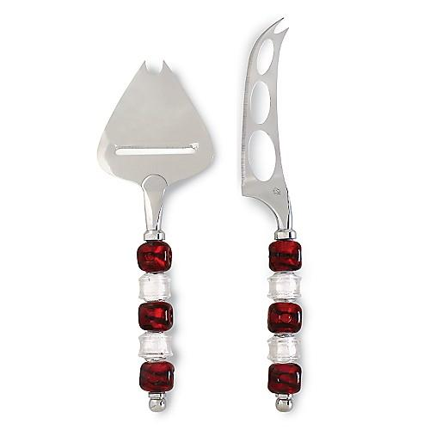  $32.00
#2904 My Safe Cutter  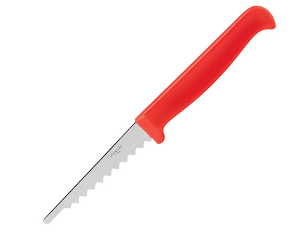  $4.50 | #2909 Stainless Cookware  – 8-Piece Set  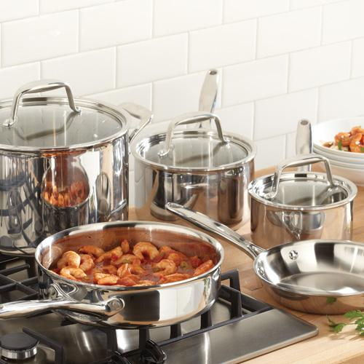  $575.00

