#2981 Microfiber Towel – Cranberry  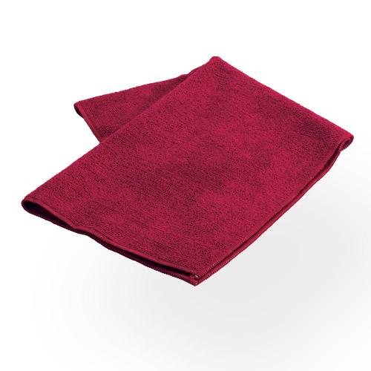  $8.50 |  | #2997 i-Slice® – Cranberry  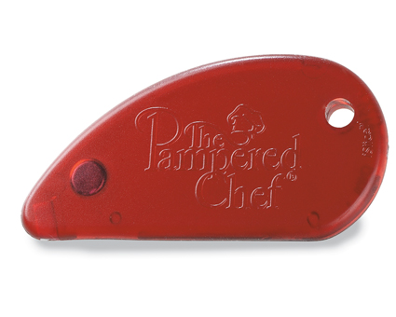  $4.00
#2999 Bamboo Prep Towels  (set of 2)  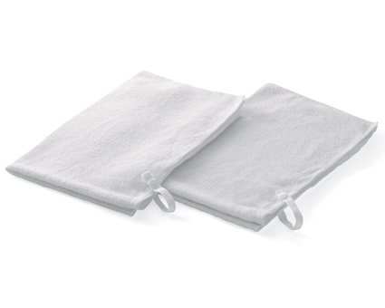  $17.50 |  | 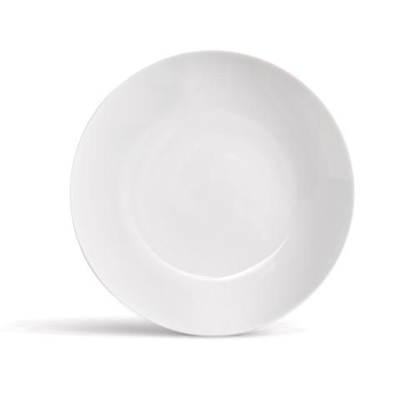  #3061 Simple Additions®  Appetizer Plates  (set of 4)  $20.00
#3062 Simple Additions®  Pasta Bowls  (set of 2)  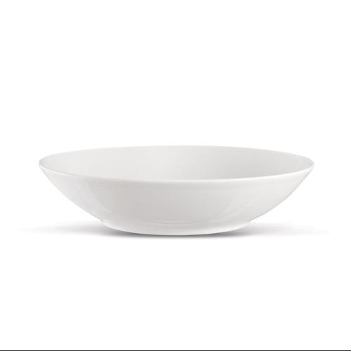  $20.00 |  | #3065 Simple Additions®  Salad Plates  (set of 2)  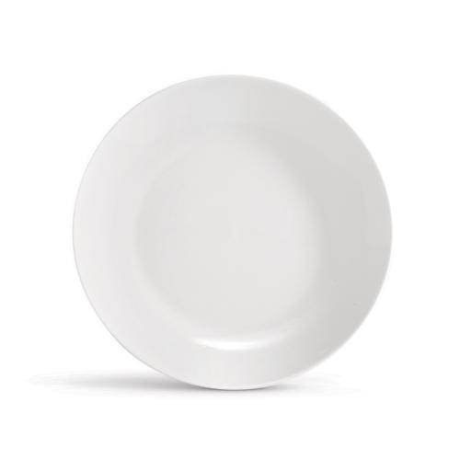  $18.00
#3066 Simple Additions®  Dinner Plates  (set of 2)  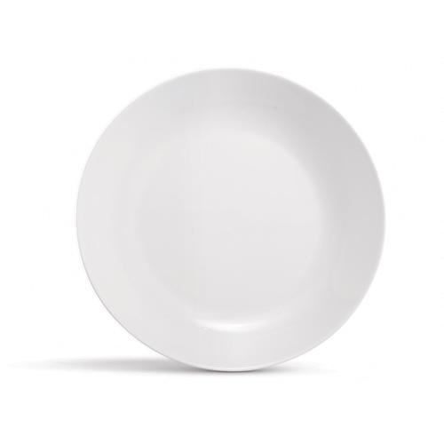  $24.00 |  | #3078 Simple Additions®  Small Square Bowls  (set of 2)  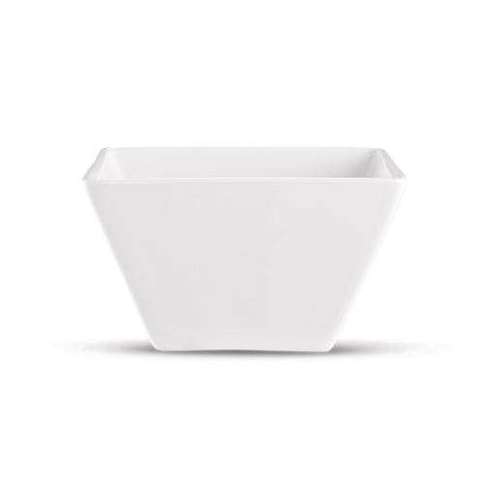  $16.00
  #3079 Simple Additions®  Cups (set of 2)  $18.00 |  | #3080 Simple Additions®  Appetizer Plates & Caddy Set  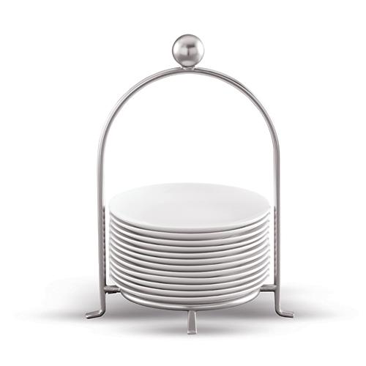  $65.00

