#2867 Executive Cookware – Double Burner Griddle  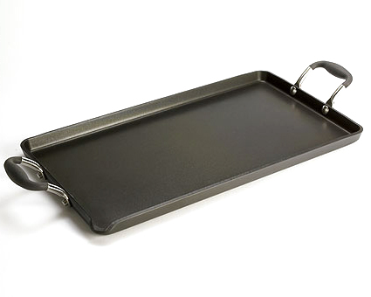  $162.00 | #2868 Executive Cookware – 11” Square Grill Pan  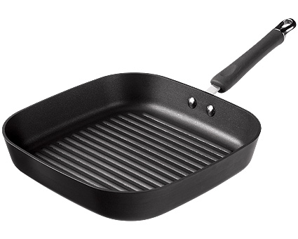  $149.00
#2872 Roasting Pan with Rack  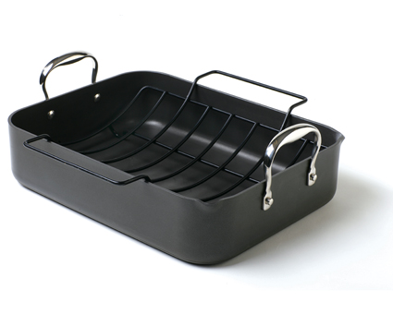  $125.00 | #2873 Executive Cookware – 12 qt. Stockpot  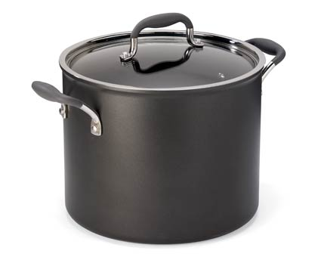  $240.00
#2874 Executive Cookware – 11” Square Griddle  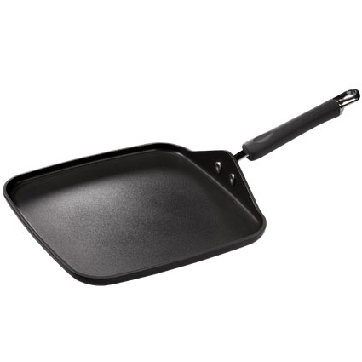  $130.00 | #2875 Executive Cookware – Grill Press  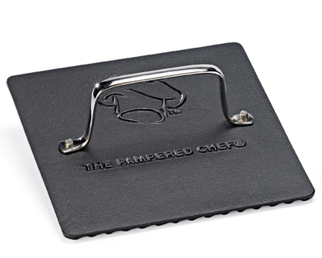  $38.00
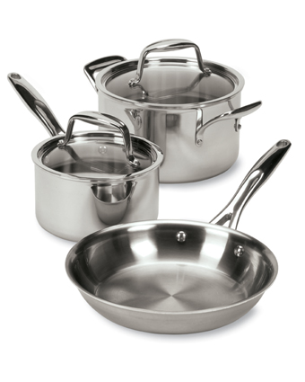  #2878 Stainless Cookware – 5-Piece Set  $345.00 | #2879 Stainless Cookware – 8” Sauté Pan  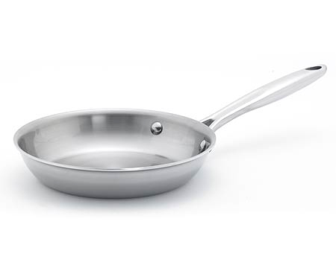  $60.00
#2885 Stainless Cookware – 12” Covered Skillet  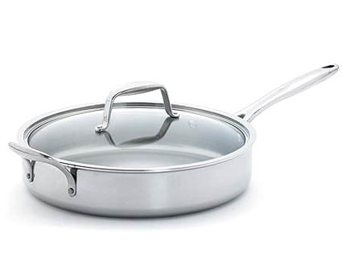  $229.00 | #2886 Executive Cookware – 10” Sauté Pan  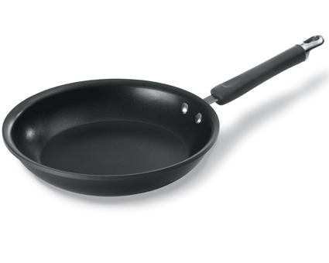  $104.00

