#2890 Stainless Cookware – 10” Covered Skillet  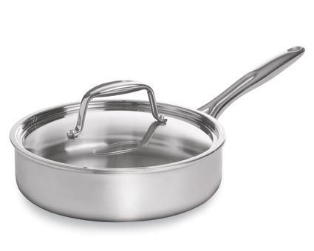  $168.00 |  | #2892 Stainless Steamer  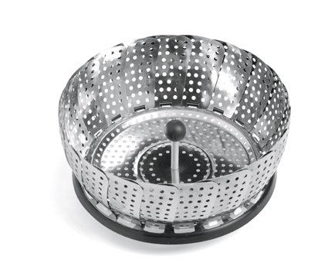  $16.50
#2893 Stainless Cookware – 3-qt. Covered Saucepan  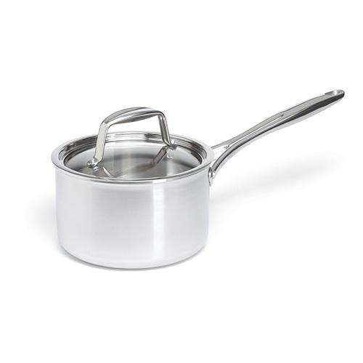  $158.00 |  | #2894 Stainless Cookware – 8-qt. Covered Stockpot  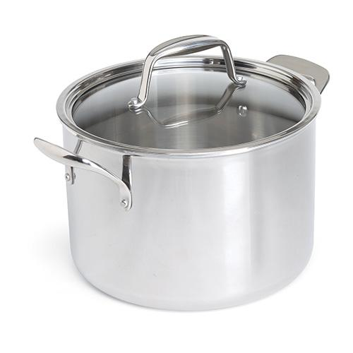  $235.00
#2895 Beaded Cheese Bistro Set  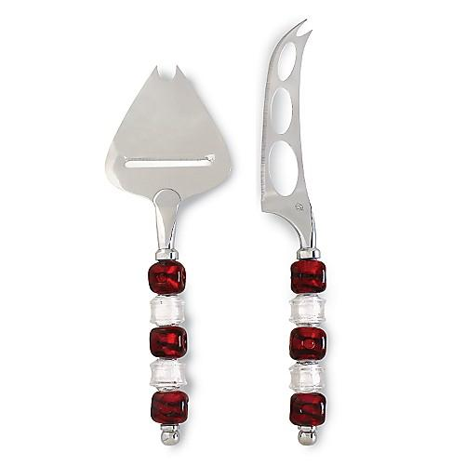  $32.00 |  | #2904 My Safe Cutter  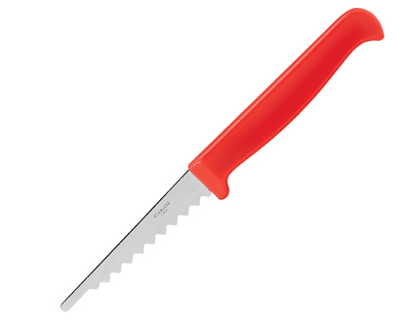  $4.50
#2909 Stainless Cookware  – 8-Piece Set  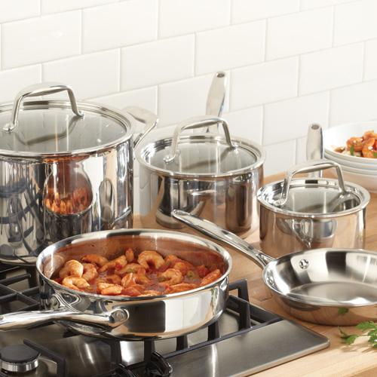  $575.00 |  | 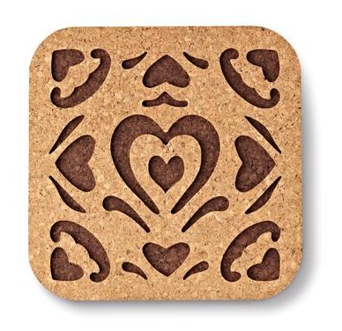  #2947 Round-Up  from the Heart®  Cork Trivet  $9.50
#2955 Chef’s Tongs  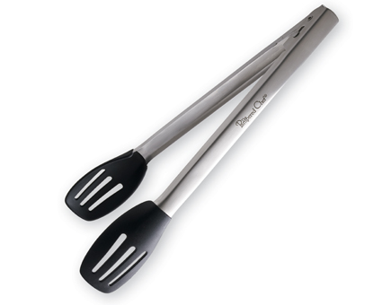  $22.50 |  | #2956 Sauté Tongs  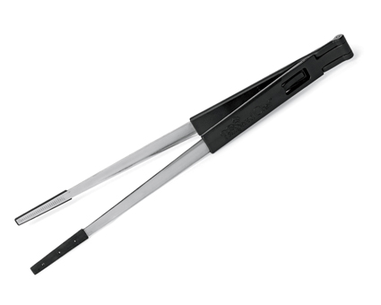  $13.50

