#2829 Outdoor Serving Set  (set of 2)  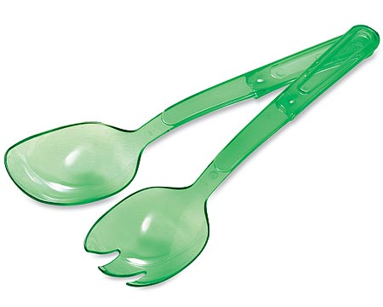  $8.00 | #2832 Trifle Bowl  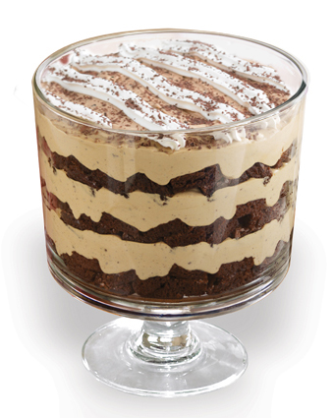  $40.00
#2836 Ice Bucket  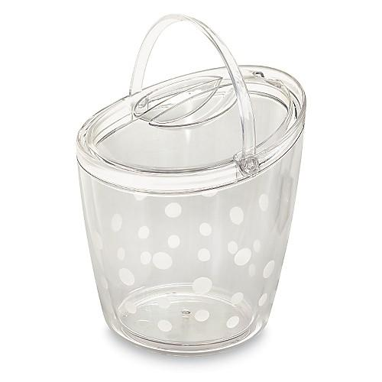  $38.00 | 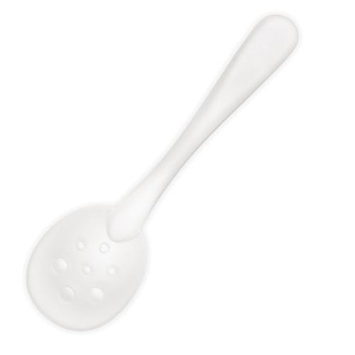  #2839 Ice Scoop  $6.00
#2861 Executive Cookware – 5-Piece Set  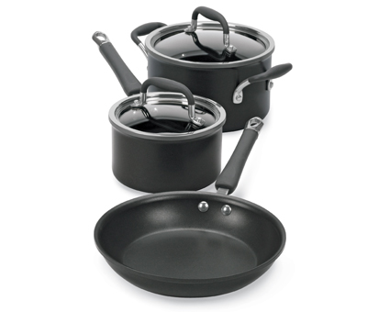  $315.00 | #2862 Executive Cookware – 7-Piece Set  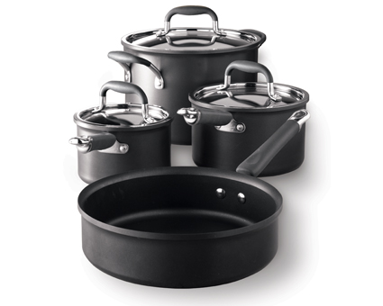  $475.00
#2863 Executive Cookware – 8” Sauté Pan  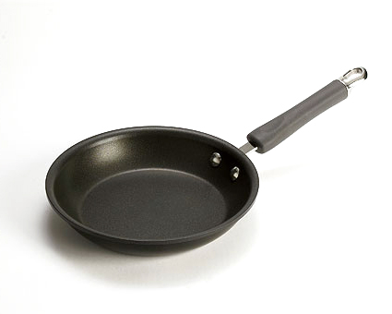  $50.00 | #2864 Executive Cookware – Stir-Fry Skillet  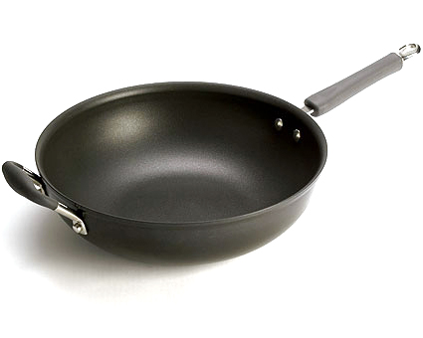  $155.00
#2865 Executive Cookware – 12” Skillet  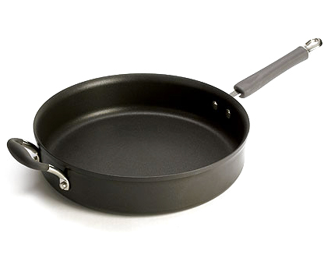  $155.00 | 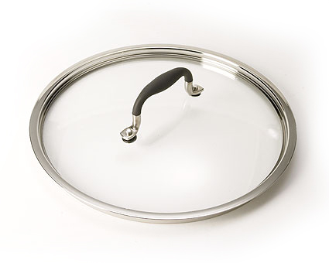  #2866 Executive Cookware – 12” Glass Lid  $42.00

