#2873 Executive Cookware – 12 qt. Stockpot  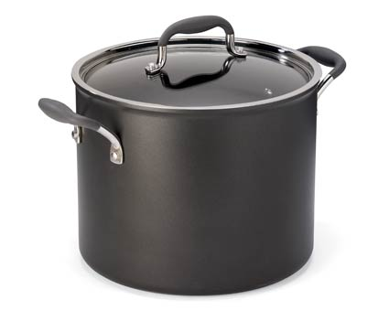  $240.00 |  | #2874 Executive Cookware – 11” Square Griddle  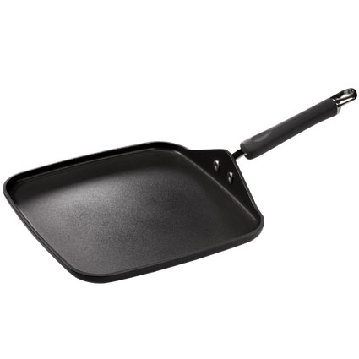  $130.00
#2875 Executive Cookware – Grill Press  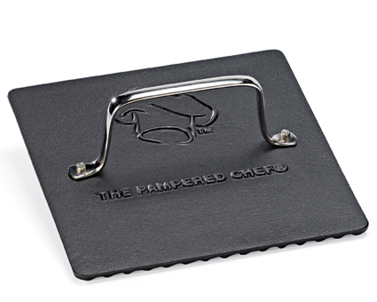  $38.00 |  | #2878 Stainless Cookware – 5-Piece Set  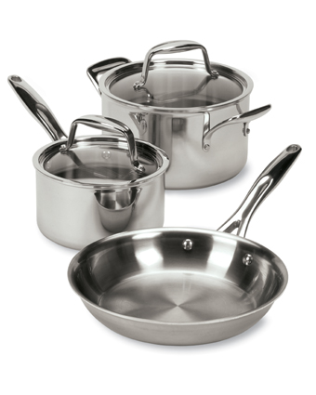  $345.00
#2879 Stainless Cookware – 8” Sauté Pan  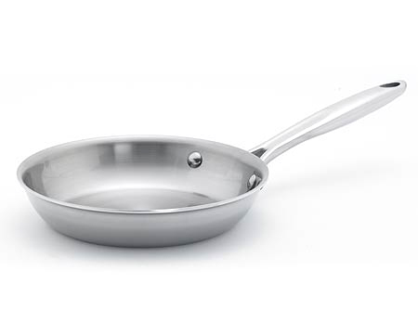  $60.00 |  | #2885 Stainless Cookware – 12” Covered Skillet  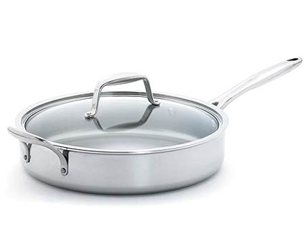  $229.00
#2886 Executive Cookware – 10” Sauté Pan  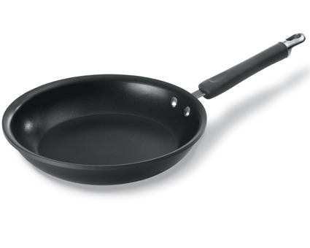  $104.00 |  | #2887 Stainless Cookware – 10” Sauté Pan  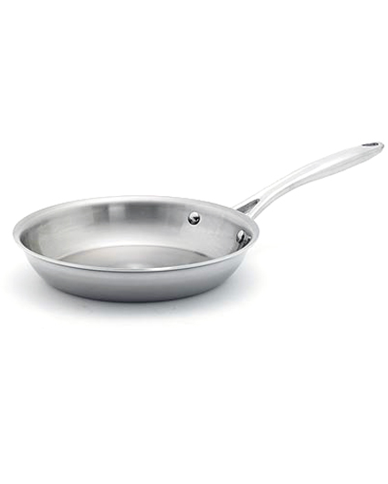  $99.00
#2888 Cookware Protectors  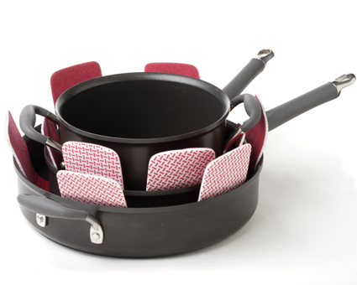  $10.50 |  | #2889 Stainless Cleaner  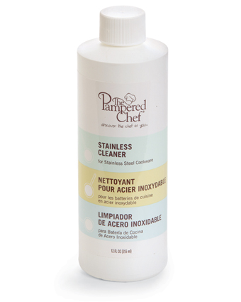  $9.75

