#2797 Stainless Mesh Colanders  (set of 3)  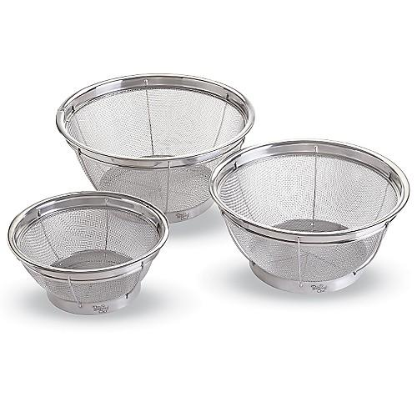  $37.00 | #2799 4 qt. Collapsible Serving Bowl  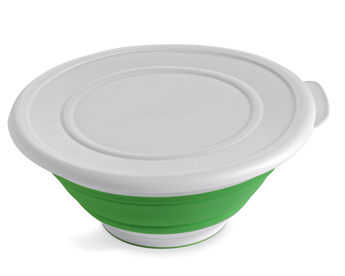  $21.50
#2801 Beaded Serving Set  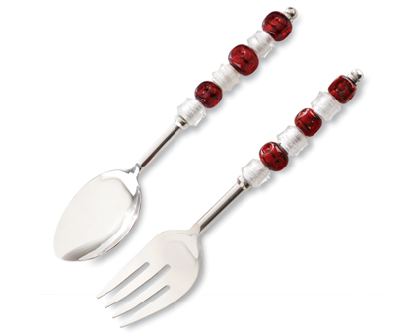  $32.00 | #2811 Beaded Spreader  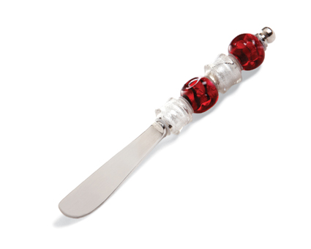  $9.00
#2812 Beaded Serving Fork  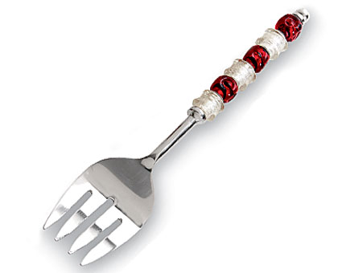  $17.00 | #2813 Beaded Serving Spoon  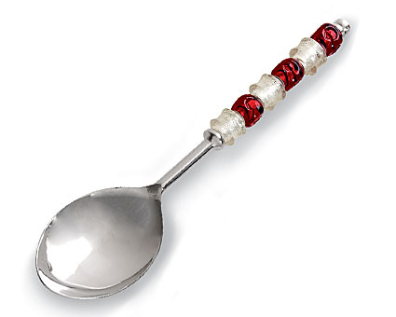  $17.00
#2814 Beaded Cheese Plane  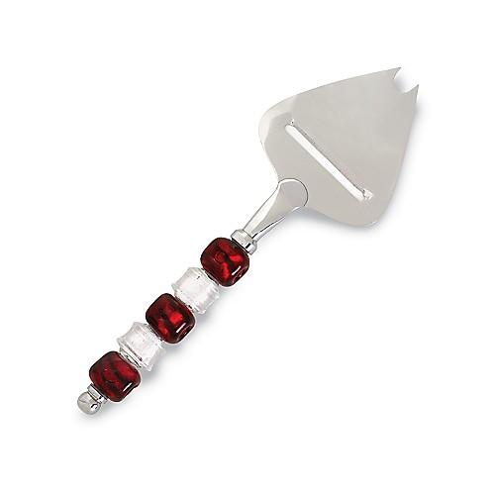  $17.00 | #2816 Beaded Cheese Knife  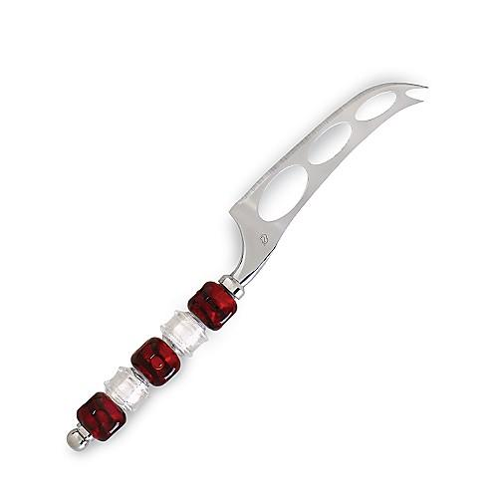  $17.00
#2817 Beaded Cake/Pie Server  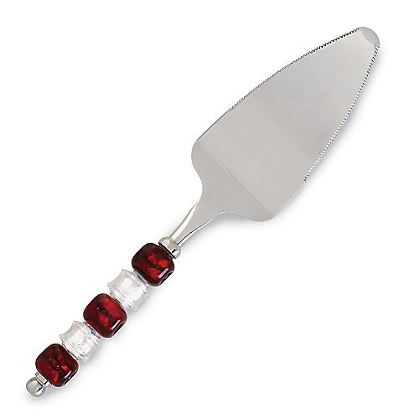  $17.00 | #2828 Outdoor Party Sticks (set of 7)  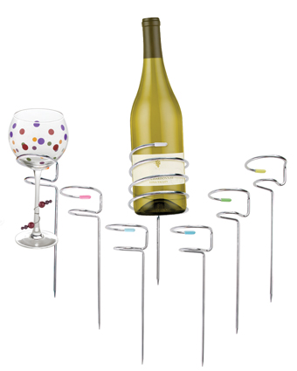  $40.00

