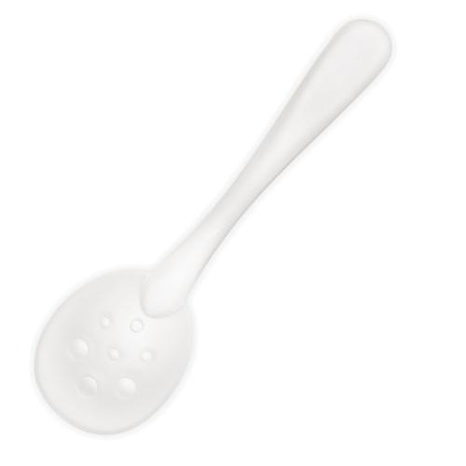  #2839 Ice Scoop  $6.00 |  | #2861 Executive Cookware – 5-Piece Set  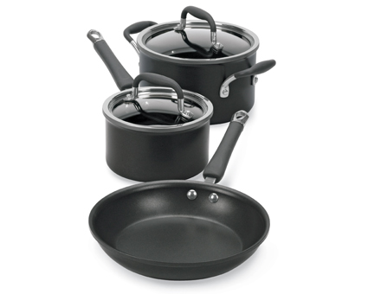  $315.00
#2862 Executive Cookware – 7-Piece Set  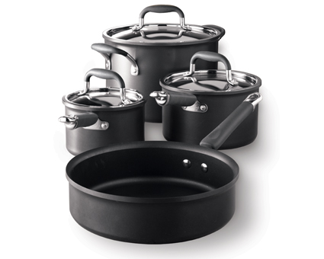  $475.00 |  | #2863 Executive Cookware – 8” Sauté Pan  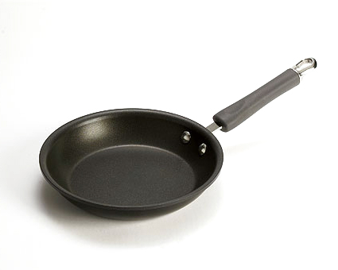  $50.00
#2864 Executive Cookware – Stir-Fry Skillet  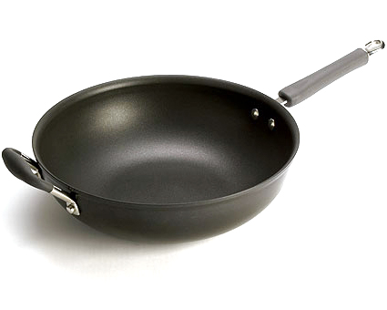  $155.00 |  | #2865 Executive Cookware – 12” Skillet  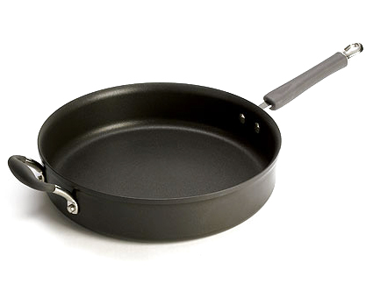  $155.00
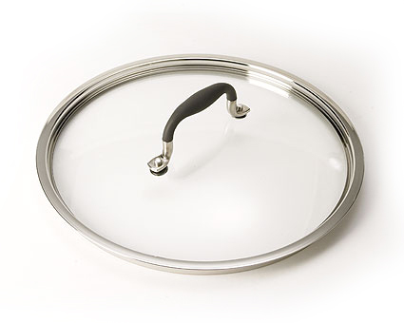  #2866 Executive Cookware – 12” Glass Lid  $42.00 |  | #2867 Executive Cookware – Double Burner Griddle  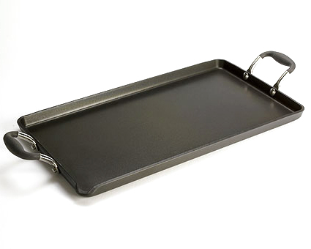  $162.00
#2868 Executive Cookware – 11” Square Grill Pan  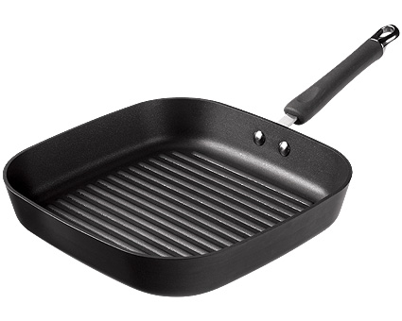  $149.00 |  | #2872 Roasting Pan with Rack  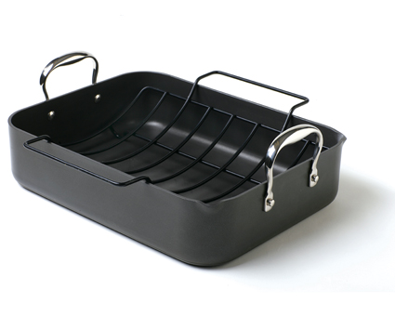  $125.00

