#2732 Kitchen Spritzer  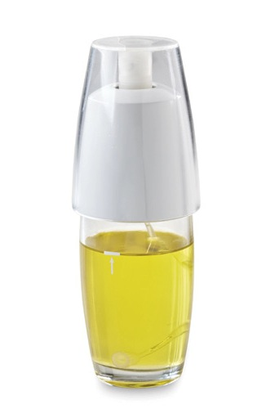  $16.00 | #2759 Smooth-Edge Can Opener  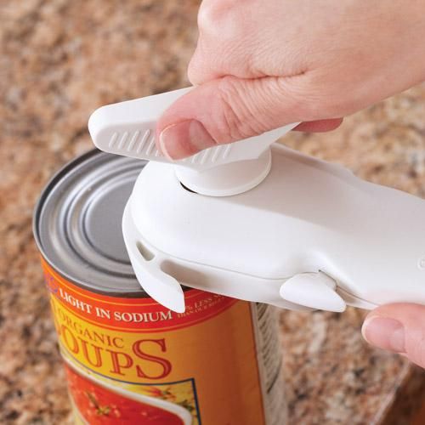  $21.00
#2776 Small Micro-Cooker®  (1 qt.)  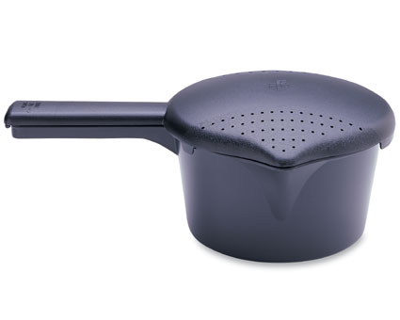  $8.50 | #2778 Large Micro-Cooker®  (2 qts.)  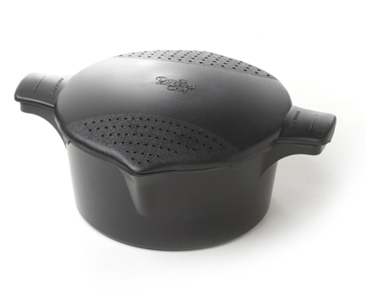  $11.00
#2779 Rice Cooker Plus  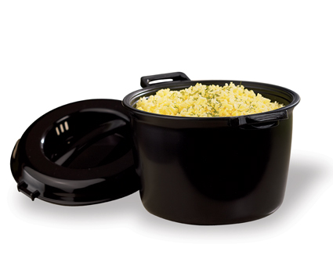  $26.50 | #2783 Small Micro-Cooker®  (1 qt.)  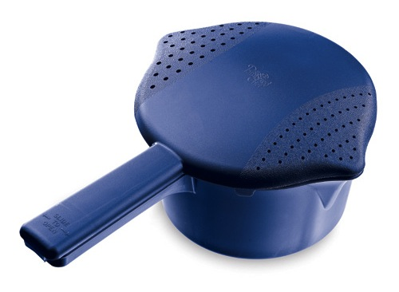  $8.50
#2784 Large Micro-Cooker®  (2 qts.)  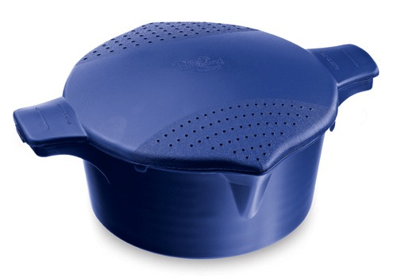  $11.00 | #2792 8 qt. Collapsible Serving Bowl  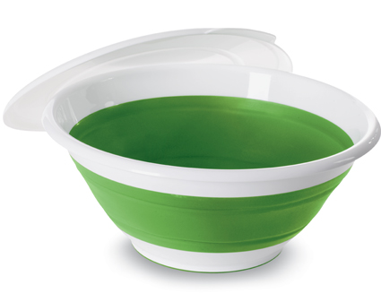  $26.50
#2793 Chip & Dip  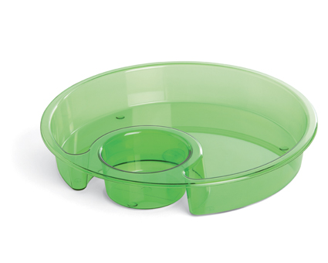  $19.50 | #2794 2 qt. Collapsible Serving Bowl  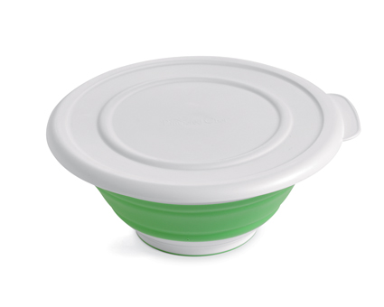  $16.50

