#2816 Beaded Cheese Knife  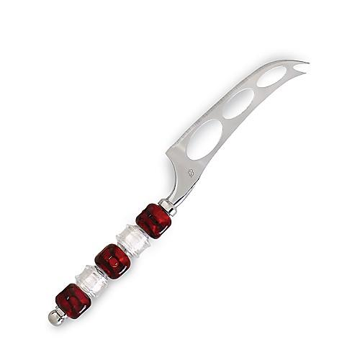  $17.00 |  | #2817 Beaded Cake/Pie Server  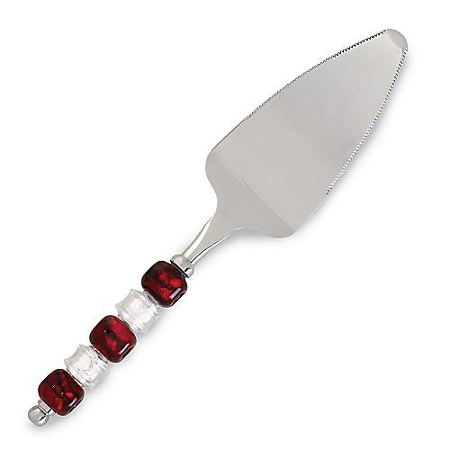  $17.00
#2823 Outdoor Party Plates (set of 6)  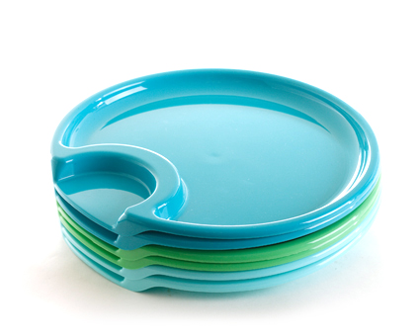  $9.50 |  | #2826 Outdoor Tumblers  (set of 6)  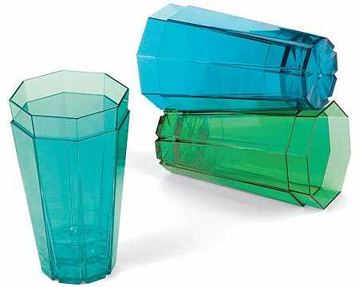  $21.50
#2827 Outdoor Utensil Set (set of 6)  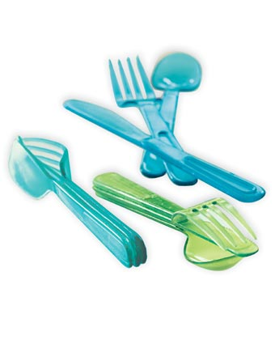  $12.50 |  | #2828 Outdoor Party Sticks (set of 7)  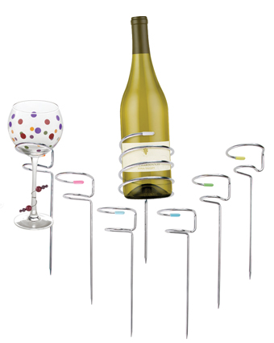  $40.00
#2829 Outdoor Serving Set  (set of 2)  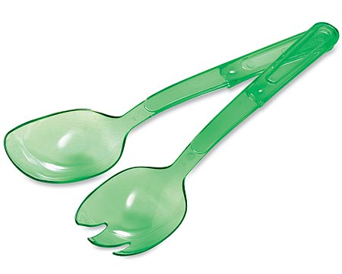  $8.00 |  | #2832 Trifle Bowl  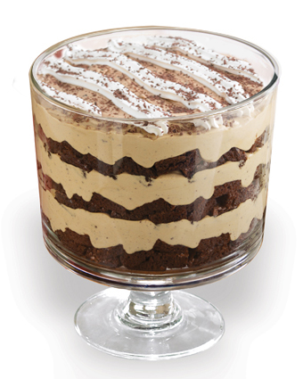  $40.00
#2834 Outdoor Caddy  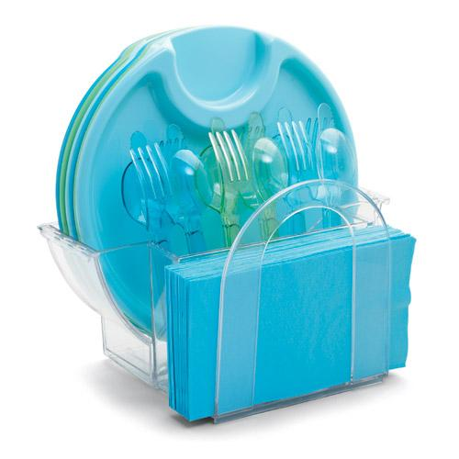  $18.50 |  | #2836 Ice Bucket  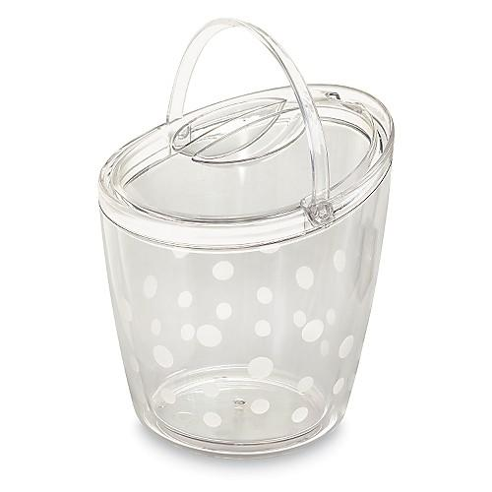  $38.00

