#1092 Bamboo Knife Block Set  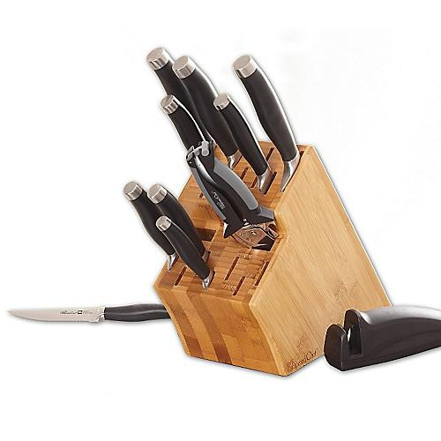  $435.00 | 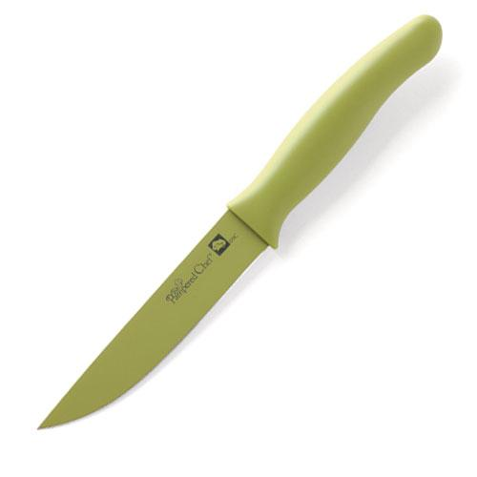  #1093 Color Coated Utility Knife  $15.50
#1094 Color Coated Chef’s Knife  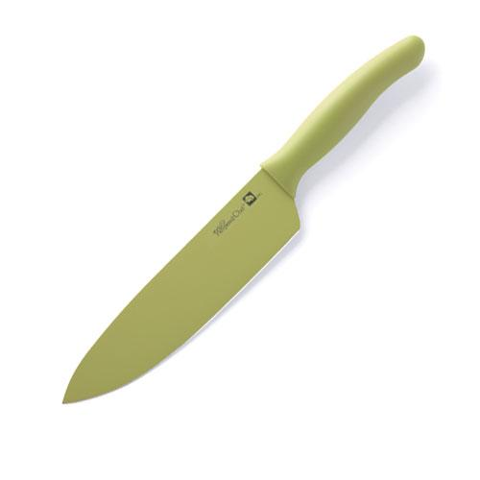  $20.00 | #1095 Creative Cutters Set  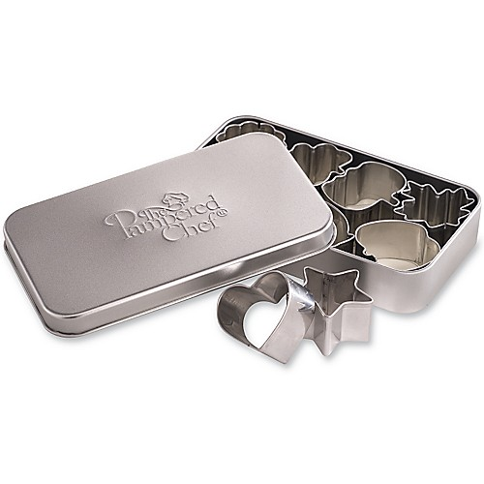  $11.50
#1099 Simple Slicer  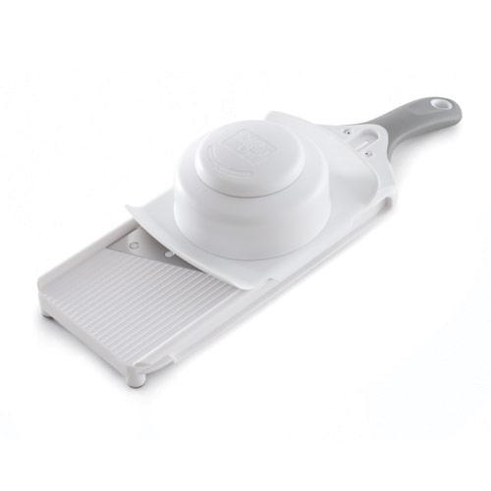  $30.00 | #1101 Hold ‘N Slice®  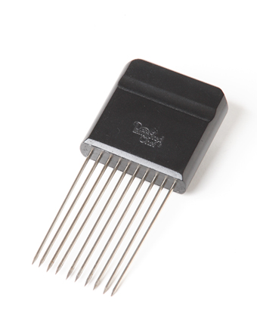  $5.00
#1103 Biscuit Cutters  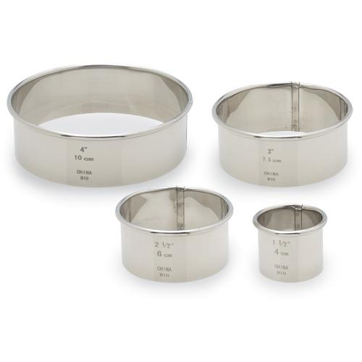  $10.50 | 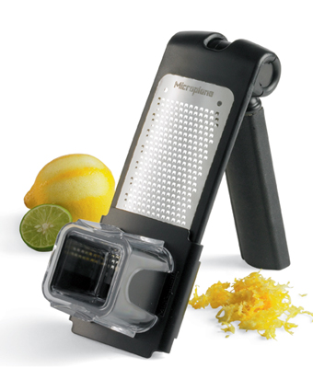  #1105 Microplane® Adjustable Grater – Fine  $27.50
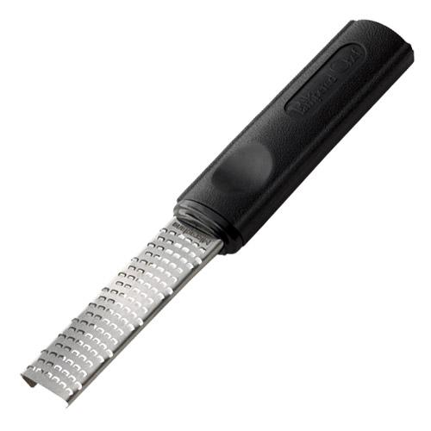  #1107 Microplane® Zester  $14.50 | #1108 Microplane® Adjustable Grater – Coarse  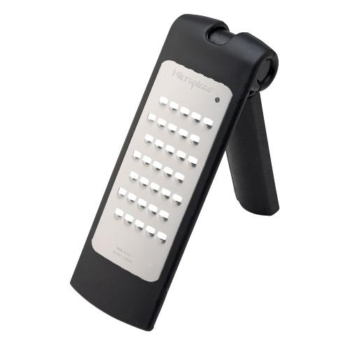  $26.50

