#2709 BBQ Cleaning Brush  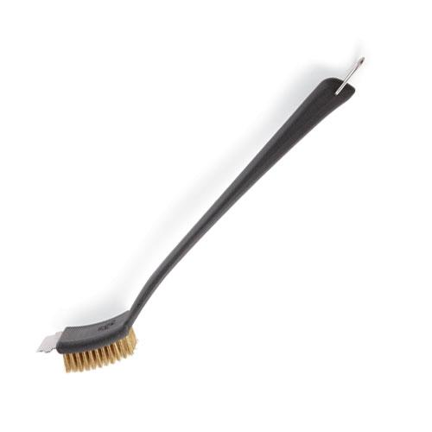  $15.50 | 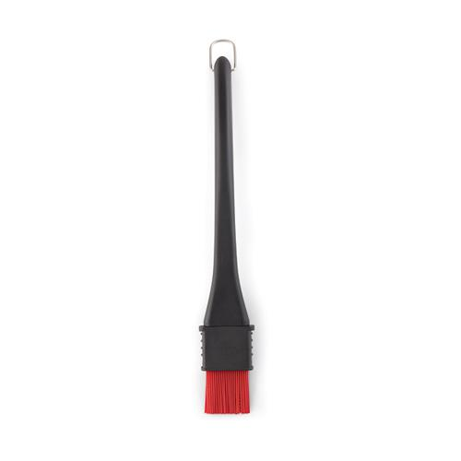  #2711 BBQ Basting Brush  $18.00
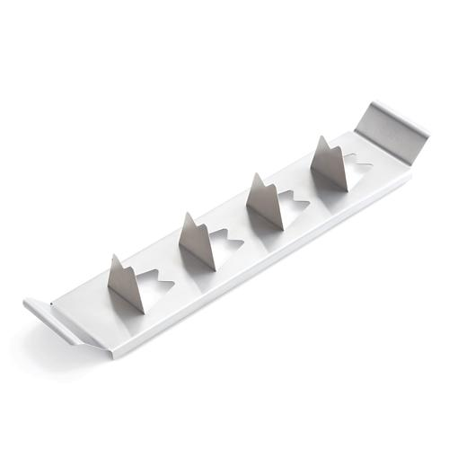  #2712 BBQ  Vegetable Rack  $10.00 | 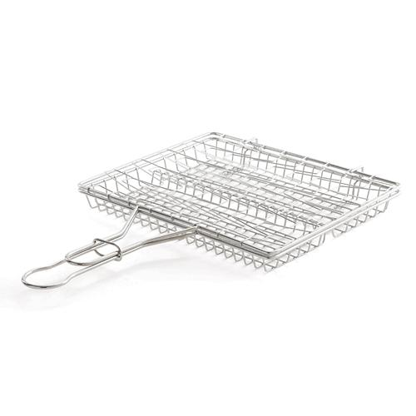  #2713 BBQ  Flexible Basket  $31.50
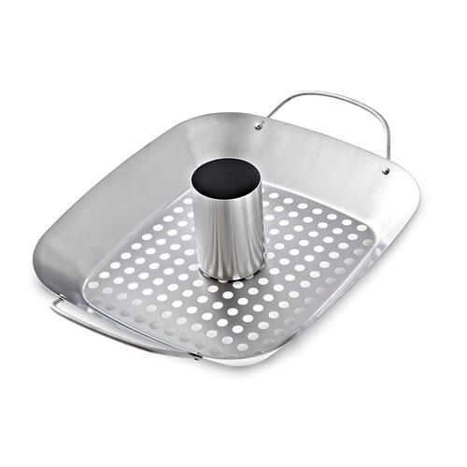  #2714 BBQ Roasting Pan & Can Holder  $39.50 | #2715 Meat Lifters  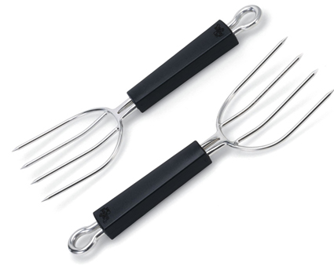  $29.00
#2716 BBQ Pizza Pan  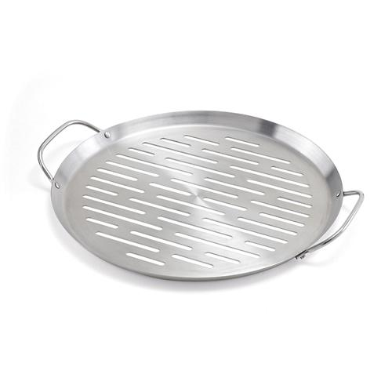  $24.00 | #2717 BBQ Slotted Spoon  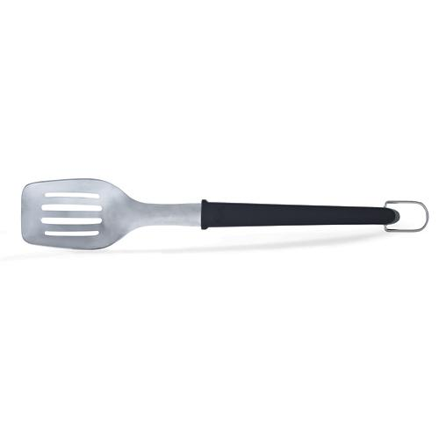  $15.50
#2718 BBQ Corn & Skewer Rack  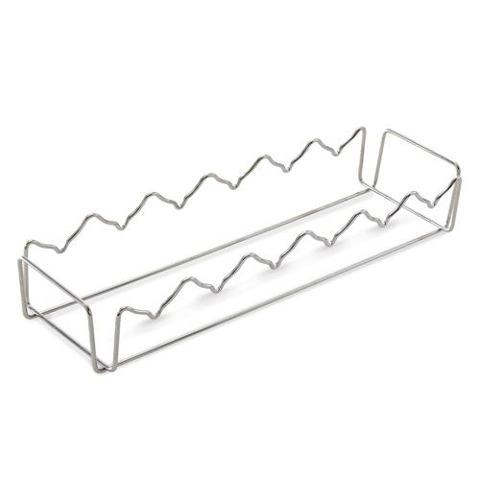  $18.00 | #2731 Ice Cream Scoop  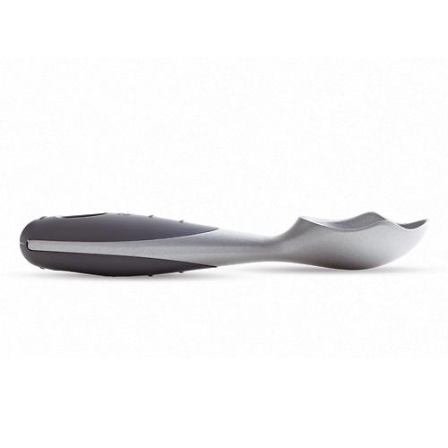  $9.00

