#2792 8 qt. Collapsible Serving Bowl  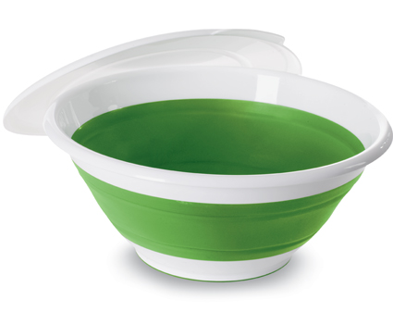  $26.50 |  | #2793 Chip & Dip  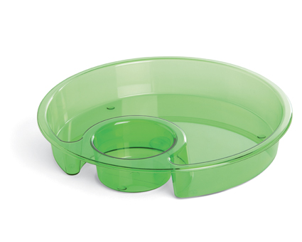  $19.50
#2794 2 qt. Collapsible Serving Bowl  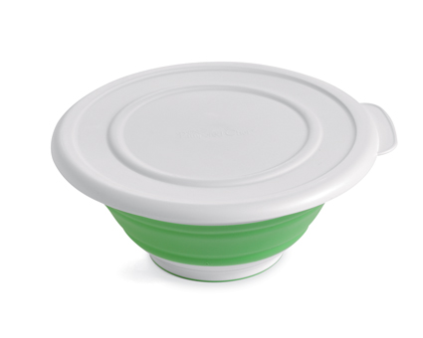  $16.50 |  | #2797 Stainless Mesh Colanders  (set of 3)  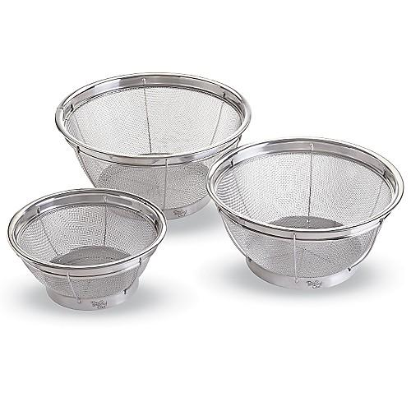  $37.00
#2799 4 qt. Collapsible Serving Bowl  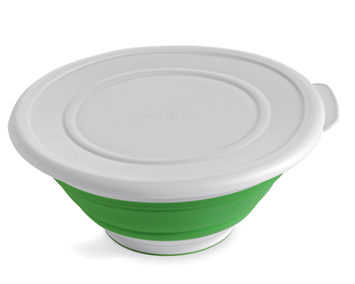  $21.50 |  | #2801 Beaded Serving Set  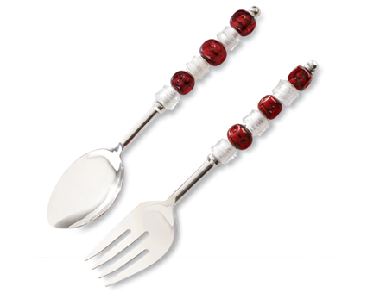  $32.00
#2811 Beaded Spreader  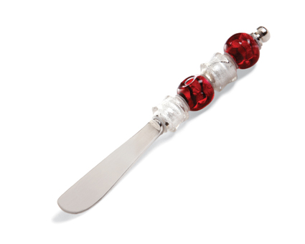  $9.00 |  | #2812 Beaded Serving Fork  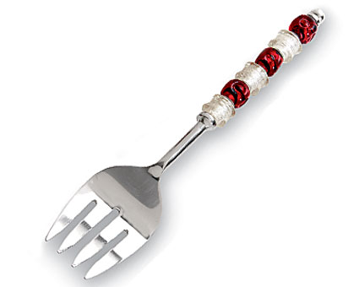  $17.00
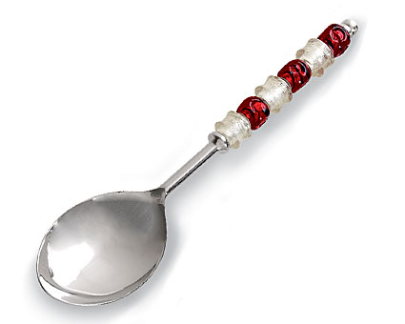  #2813 Beaded Serving Spoon  $17.00 |  | #2814 Beaded Cheese Plane  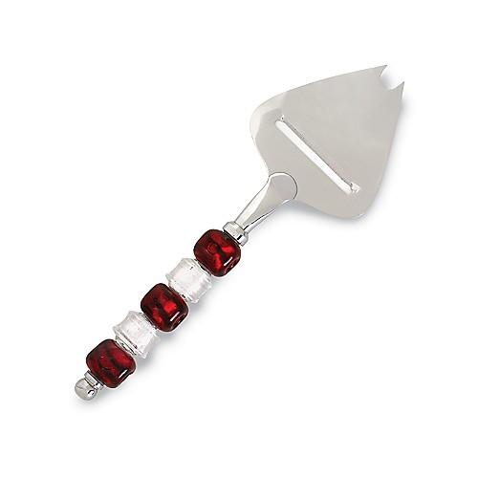  $17.00

