#2691 BBQ Tongs  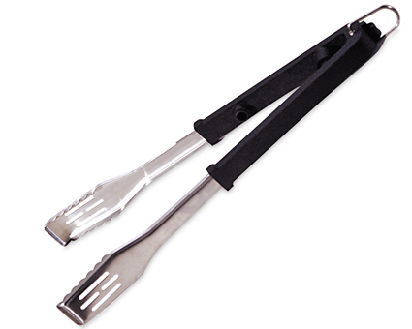  $19.50 | #2692 BBQ Turner  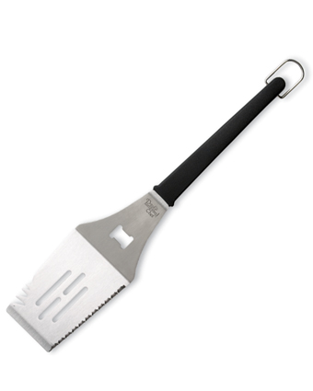  $19.50
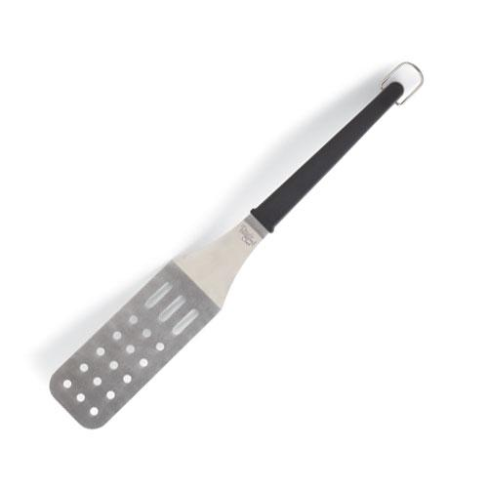  #2694 BBQ  Flexible Turner  $19.50 | #2696 BBQ Mitt  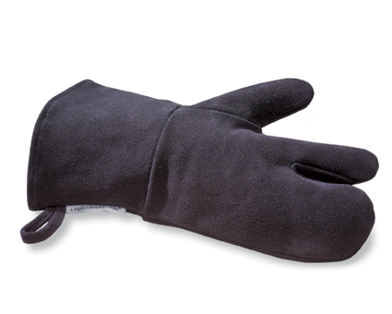  $17.50
#2701 BBQ Skewer Set  (set of 4)  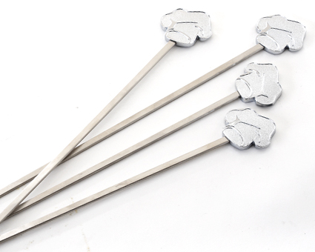  $20.50 | 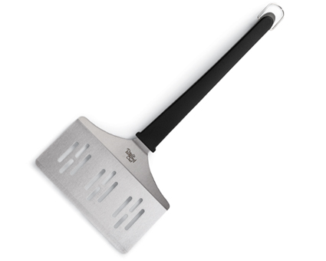  #2703 BBQ  J umbo Turner  $21.00
#2704 BBQ Basting Bottle  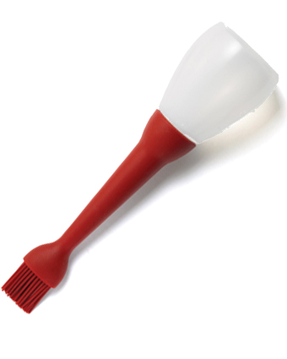  $16.00 | #2705 Meat Tenderizer  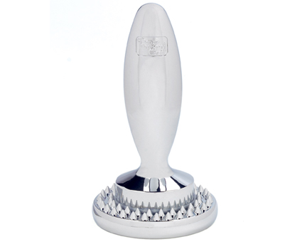  $30.00
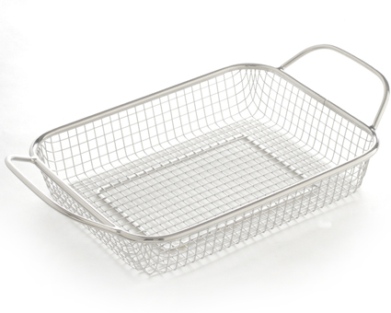  #2707 BBQ  Grill Basket  $28.50 | #2708 BBQ Grill Tray  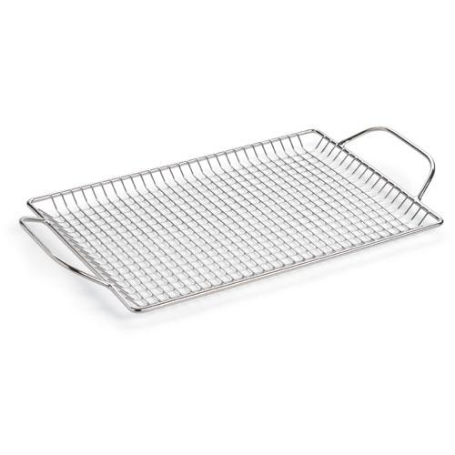  $31.50

