#2714 BBQ Roasting Pan & Can Holder  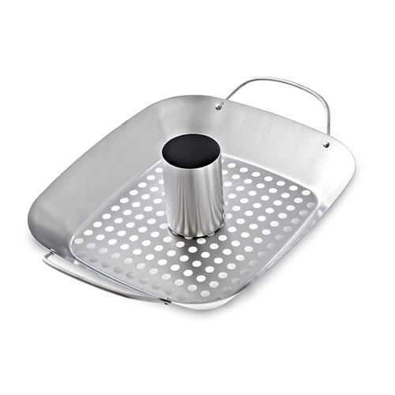  $39.50 |  | #2715 Meat Lifters  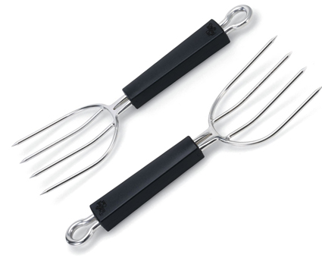  $29.00
#2716 BBQ Pizza Pan  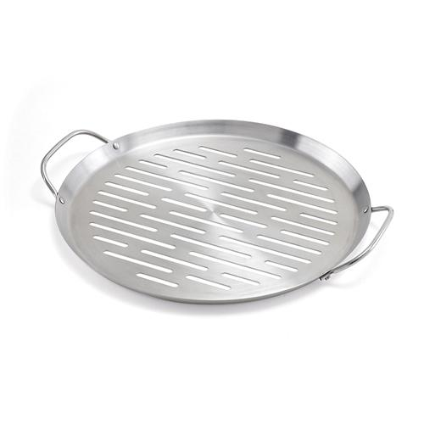  $24.00 |  | #2717 BBQ Slotted Spoon  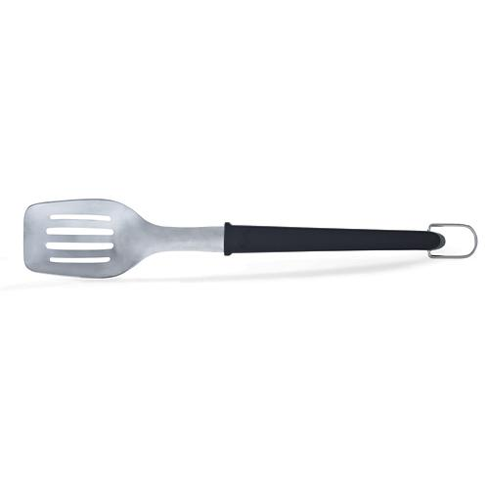  $15.50
#2718 BBQ Corn & Skewer Rack  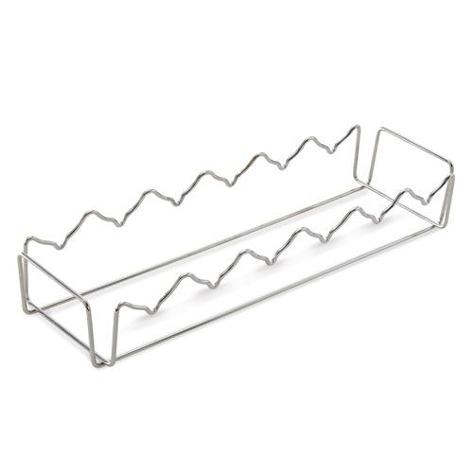  $18.00 |  | #2731 Ice Cream Scoop  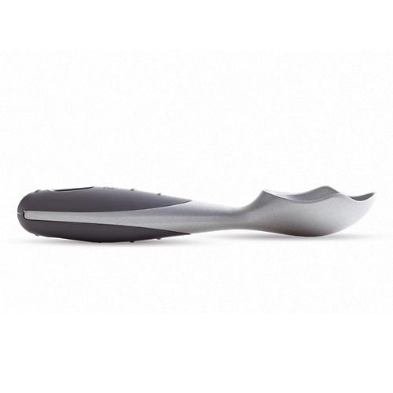  $9.00
#2759 Smooth-Edge Can Opener  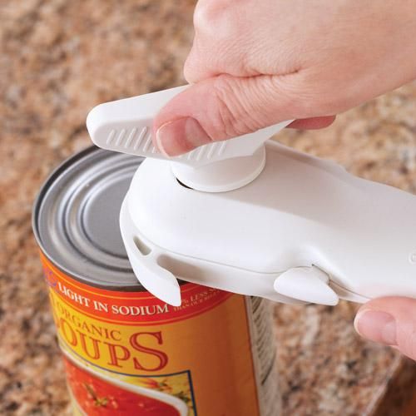  $21.00 |  | #2776 Small Micro-Cooker® (1 qt.)  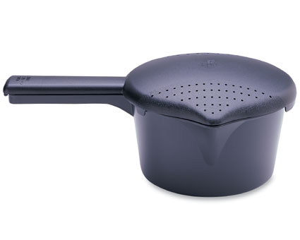  $8.50
#2778 Large Micro-Cooker® (2 qts.)  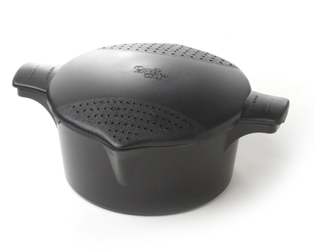  $11.00 |  | #2779 Rice Cooker Plus  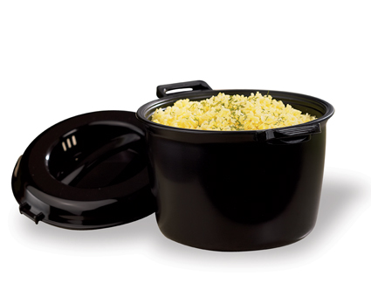  $26.50

