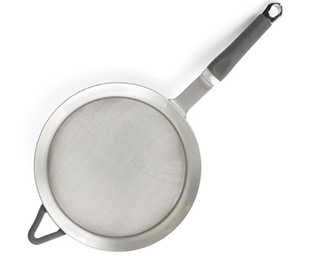  #2606 7” Strainer  $31.50 | #2610 Pan Scrapers  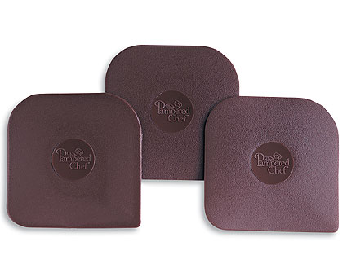  $3.00
#2622 Mini-Serving Spatula  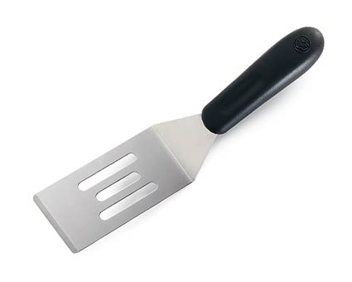  $6.00 | #2626 Large Serving Spatula  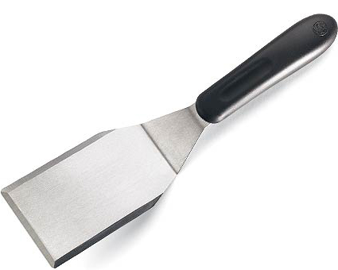  $10.00
#2635 Mini-Whipper  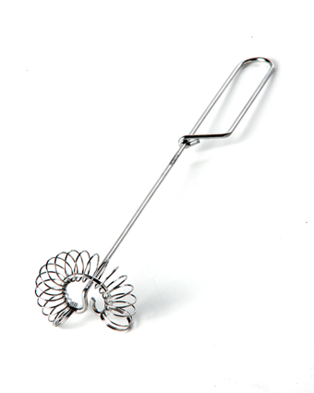  $4.50 | 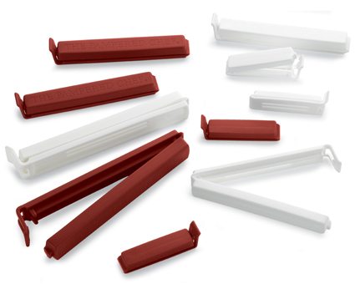  #2651 Twixit! Clip Combo Pack (Cranberry & White)  $6.00
#2677 J ar Opener  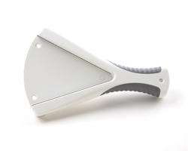  $11.50 | #2678 Flexible Openers  (set of 2)  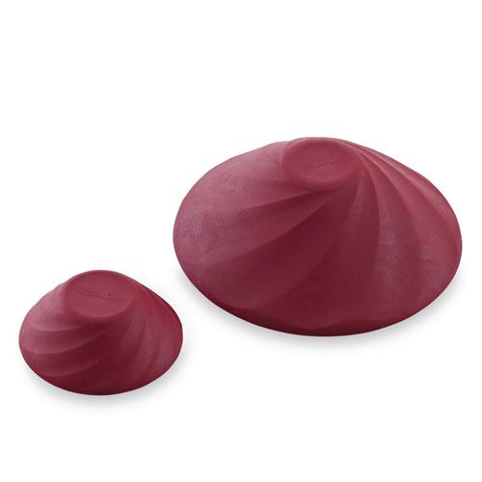  $10.00
#2685 Mix ‘N Masher  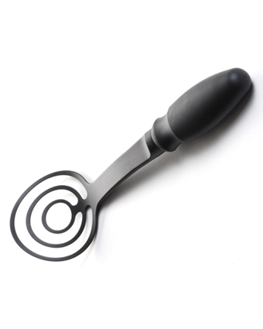  $11.50 | 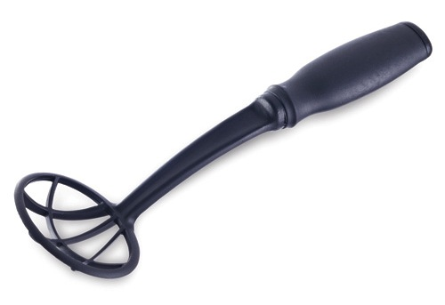  #2686 Mix ‘N Chunk  $11.50

