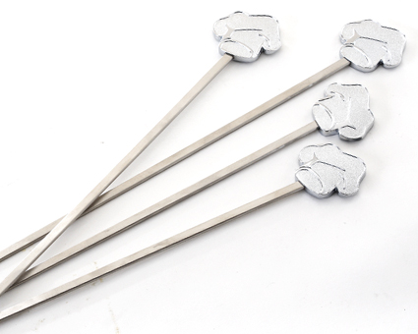  #2701 BBQ Skewer Set  (set of 4)  $20.50 |  | #2703 BBQ J umbo Turner  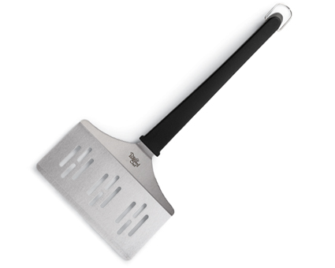  $21.00
#2704 BBQ Basting Bottle  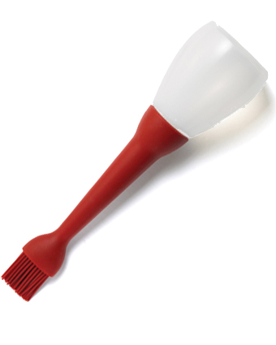  $16.00 |  | #2705 Meat Tenderizer  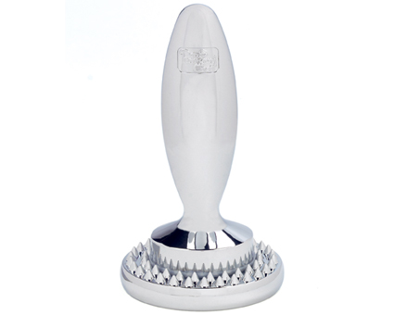  $30.00
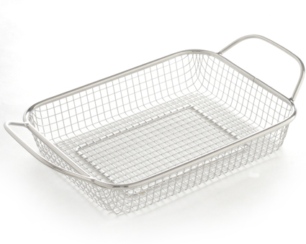  #2707 BBQ  Grill Basket  $28.50 |  | #2708 BBQ Grill Tray  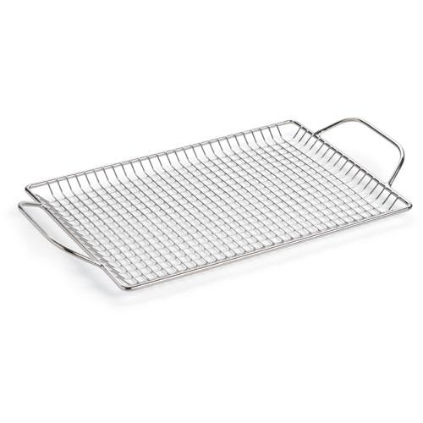  $31.50
#2709 BBQ Cleaning Brush  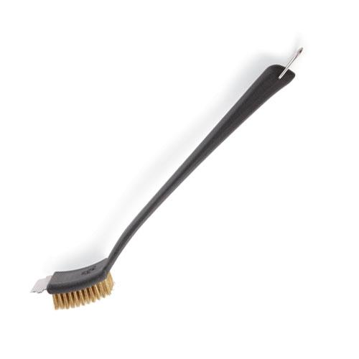  $15.50 |  | 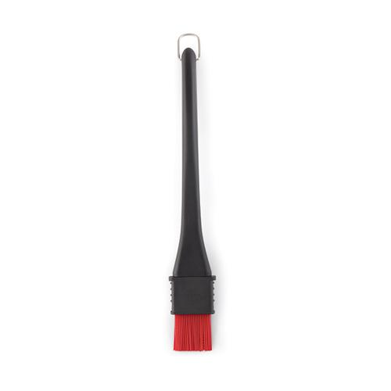  #2711 BBQ Basting Brush  $18.00
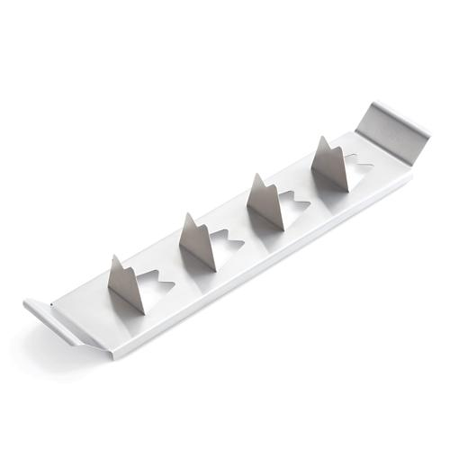  #2712 BBQ  Vegetable Rack  $10.00 |  | 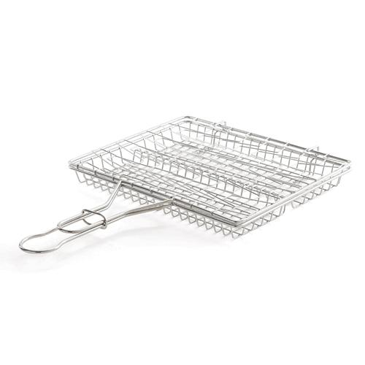  #2713 BBQ  Flexible Basket  $31.50

