#2578 Garlic Peeler & Slicer Set  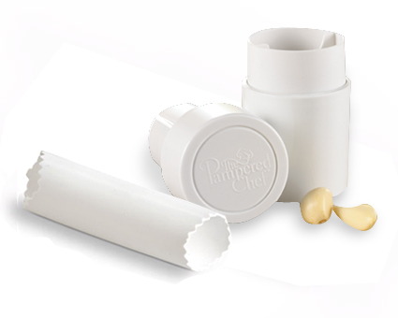  $19.50 | 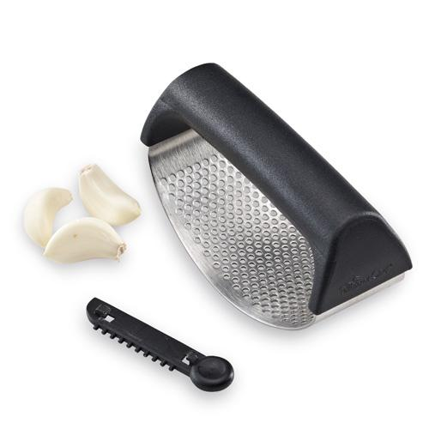  #2579 Garlic  Smash & Paste  $14.50
#2581 Manual Food Processor  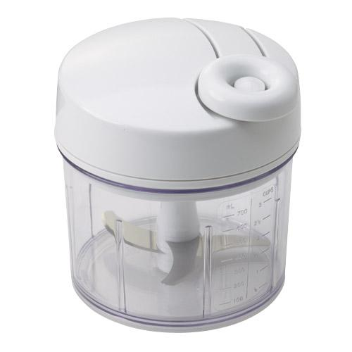  $49.00 | #2582 Salad Chopper  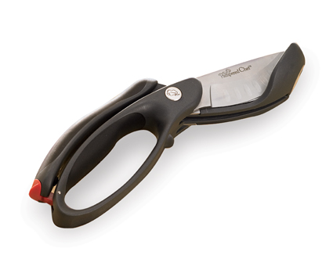  $26.50
#2583 Mix ‘N Chop  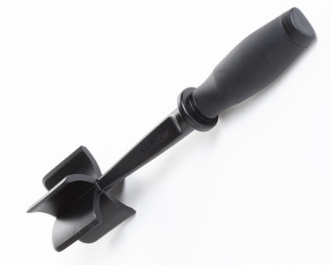  $11.00 | 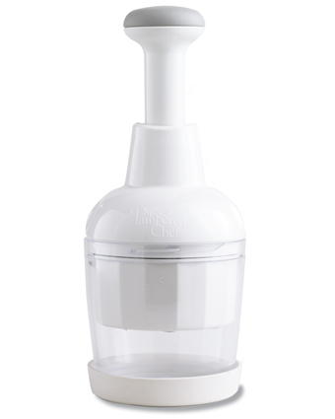  #2585 Food Chopper  $32.00
#2586 Garlic Peeler  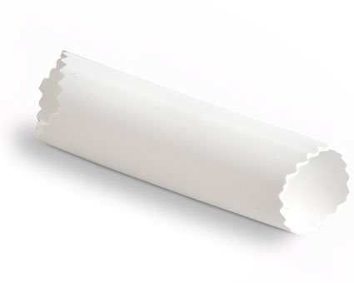  $8.00 | #2590 Easy Opener  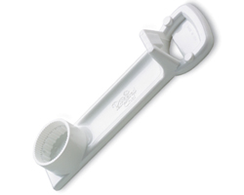  $5.50
#2595 Citrus Press  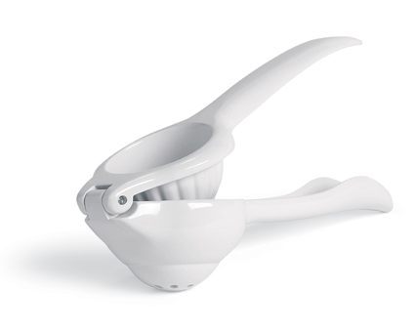  $19.00 | #2605 Coating Trays & Tool  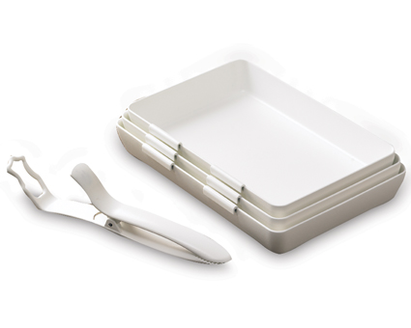  $23.00

