#2626 Large Serving Spatula  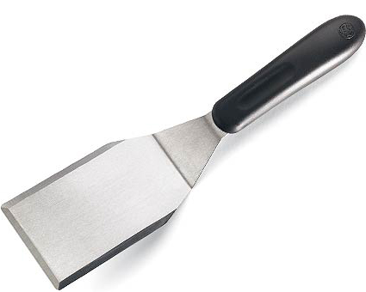  $10.00 |  | #2635 Mini-Whipper  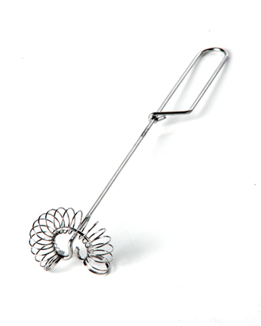  $4.50
#2651 Twixit! Clip Combo Pack (Cranberry & White)  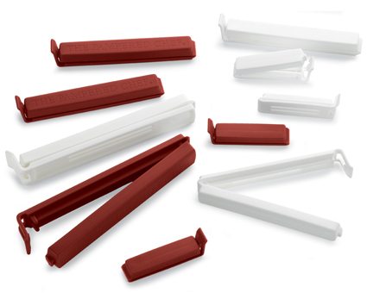  $6.00 |  | #2677 J ar Opener  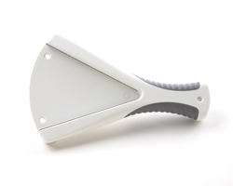  $11.50
#2678 Flexible Openers  (set of 2)  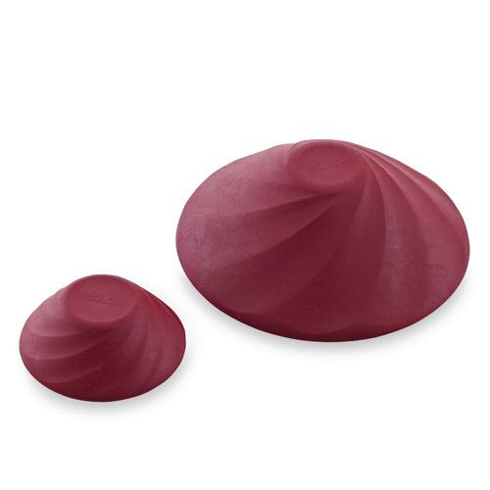  $10.00 |  | #2685 Mix ‘N Masher  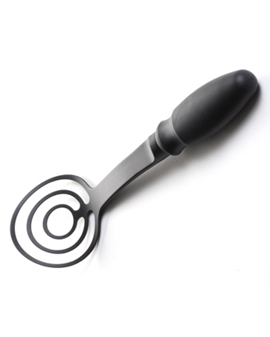  $11.50
#2691 BBQ Tongs  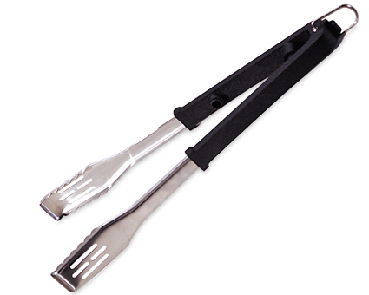  $19.50 |  | #2692 BBQ Turner  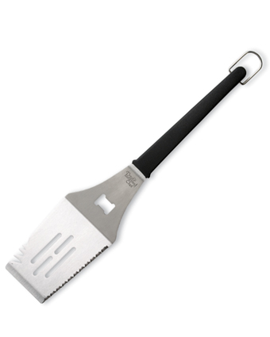  $19.50
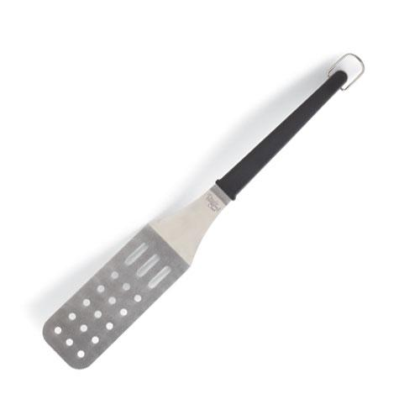  #2694 BBQ  Flexible Turner  $19.50 |  | #2696 BBQ Mitt  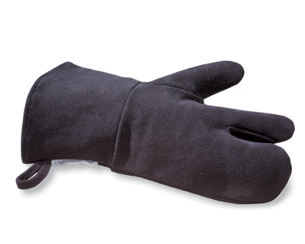  $17.50

