#2532 Manual Food Processor Set  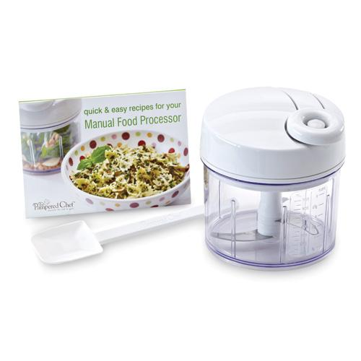  $64.00 | 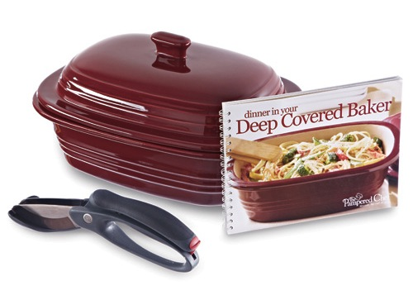  #2537 Deep Covered Baker Dinner Set  $118.00
#2538 Skillet Dinner Set  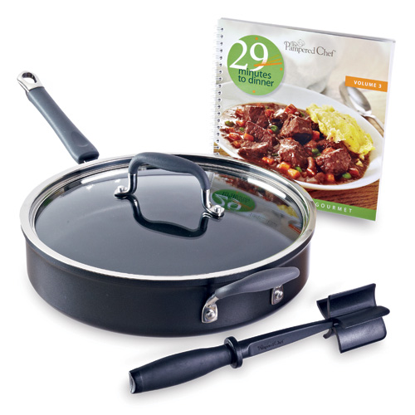  $220.00 | 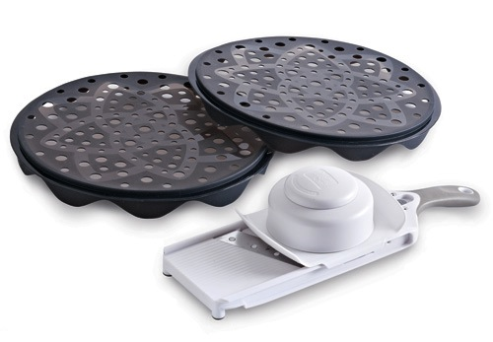  #2539 Make-Your-Own Chips Set  $55.00
#2540 Medium Scoop  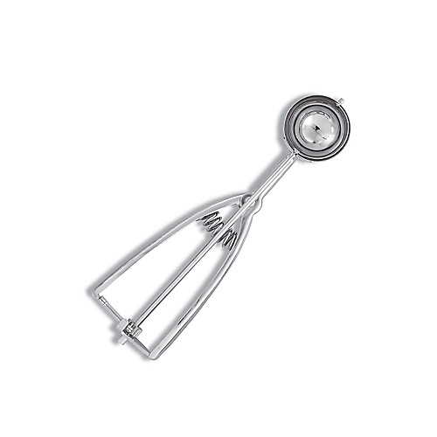  $16.50 | #2543 Get Your Grill On Set  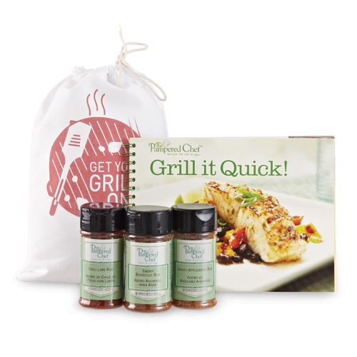  $19.00
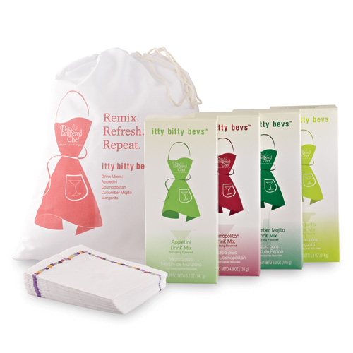  #2544 Remix, Refresh, Repeat Set  $34.50 | #2545 Double Dip (We Won’t Tell) Set  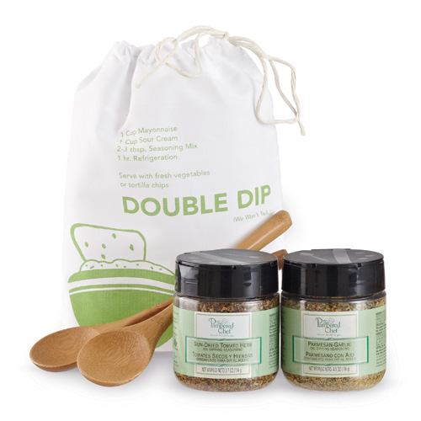  $19.00
#2555 Scoop Clip  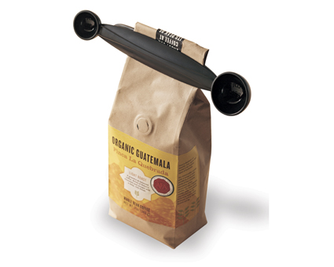  $6.00 | #2576 Garlic Press  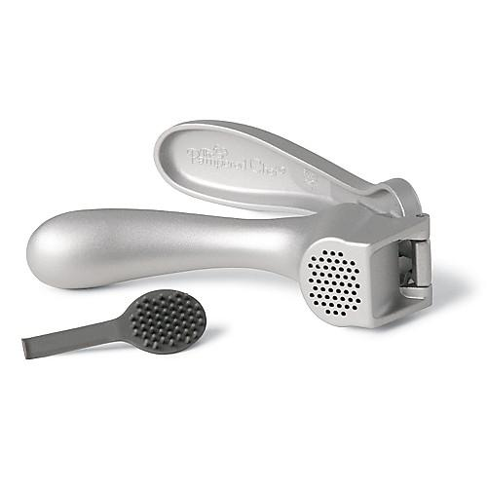  $16.50

