#2582 Salad Chopper  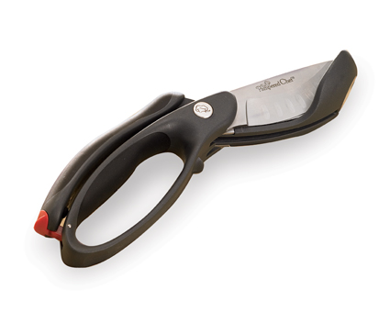  $26.50 |  | #2583 Mix ‘N Chop  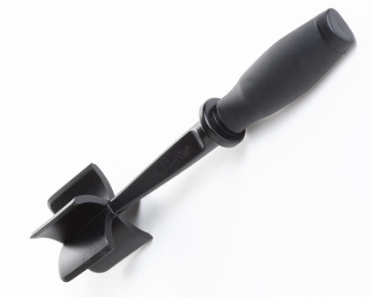  $11.00
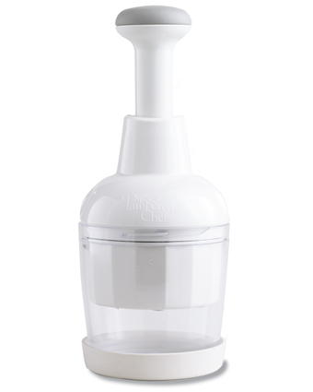  #2585 Food Chopper  $32.00 |  | #2586 Garlic Peeler  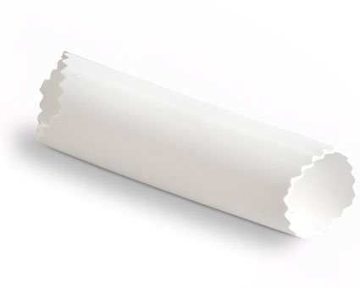  $8.00
#2590 Easy Opener  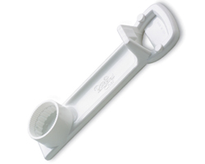  $5.50 |  | #2595 Citrus Press  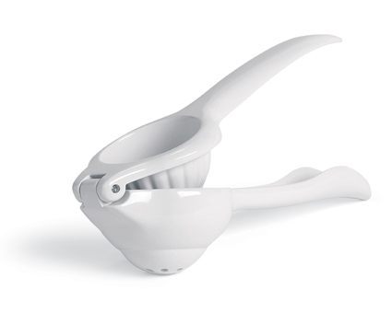  $19.00
#2605 Coating Trays & Tool  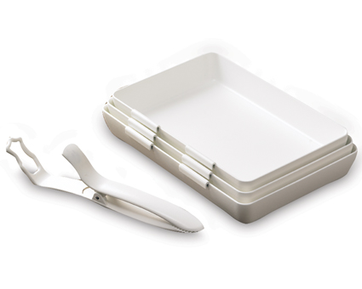  $23.00 |  | #2606 Chef’s Tools – 7” Strainer  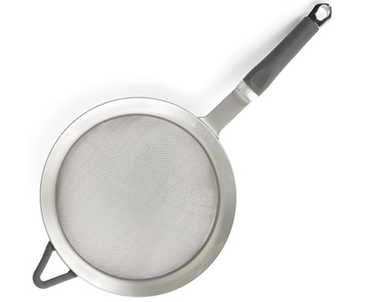  $31.50
#2610 Pan Scrapers  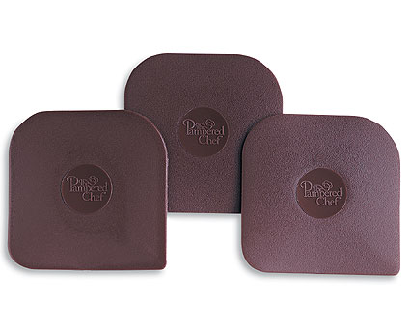  $3.00 |  | #2622 Mini-Serving Spatula  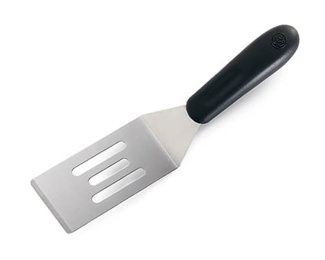  $6.00

