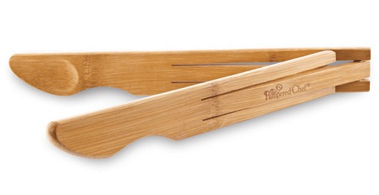  #2479 Bamboo Salad Tongs  $12.50 | 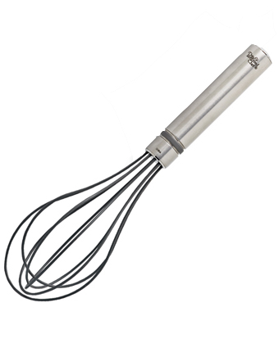  #2481 Stainless/Silicone Sauce Whisk  $18.00
#2482 Stainless/Silicone Flat Whisk  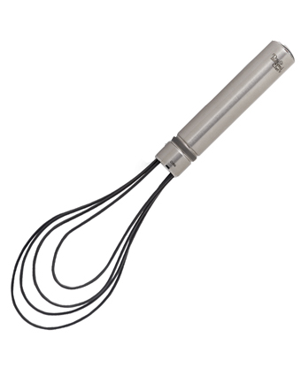  $18.00 | 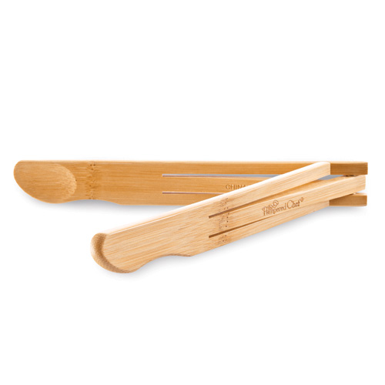  #2483 Bamboo Tongs  $9.00
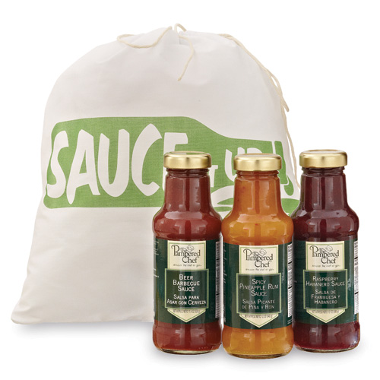  #2484  Sauce it Up Set  $34.50 | 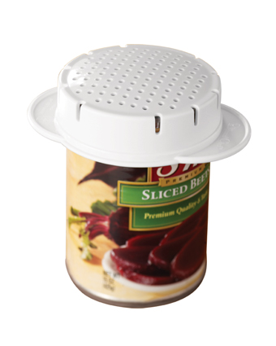  #2495 Can Strainer  $5.50
#2496 5” Strainer  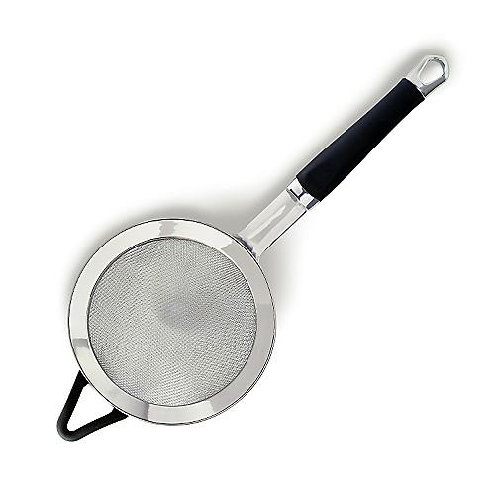  $24.00 | 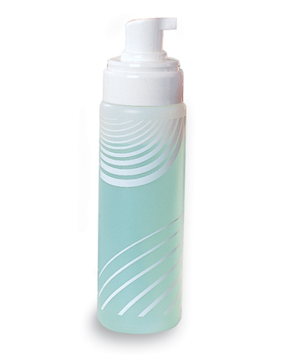  #2517 The Suds Pump®  $11.50
#2530 Small Scoop  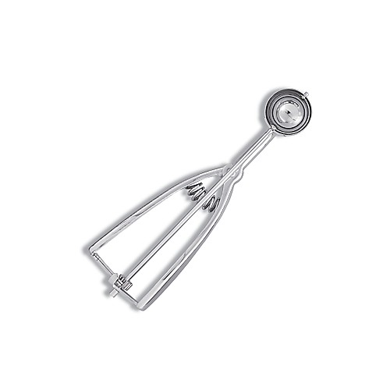  $15.50 | #2531 Grill Pan Dinner Set  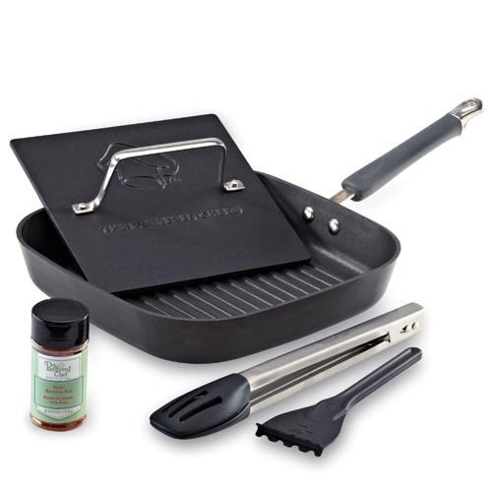  $215.00

