#2530 Small Scoop  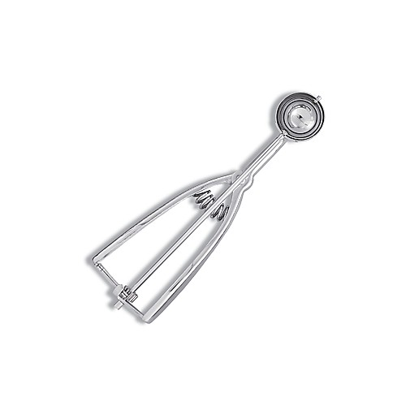  $15.50 |  | 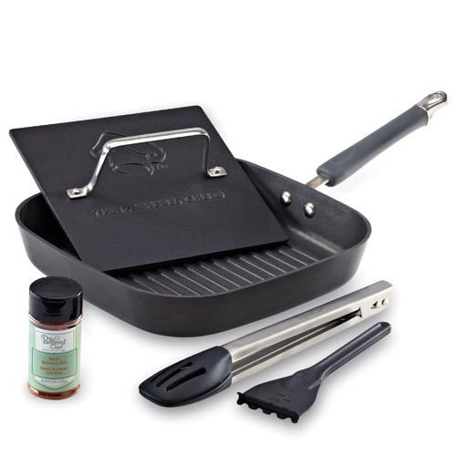  #2531 Grill Pan Dinner Set  $215.00
#2532 Manual Food Processor Set  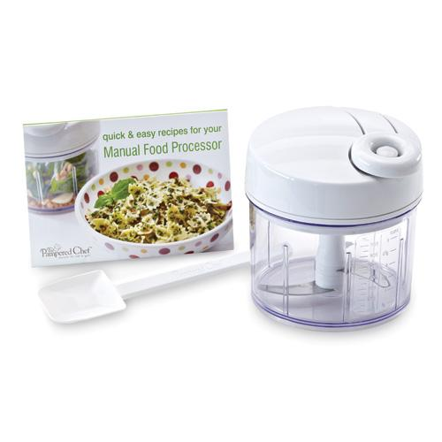  $64.00 |  | 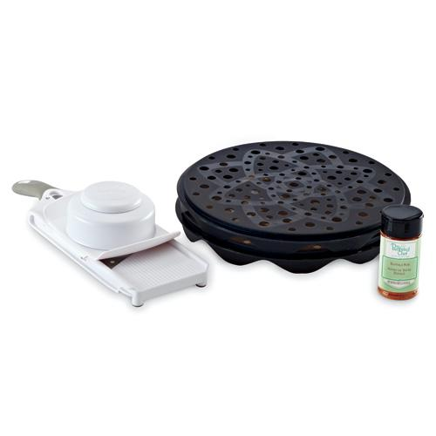  #2533 Make-Your-Own-Chips Set  $59.00
#2540 Medium Scoop  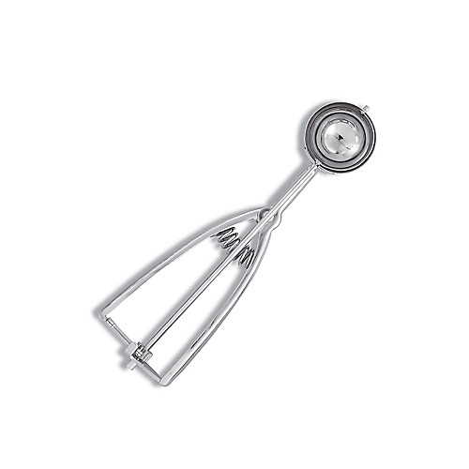  $16.50 |  | #2555 Scoop Clip  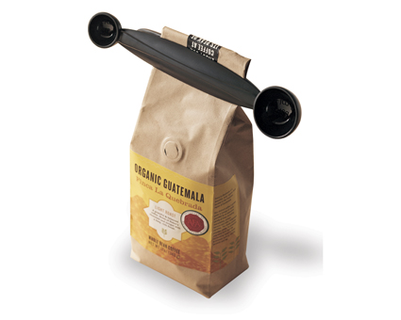  $6.00
#2576 Garlic Press  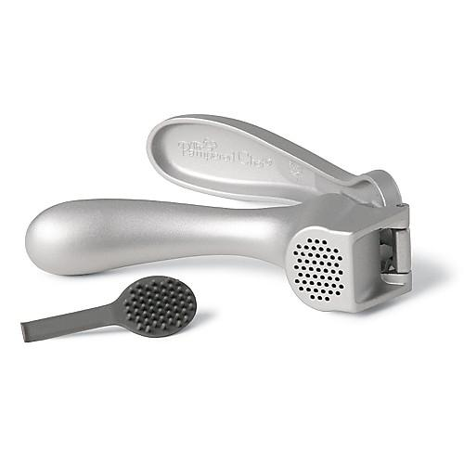  $16.50 |  | #2578 Garlic Peeler & Slicer Set  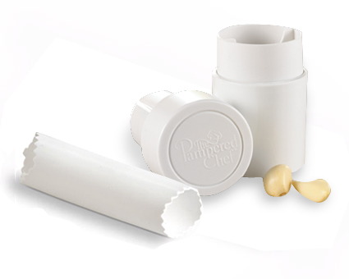  $19.50
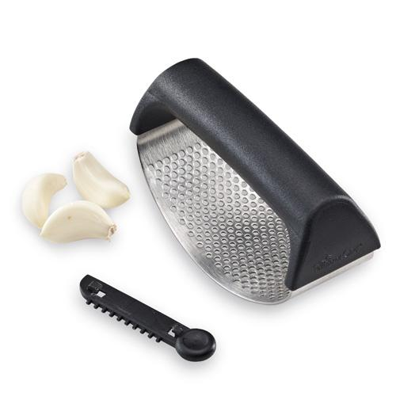  #2579 Garlic  Smash & Paste  $14.50 |  | #2581 Manual Food Processor  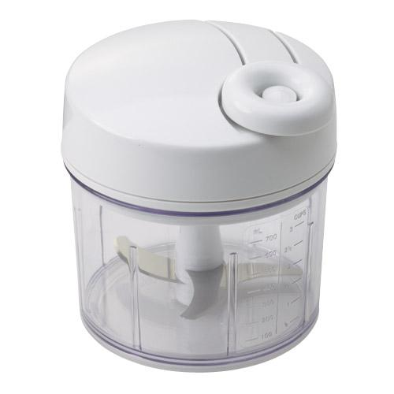  $49.00

