#2460 Corn Butterer  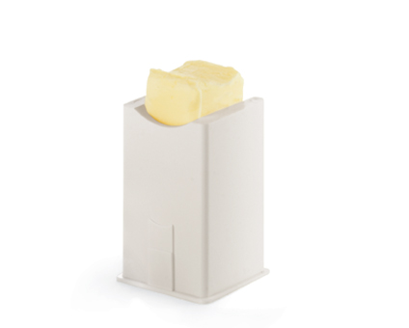  $4.00 | #2461 Windowpane Placemats – Cranberry (set of 4)  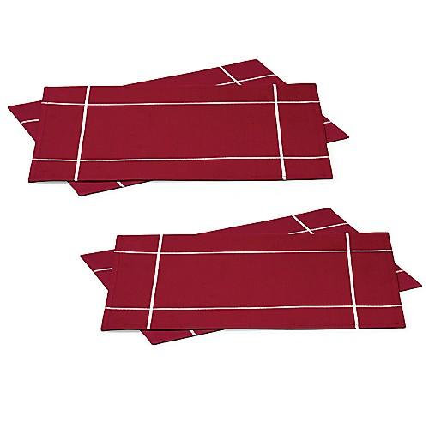  $15.00
#2462 Windowpane Placemats – White (set of 4)  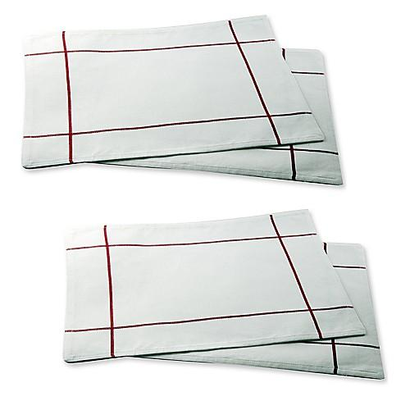  $15.00 | #2463 Windowpane Napkins – White (set of 4)  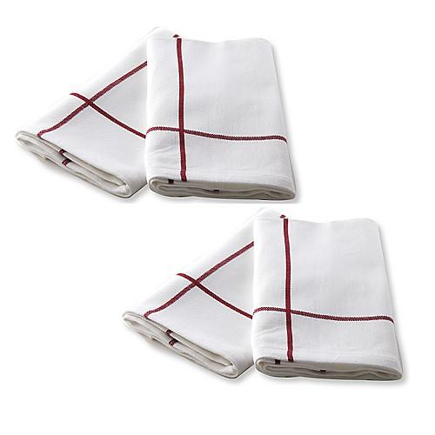  $9.00
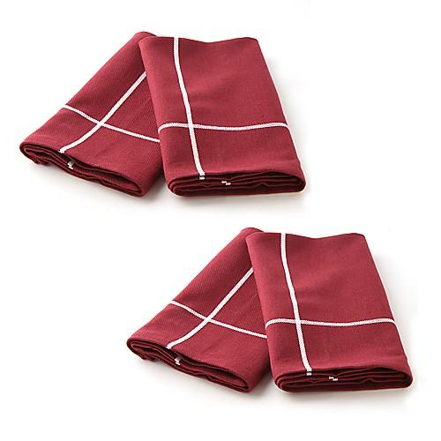  #2464  Windowpane Napkins – Cranberry  (set of 4)  $9.00 | #2465 Square Napkin Rings  (set of 4)  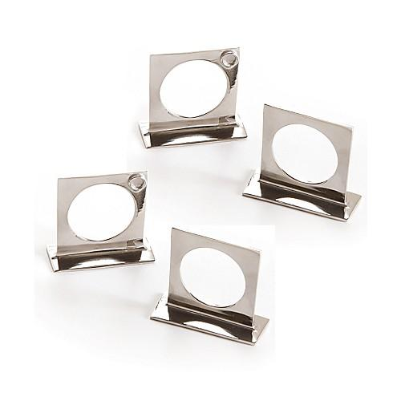  $9.00
#2473 29 Minutes to Dinner,  Volume 3 cookbook    $15.00 | #2474 Favorites Made Gluten-Free  recipe collection  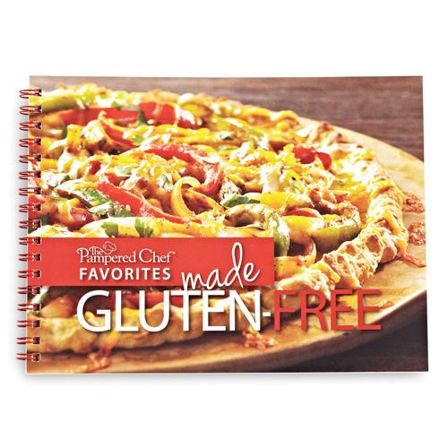  $8.00
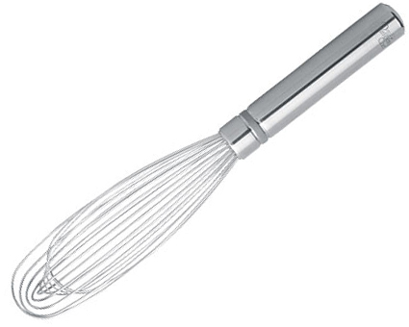  #2475 Stainless Whisk  $13.50 | #2477 Stainless Mini Whisk  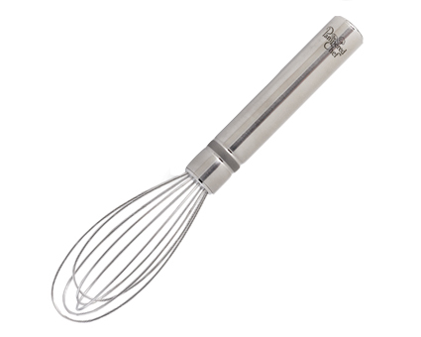  $10.00

