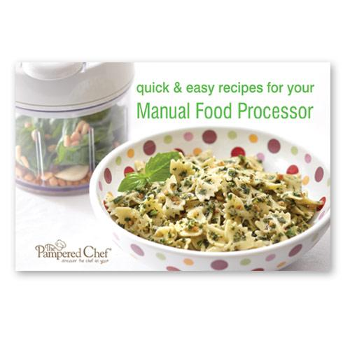  #2457 TPC Quick & Easy Recipes for Your Manual Food Processor recipe cards  $7.00 |  | #2459 TPC® Great Grilling Recipes cookbook  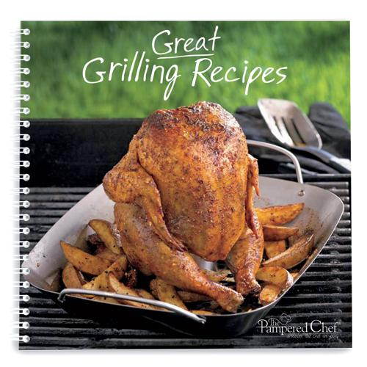  $15.00
#2460 Corn Butterer  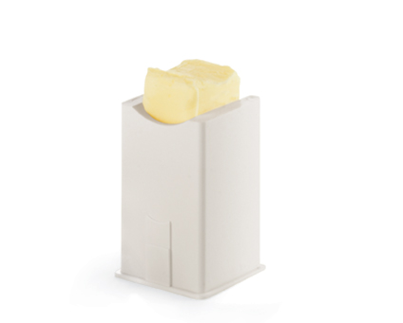  $4.00 |  | #2461 Windowpane Placemats – Cranberry (set of 4)  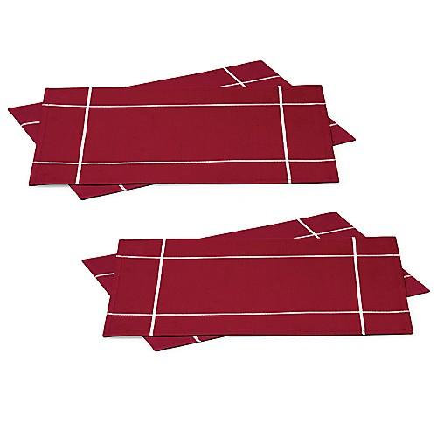  $15.00
#2462 Windowpane Placemats – White (set of 4)  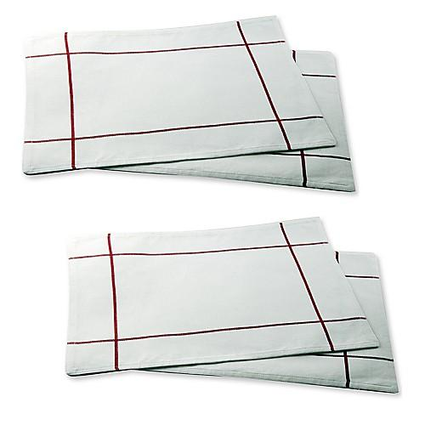  $15.00 |  | #2463 Windowpane Napkins – White (set of 4)  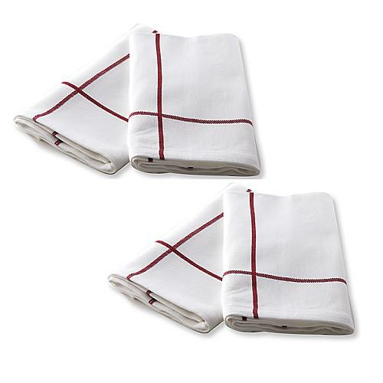  $9.00
#2464 Windowpane Napkins – Cranberry (set of 4)  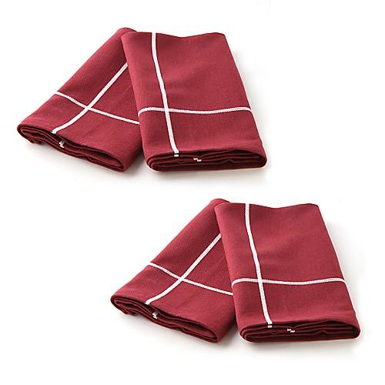  $9.00 |  | #2465 Square Napkin Rings  (set of 4)  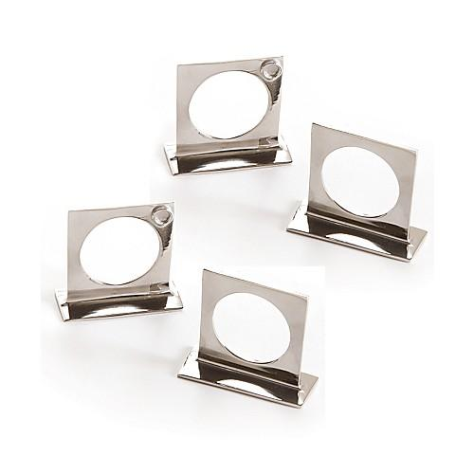  $9.00
#2473 TPC 29 Minutes to Dinner,  Volume 3 cookbook  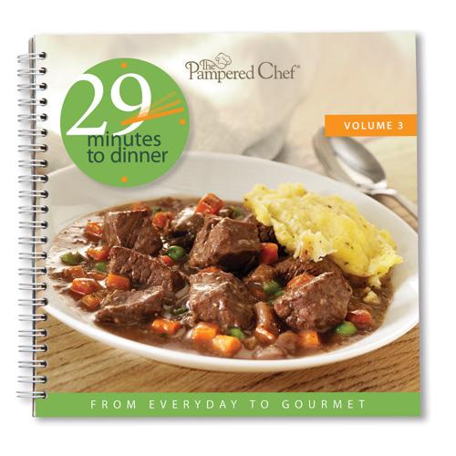  $15.00 |  | #2474 TPC Favorites Made Gluten-Free  recipe collection  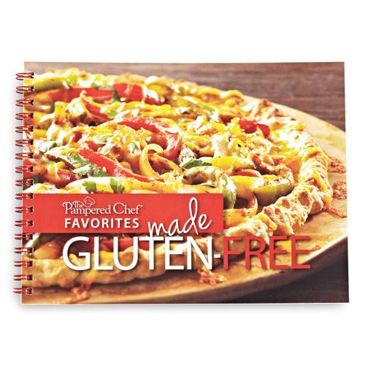  $8.00

